# Table of grammar contents – B2

## Complete list of B2 grammar contents

This is a list of all the grammar topics covered in level A1. But if you want to learn B2 grammar, we recommend studying the topics in the order that they appear in: Grammar points » [B2 Grammar lessons and exercises](https://test-english.com/grammar-points/b2/).

### Past tenses

B2 [Narrative tenses, used to, would](https://test-english.com/grammar-points/b2/narrative-tenses-used-to-would/)

### Future

B2 [Future forms: Expressing future time](https://test-english.com/grammar-points/b2/future-forms-expressing-future-time/)  
B2 [Other ways to express future: Be about to, be due to, etc.](https://test-english.com/grammar-points/b2/ways-express-future/)  
B2 [Future in the past](https://test-english.com/grammar-points/b2/future-in-the-past/)

### Modals, the imperative, etc .

B2 [Modal verbs: permission, obligation, prohibition, necessity](https://test-english.com/grammar-points/b2/modal-verbs-permission-obligation-prohibition-necessity/)  
B2 [Speculation and deduction: Modal verbs and expressions](https://test-english.com/grammar-points/b2/speculation-deduction/)  
B2 [Verbs of the senses](https://test-english.com/grammar-points/b2/verbs-of-the-senses/)  
B2 [Get: Different meanings](https://test-english.com/grammar-points/b2/get/)

### Conditionals, ****if****, ****wish****, etc.

B2 [All conditionals: mixed conditionals, alternatives to if, inversion](https://test-english.com/grammar-points/b2/all-conditionals-mixed-conditionals-alternatives-if-inversion/)  
B2 [Mixed conditionals: If I were you, I wouldn’t have done it](https://test-english.com/grammar-points/b2/mixed-conditionals/)  
B2 [Wish, rather, if only, it’s time: unreal uses of past tenses](https://test-english.com/grammar-points/b2/unreal-uses-past-tenses/)  
B2 [Unless, even if, provided, as long as, etc.: Other expressions in conditionals](https://test-english.com/grammar-points/b2/unless-even-if-provided-as-long-conditionals/)

### Passive

B2 [Distancing: Expressions and passive of reporting verbs](https://test-english.com/grammar-points/b2/distancing/)  
B2 [Passive verbs with two objects](https://test-english.com/grammar-points/b2/passive-verbs-with-two-objects/)

### -ing and the infinitive

B2 [Verb + object + infinitive/gerund: Verb patterns](https://test-english.com/grammar-points/b2/verb-object-infinitive-gerund/)  
B2 [Gerunds and infinitives: Complex forms](https://test-english.com/grammar-points/b2/gerunds-infinitives-complex-forms/)

### Articles, nouns, pronouns, and determiners.

B2 [Reflexive and reciprocal pronouns](https://test-english.com/grammar-points/b2/reflexive-reciprocal-pronouns/)  
B2 [Generic or common-gender pronouns](https://test-english.com/grammar-points/b2/generic-pronouns/)  
B2 [Compound nouns and possessive forms](https://test-english.com/grammar-points/b2/compound-nouns-possessive-forms/)  
B2 [Possessive ’s with time expressions: Two hours’ walk](https://test-english.com/grammar-points/b2/possessive-s-with-time-expressions-two-hours-walk/)

### Relative clauses, relative pronouns and adverbs

B2 [Relative clauses: Defining and non-defining](https://test-english.com/grammar-points/b2/relative-clauses/)

### ****there**** and ****it****

B2 [‘There’ and ‘it’: Preparatory subjects](https://test-english.com/grammar-points/b2/there-and-it/)

### Auxiliary verbs

B2 [Have: Auxiliary or main verb](https://test-english.com/grammar-points/b2/have-auxiliary-main-verb/)  
B2 [Ellipsis and substitution](https://test-english.com/grammar-points/b2/ellipsis-and-substitution/)

### Adjectives and adverbs

B2 [Modifying comparatives](https://test-english.com/grammar-points/b2/comparative-structures-modifying-comparatives/)  
B2 [Compound adjectives in English](https://test-english.com/grammar-points/b2/compound-adjectives-in-english/)  
B2 [Inversion with negative adverbials](https://test-english.com/grammar-points/b2/inversion-negative-adverbials/)

### Prepositions

B2 [50 common Noun + Preposition collocations](https://test-english.com/grammar-points/b2/50-common-noun-preposition-collocations/)

### Conjunctions and clauses

B2 [Clauses of contrast, purpose, reason and result](https://test-english.com/grammar-points/b2/clauses-contrast-purpose-reason-result/)  
B2 [Discourse markers: Linking words](https://test-english.com/grammar-points/b2/discourse-markers/)  
B2 [Participle clauses](https://test-english.com/grammar-points/b2/participle-clauses/)

### Word order

B2 [Cleft sentences: Adding emphasis](https://test-english.com/grammar-points/b2/cleft-sentences/)

### Past tenses

## Narrative tenses

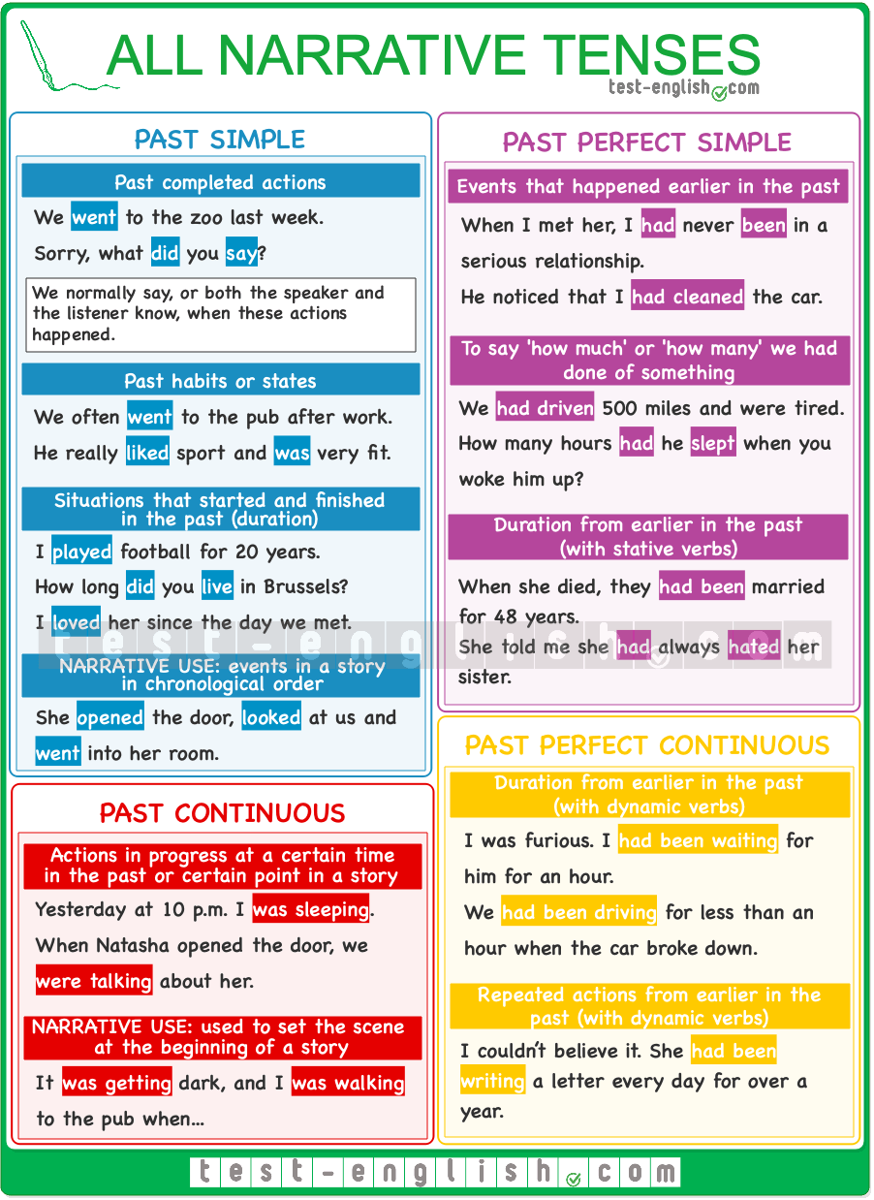

### Past simple

We use the past simple to talk about **past events in chronological order**; i.e. the main events of a story.

* When she **opened** the door, she **pretended** we weren’t there, and she **went** to her room.
* He **called** me and **asked** me to pick him up, but he wasn’t there when I **arrived**.

We also use the past simple to talk about **past habits** or **past states**.

* We often **went** to the bar for a drink before dinner.
* He really **liked** sport and **was** very fit.

### Past continuous

We use the past continuous to **set the scene** in a story.

* Last night, I **was walking** home and **listening** to my Ipod when …
* The sun **was shining**, and lots of tourists **were lying** on the beach. Suddenly …

We use the past continuous for **actions in progress** in the past or longer actions interrupted by shorter actions in the past simple.

* After dinner, I went into the living room and saw she **was crying**.
* When she opened the door, we **were talking** about her.

### Past perfect simple

We use the past perfect simple to talk about an earlier past: events that happened before the main event.

#### Earlier single events

We use the past perfect simple to talk about earlier events and experiences or single actions completed earlier in the past.

* When she opened the door, he **had** already **left**.
* I realised that I **had been** there before.
* When I met her, I **had** never **been** in a serious relationship.
* He noticed I **had cleaned** the car. It was smooth and shiny.

We also use the past perfect simple (and not continuous) to say **how much or how many** we had done of something earlier in the past.

* We **had driven** 500 miles, and we needed some rest.
* How many hours **had** he **slept** when you woke him up?

#### Duration from earlier in the past (stative verbs)

We use the past perfect simple with stative verbs to talk about states or situations that had started earlier in the past. We often use **how lon**g, **for** or **since, always**, **etc**.

* The day Anne died, they **had been** married for 48 years.
* The day I left, I **had been** in England for exactly four years.
* She told me she **had** always **hated** her sister.

### Past perfect continuous

#### Duration from earlier in the past (dynamic verbs)

We use the past perfect continuous with dynamic verbs to talk about **longer continuous actions that started earlier in the past** than the main events of the story.

* I was very angry. I **had been waiting** for him in the cold, and he didn’t call to say he’d be late.
* We **had been driving** for less than an hour when the car broke down.

#### Repeated actions from earlier in the past (dynamic verbs)

We use the past perfect continuous with dynamic verbs to talk about **repeated actions from earlier in the past**.

* I couldn’t believe it. She **had been writing** a letter every day for over a year.

## Used to & Would

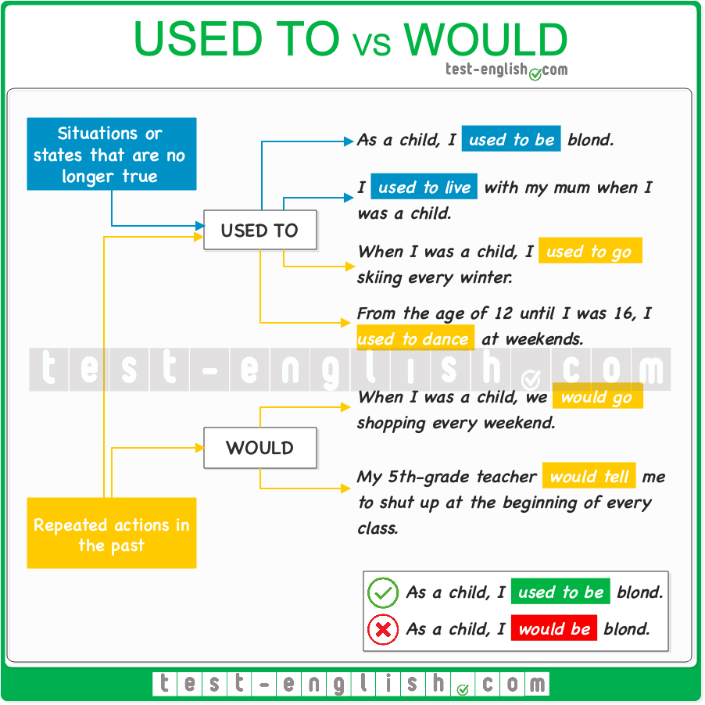

### ****Used to**** + infinitive

#### Repeated actions in the past

We can use **used to** + infinitive to talk about **things** that **we did repeatedly** in the past.

* When I was a child, I **used to go** skiing every winter.
* From the age of 12 till I was 16, I **used to dance** at weekends.
* I **didn’t use to smoke** before I got this job.

#### Situations or states that are no longer true

We can use **used to** + infinitive to talk about situations or states (stative verbs) which were true in the past but are no longer true.

* As a child, I **used to be** blond.
* I **used to live** with my mum when I was a child.

### ****Would**** + infinitive

#### Repeated actions in the past

We can use **would** + infinitive to talk about **things** that **we repeatedly did** in the past.

* Every Saturday we **would go** to the shopping centre with my parents.
* My 5th-grade teacher **would tell** me to shut up at the beginning of every class.

#### Situations or states that are no longer true

We can NOT use **would** to talk about situations or states (stative verbs) which are no longer true.

* I **would be** blond as a child. 
* I **used to be** blond as a child. 

### Future

## Intentions, plans, decisions

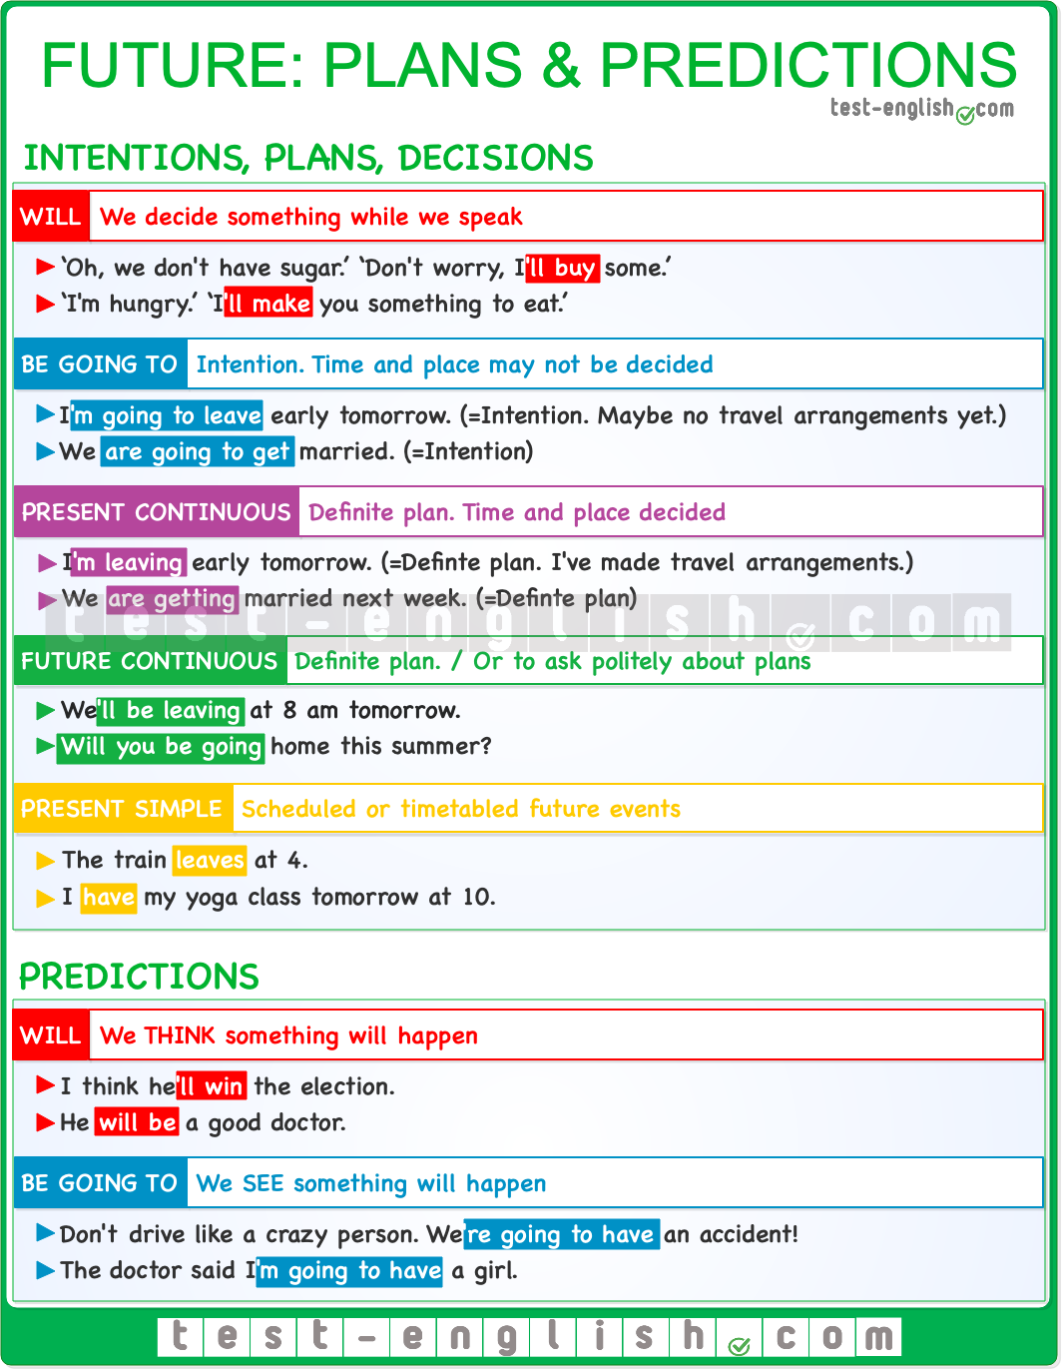

#### Will

We use **will** for decisions we make at the moment of speaking (**instant decisions)**.

* ‘Oh, we don’t have sugar.’ ‘Don’t worry, I’**ll buy** some.’

#### Present continuous

We often use the **present continuous** to talk about future events that are already planned and decided –when a date and/or a place have been chosen.

* I’**m seeing** the dentist at 6.
* We **are getting** married next week.
* I’**m flying** to New York tomorrow morning.

#### ****Be going to****

We can also use **be going to**to talk about future arrangements.

* I’**m going to** play tennis with Elisabeth today.

#### Present continuous vs ****be going to****

We can normally use both the present continuous and **be going to** to talk about future plans, but the **present continuous** emphasises that we have already decided on a place and/or time, whereas **be going to** emphasises our intention to do something, without necessarily implying that all the arrangements have been made.

* I’**m going to have** a drink after work. (=it’s my intention)
* I’**m having a drink** with some colleagues after work. (=it has been arranged)

#### Future continuous

We can also use the [future continuous](https://test-english.com/grammar-points/b1-b2/future-continuous-and-future-perfect/) instead of the **present continuous** for **future events** already **planned** or **decided**.

* We’**ll be coming** next weekend.
* We’**ll be leaving** at 8 a.m. tomorrow.

We often use the future continuous to ask politely about future arrangements.

* **Will** you **be going** home this summer?

Of course, we can also use the **future continuous** to talk about situations or actions that will be **in progress** at a particular time in the future.

* This time next week, we’**ll be travelling** to Paris.
* Tomorrow at 10, you’**ll be doing** your exam.

#### Present simple

We use the present simple for future events that are scheduled or timetabled.

* The train **leaves** at 4.
* Shops **close** at 6.
* I **have** my yoga class tomorrow at 10.

## Predictions

#### ****Will****

We use **will** to talk about something we **think** will happen:

* I think he’**ll win** the election.
* He **will be** a good doctor.

#### ****Be going to****

We use **be going to** to talk about something that is very near to happen or that we **see** is going to happen (there is present evidence)

* Don’t drive like a crazy person. We’**re going to have** an accident!
* The doctor said I’**m going to have** a girl.

## Future perfect

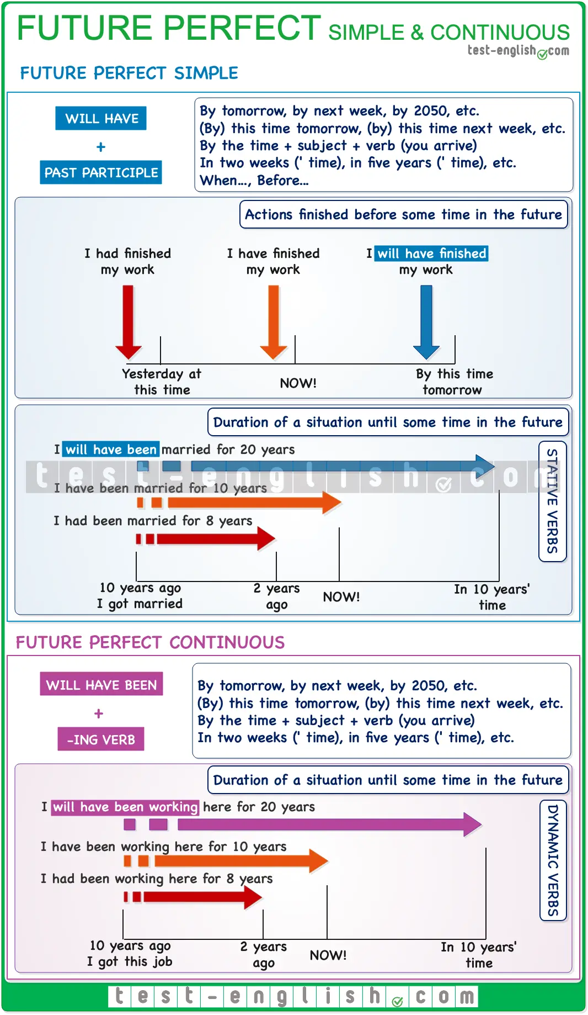

#### Future perfect simple

We use the [future perfect simple](https://test-english.com/grammar-points/b1-b2/future-continuous-and-future-perfect/) for actions that will be finished before a specific time in the future.

* By 2050, researchers**will have found** a cure for cancer.
* By this time next year, I’**ll have graduated**.

We can also use the **future perfect simple** to talk about the duration of a situation until a specific time in the future (with stative verbs).

* I **will have been** in England for six months by the time I leave.
* In 2 years, **we will have been** married for 20 years.

#### Future perfect continuous

We use the **future perfect continuous** with dynamic verbs to talk about the duration of a situation until a particular time in the future.

* By the end of the year, she **will have been working** on the publication for over ten years.
* When he steps into the boxing ring on Saturday, he **will have been training** for about 18 months.

## Future time clauses (****when, as soon as, until, before, after****)

Use **present simple** to talk about the future in sentences with **when, as soon as, until, before, after**

* I’ll retire when I’**m** 70. (NOT: **when I’ll be **)
* I won’t call you until I **arrive** (NOT: **will arrive **)

## Other uses of ****will****

#### Promises and refusals

* I **will help** you whenever you need me.
* I **won’t lend** him my car.

#### Future facts

* The president **will visit** the Vatican next November.

#### Offers

When we offer to do something for somebody, we use **I will** in statements or **shall** **I** in questions.

* I’**ll carry** that bag for you.
* Shall I **organise** the meeting?

#### Suggestions

We use **shall** **we**to make suggestions.

* Shall we **eat** out today?

#### Requests

* Will you **open** the door, please?

## Other ways to express future: Grammar chart

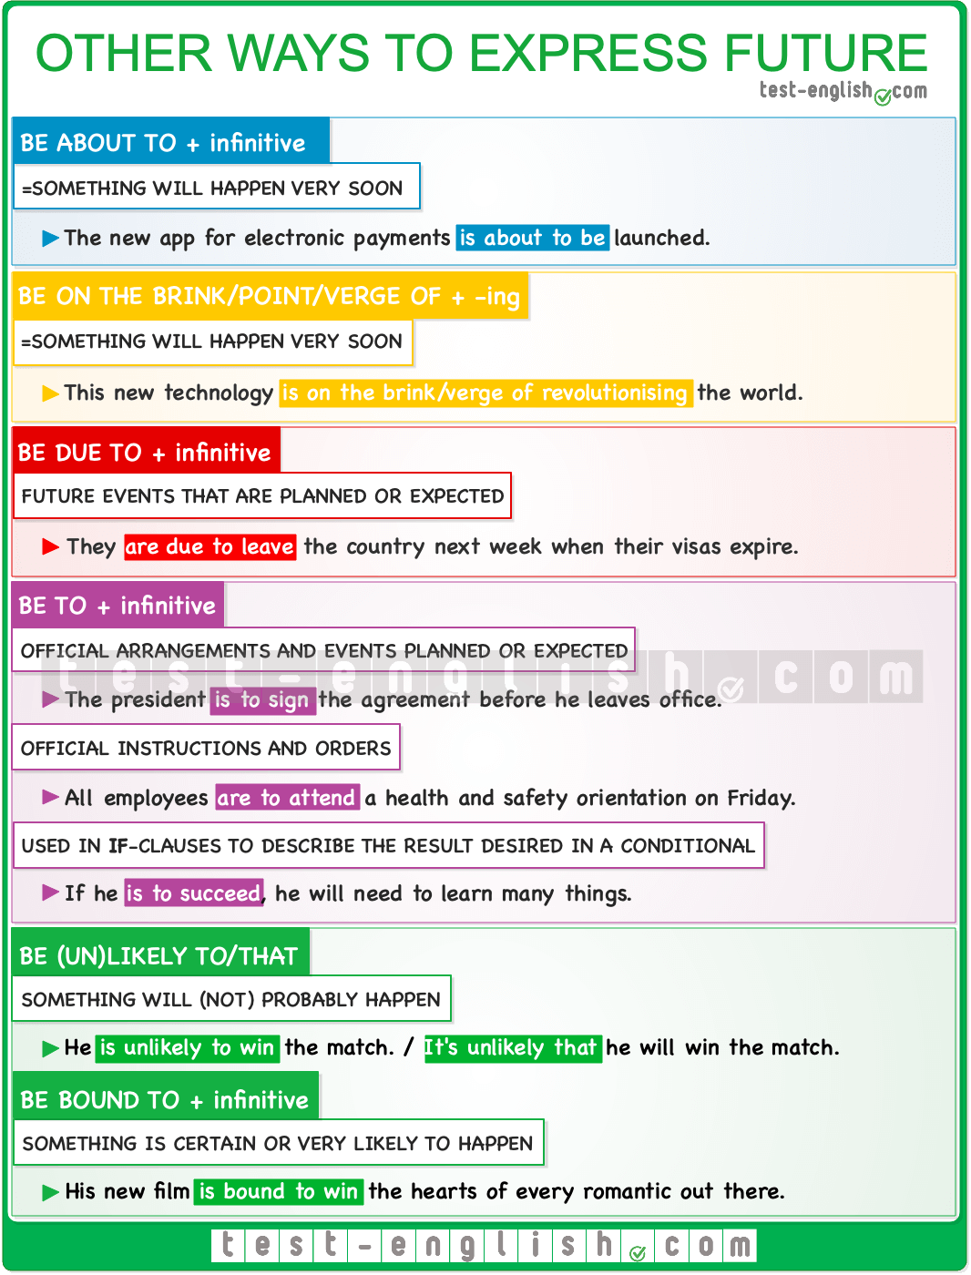

## Be about to, be on the brink/verge/point of

#### Be about to

We often use **be about to** + infinitive to say that something will happen in the very near future.

* Some apps **are about to disappear** from the market.
* Scientists say they **are about to find** a vaccine.

#### Be on the brink/verge/point of

We can also use **be on the brink of, be on the verge of**, or **be on the point of** to say that something will happen very soon.

* Our country’s economy is **on the brink of collapse**.
* This historical museum is **on the brink of losing** half its masterpieces.
* They are **on the verge of becoming** the team to win the most finals in history.
* The two historical enemies **are on the point of reaching** an agreement.

## Be due to

We use **be due to** + infinitive to talk about future events that are planned or expected to happen.

* Greece **is due to repay** around £6 billion to its creditors next semester.
* The secretary **is due to arrive** in Montreal tomorrow morning.

## Be to

We can use **be to** + infinitive in different situations.

#### Official arrangements

**Be to** + infinitive is often used in news reports to talk about official arrangements and events that are planned or expected to happen. The meaning is usually something like ‘it is expected’.

* Prince William **is to visit** Paris for the first time since his mother died. (=It is expected that Prince William will…)
* Nine care homes for the elderly **are to close** by the end of March.

#### Formal instructions and orders

We can also use**be to** + infinitive to talk about **official instructions** and**orders**. When used in the negative form, it expresses **prohibition**.

* All employees **are to attend** a health and safety orientation at the end of the week.
* You **are not to leave** this room until I say so.

#### ****If**** clauses

We often use **be to** + infinitive in an **if**-clause. In these cases, we say what should be done (main clause) to achieve the desired result (**if**-clause).

* We need to be open to everybody’s opinion if we **are to avoid** repeating the mistakes of the past.
* If he **is to succeed**, he will need to learn to represent the interests of all Americans.

## Be bound to, be likely to (probability)

#### Be bound to

We use **be bound to** + infinitive to say that something is certain or very likely to happen.

* They **are bound to like** him. He is such a sweet guy.
* His new film **is bound to win** the hearts of every romantic out there.

#### Be likely to

We use [**be likely to**](https://test-english.com/grammar-points/b1-b2/likely-unlikely-bound-definitely-probably/) + infinitive to say that something will probably happen. We can also use **It + be likely that** + clause.

* The government **is likely to pass**new regulations very soon.
* **It’s likely that** the company will have to pay for the damages.

We use **be unlikely**+ infinitive to say that something will probably not happen. We can also use **It + be unlikely that** + clause.

* He **is unlikely to win** this match.
* It’**s unlikely that** the weather will change over the next few days.

## Using future in the past

Sometimes, we talk about a past event and want to refer to something that happened in the future at that particular point in the past. When we want to express future time seen from the past, we use the past of the [regular future forms](https://test-english.com/grammar-points/b2/future-forms-expressing-future-time/).  
  
Check the following sentences to see the future forms and their corresponding past forms.  
  
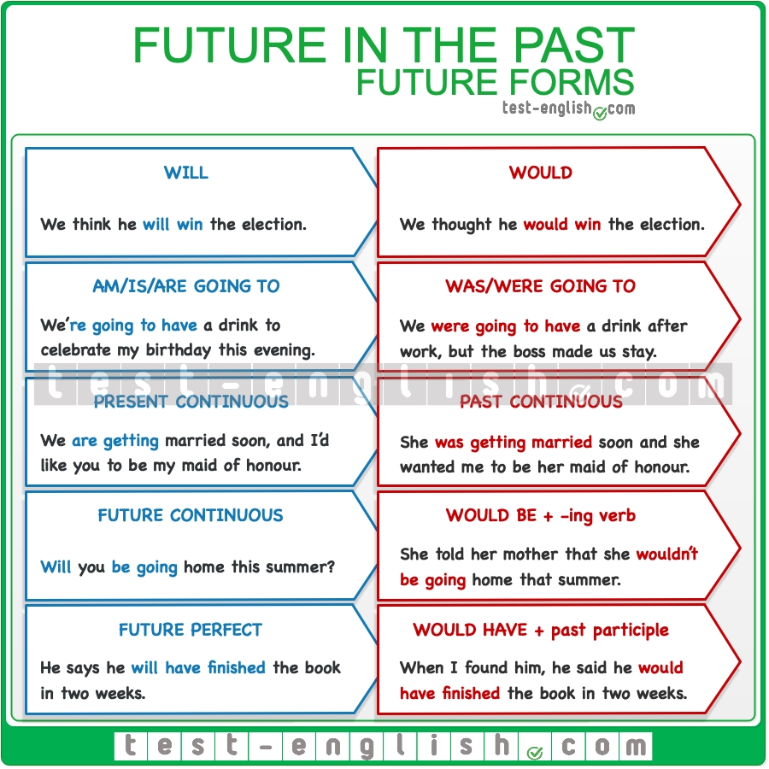

We can also talk about the future seen from the past using [other ways to express future](https://test-english.com/grammar-points/b2/ways-express-future/). Check the table below.  
  
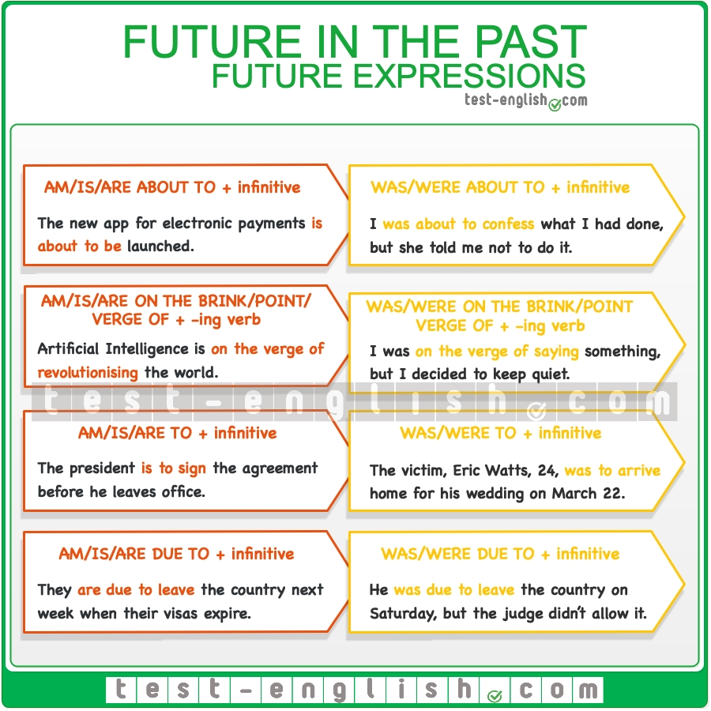

### Modals, the imperative, etc .

## Permission

#### Can, could, may, might

The most common modal verbs to talk about permission are **can**, **could**, **may** and **might**.

* ASKING FOR PERMISSION (INFORMAL): **Can** I sit here?
* ASKING FOR PERMISSION (FORMAL): **Could** I **use** this chair? **Might/May** I **use** this chair?
* GIVING PERMISSION (INFORMAL): You **can** sit here.
* GIVING PERMISSION (FORMAL): You **may use** this chair.
* REFUSING PERMISSION (INFORMAL): Sorry, you **can’t** **use** this chair.
* REFUSING PERMISSION (FORMAL):  Sorry, you **may not** **use** this chair.

#### Was/were allowed to, couldn’t

To talk about permission in the past, we can use the forms **was/were allowed to** or the negative form **couldn’t**. We don’t use the affirmative form **could** to talk about permission in the past.

* He **wasn’t allowed to sit** down during the lesson.
* He **couldn’t sit** down during the lesson.
* He **could receive** visits. 
* He **was allowed to receive** visits. 

## Obligation

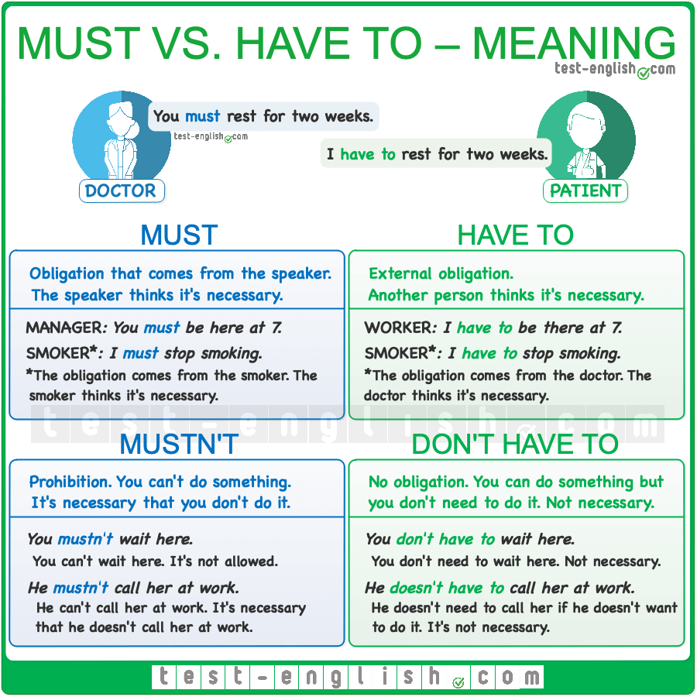

#### Must / have to

**Must** and **have to** are used to express obligation. When we use **must** this usually means that the obligation comes from the speaker, it’s like a personal obligation, whereas **have to** normally means that the obligation is external.

* I **must give up** smoking. (I need to, I say so)
* I **have to give up** smoking. (I’m obliged. My doctor says so)

In informal English can also use **‘ve got to** to express obligation  (⇒ See [Have – auxiliary or main verb](https://test-english.com/grammar-points/b2/have-auxiliary-main-verb/)).

* I’**ve got to be** there before ten.

In the past, we use **had to** in every instance.

* I **had to give up** smoking. (because I needed to, or because my doctor forced me to).

#### Mustn’t / don’t have to

The negative forms **mustn’t** and **don’t have to** are completely different. **Mustn’t** is used to express prohibition (an obligation **not** to do something), whereas **don’t have to** is used to express an absence of obligation. (⇒ See [Have to, must, should – obligation, prohibition, necessity, advice](https://test-english.com/grammar-points/b1/have-to-must-should/))

* You **mustn’t reveal** where you get the information. (=you have the obligation **not** to do it)
* You **don’t have to arrive** before 7. (=you can do it, but it’s not necessary, there’s no obligation)

## Necessity

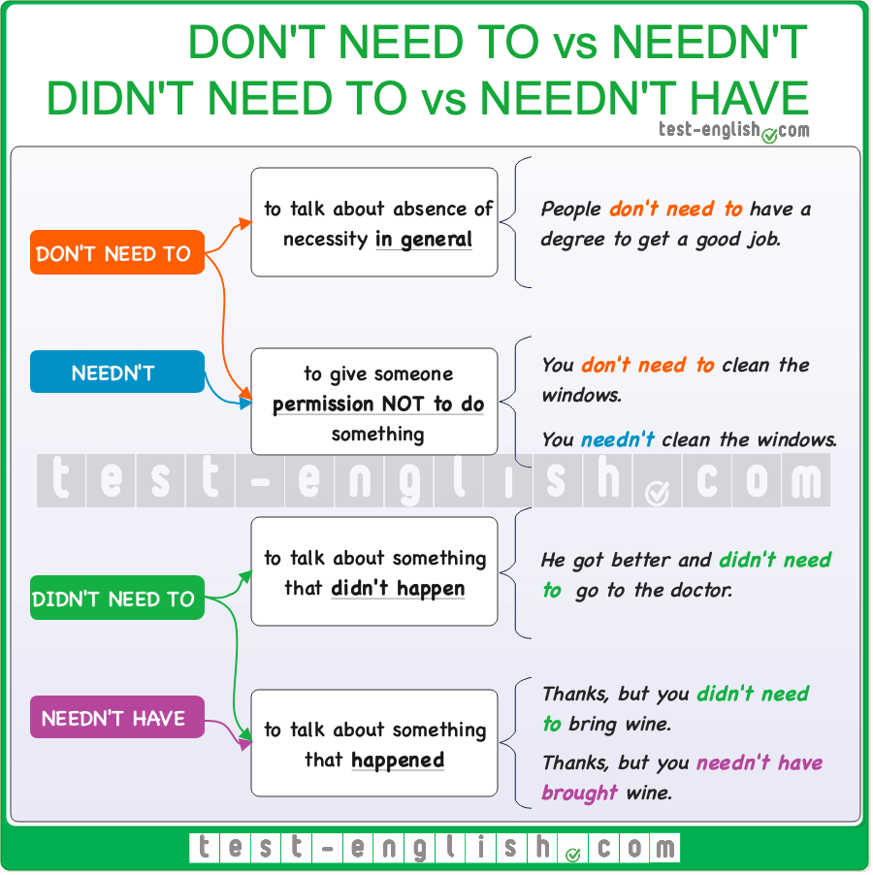

#### Need to, have to, don’t need to, don’t have to

We use **need to/have to** or **don’t need to/don’t have to** + infinitive to say that something is or is not necessary.

* We **need to/have to confirm** our reservations before Friday.
* You **don’t need to/don’t have to believe** in God to be a good person.

#### Don’t need to / needn’t

We can use both **don’t need to** or **needn’t** + infinitive to say that it is unnecessary to do something. However, when we are talking about a **general necessity** (in general, not on one specific occasion), we normally use **don’t need to**, and we can use both **don’t need to** or **needn’t** + infinitive when we are talking about a **specific necessity** (on one specific occasion).

* The doctor said I **don’t need to wear** glasses. (In general, all the time)
* Tell him he **doesn’t need to/needn’t wash** the dishes. I’ll do it later. (On one specific occasion)

#### Didn’t need to / needn’t have

When something was not necessary but **we did it**, we can use both **didn’t need to** + **infinitive** and **needn’t have + past participle**.

* Thanks, it’s very beautiful, but you **didn’t need to buy/needn’t have bought** anything. (=you did it)

However, when something was not necessary and we **did not do it**, we can only use **didn’t need to**.

* I didn’t buy any groceries because Sarah told me I **needn’t have bought** anything. 
* I didn’t buy any groceries because Sarah told me I **didn’t need to** buy anything. 

## Be able to, be allowed to, be permitted to, be supposed / meant to, had better

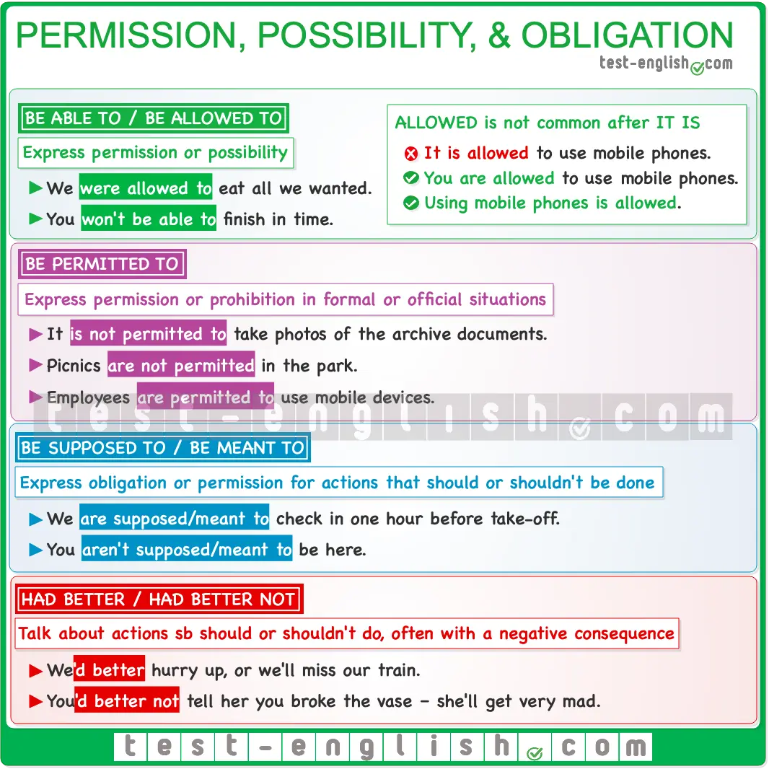

#### Be able to / be allowed to

We can use subject + **be able to / be allowed to** instead of **can**to express permission or possibility. (⇒ See [Can, could, be able to – ability and possibility](https://test-english.com/grammar-points/b1/can-could-be-able-to/))

* We **were allowed to eat** all that we wanted.
* You **won’t be able to finish** before the deadline.

We do NOT normally use **it + be able to**/**be allowed to**+ infinitive.

* **It is allowed to use** mobile phones. 
* **You are allowed to use** mobile phones. 
* **Using mobile phones is allowed**. 

#### Be (not) permitted to

We can use **be (not) permitted** **to** +infinitive to express permission or prohibition in formal or official situations, to say what the rules or laws are. The form **it + be (not) permitted** **to** +infinitive can be used.

* **It is not permitted to take** photos of the archive documents.
* Picnics **are not permitted** in the park.
* Employees **are permitted to use** mobile devices.

#### Be supposed to / be meant to

We can also use **be supposed/meant to + infinitive** to express obligation or permission, to say what we should or shouldn’t do.

* We **are supposed/meant to check** **in** one hour before take-off.
* What are you doing? You **aren’t supposed/meant to be** here.

#### Had better, had better not

We use **had better**+ infinitive (without **to**) to talk about actions we think someone should or shouldn’t do. There is often a **negative result** if the action is carried out. We normally use the shortened form **‘d better**, and the negative form is  **‘d better not**(**hadn’t** is NOT used).

* We’**d better hurry up** or we’ll miss our train.
* You’**d better not** tell her you broke the vase –she’ll get very mad. 
* You **hadn’t better** tell her you broke the vase. 

## Modal verbs of speculation and deduction

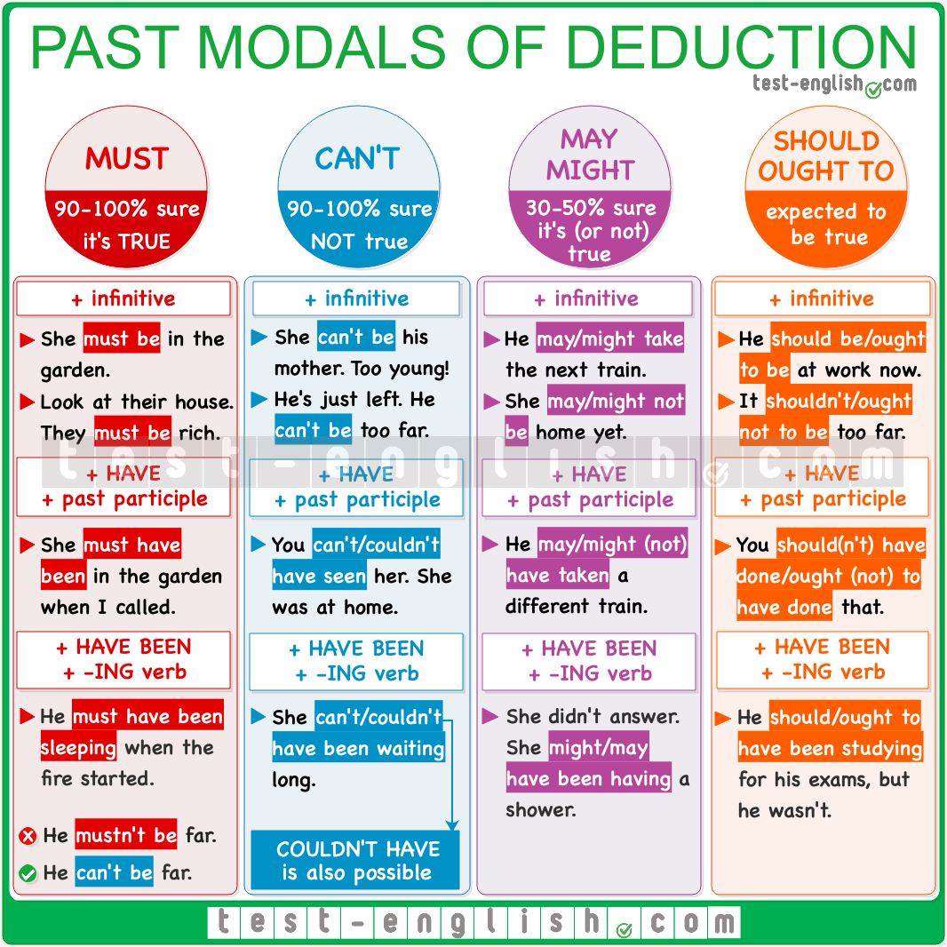

#### Must

We use **must** + infinitive for obligation and strong recommendation, but also to say that we are **quite sure that something is true**.

* They are almost identical. They **must** **be** sisters.
* But I answered all the questions correctly. There **must be** a mistake.

We use **must be** + –**ing** with dynamic verbs to say that we are quite **sure that something is happening now**.

* What you are saying is not possible. You **must be kidding**.
* Can you hear the shouting? Our neighbours **must be arguing** again.

We use **must have** + past participle or **must have been + -ing** to say that we are quite sure that something **was true or happened in the past**.

* I can’t find my wallet! I **must have dropped** it in the taxi.
* You **must have had** a real scare when you saw the crocodile.
* He was the only victim. He **must have been sleeping** when the fire started.

#### Can’t

We can use **can’t** + infinitive to say that we are **quite sure that something is NOT true**.

* He **can’t be** that famous. I’ve never heard his name before.
* She **can’t be** married. I have never seen a ring on her finger.

We use **can’t be** + –**ing** to say that we are quite **sure that something is NOT happening now**.

* They **can’t be travelling** by bus. There is no bus service on Sundays.

We use **can’t/couldn’t have** + past participle or **can’t have been + -ing** to say that we are **quite sure that something did NOT happen or was NOT true in the past**.

* You **can’t/couldn’t have seen** John last night. He was in hospital.
* She **can’t/couldn’t have passed** the test. She didn’t even open the books.

❗ **Note** that for negative deduction, we use **can’t** (NOT **mustn’t**):

* He **mustn’t be** that famous. 
* He **can’t be** that famous. 

#### Could/might/may

We can use **could/might/may**+ infinitive to say that **it’s possible that something is true**(but we are not sure).

* I can’t get hold of him on the phone. He **could/might/may be** away.
* *We didn’t do anything when we could, and now it* ***could/might/may be****too late.*

We use **could/might/may be** + –**ing** to say that we are quite **it’s possible that something is happening now**(but we are not sure).

* Tom isn’t at the office. He **might/may be working** from home today.
* ‘*Why isn’t she picking up her phone.’ ‘She might/may****be driving.’***

We can use **could/might/may have** + past participle or **might/may have been + -ing** to say that **it’s possible that** **something was true or happened** in the past.

* It’s been three days. They **could/might/may** **have finished** painting the house by now.
* *If they left at 9, they****could/****might/may have already arrived.*
* *She was home last night but didn’t answer the door. She might/may have been having a shower.*

We can use **could have** + past participle to say that something was possible in the past but did not happen.

* He **could have played** in the first division but had a terrible injury.
* He **could have had** better jobs if he had spoken English.

❗ **Note** that we use **might not** or **may not** (NOT **could not**) to talk about a negative possibility.

* He seems too calm. He **might/may** **not be** aware of the risks.
* She **might/may not have heard** us. Knock again.

#### Should/ought to

We use **should**/**ought to** + infinitive to talk about a situation that we expect to happen (present or future).

* He **should/ought to be** home by now. He is always home before 7.
* They **should/ought to arrive** before midnight.

We use **should have**/**ought to have**+ past participle to talk about a situation expected to happen in the past. We can also use this form to express criticism.

* He **should/ought to** **have received** the parcel yesterday. I sent it two days ago.
* He **should/ought to have studied** more. Nobody fails if they study.

## Expressions for speculation

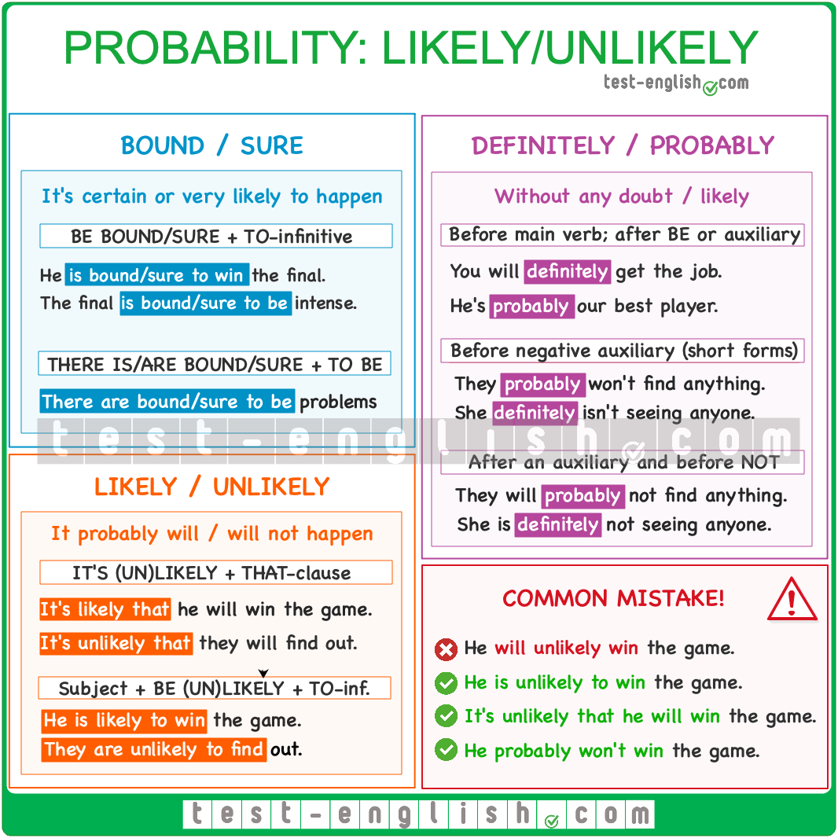

#### Bound/sure

**Bound** and **sure** are adjectives used to say that we are quite sure that something will be true or happen. We use them in the structure **be bound/sure + to**-infinitive.

* The Jamaican **is** **bound/sure** **to win** the final.
* There **are bound/sure** **to be** some discrepancies during the meeting, so be prepared.

#### Likely/unlikely

**Likely** and **unlikely** are adjectives. If something **is likely to happen**, it means that it will probably happen or is expected to happen. If something **is unlikely to happen**, it means that it probably won’t happen. We can use these two adjectives in two ways.  
  
**It is likely/unlikely that** + clause

* **It’s likely that** just in a few years, we will change our economic model.
* **It’s unlikely that** the police had anything to do with it.

Subject + **be likely/unlikely** + **to**-infinitive

* He **is likely to** win this game.
* They **are unlikely to** reach an agreement.

#### Definitely/probably

**Definitely** and **probably** go before the main verb and after the auxiliary verb (if there is one) in positive sentences.

* You’**ll** **definitely** get the job. Nobody’s got your qualifications and experience.
* He’**s definitely** our best player.

And they go before the auxiliary verb in negative sentences.

* They **definitely won’t find** any evidence.
* She **definitely isn’t seeing** anyone right now.

## Stative or dynamic uses of sense verbs

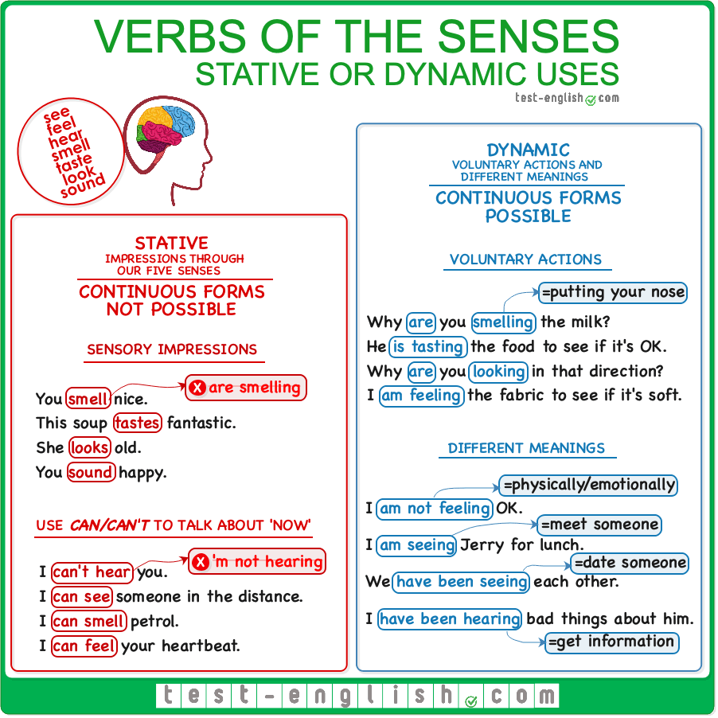

#### Stative uses of ****feel, hear, see, smell, taste****

When we use the verbs **feel, hear, see, smell**, or **taste** to talk about the impressions that we receive through our five senses (touch, hearing, sight, smell, taste), they are all non-action verbs and cannot be used in progressive forms.

* You **smell** nice. (NOT **you are smelling**)
* This soup **tastes** fantastic. What did you put in it? (NOT **is tasting**)

#### ****Can/can’t (feel, hear, see, smell, taste)****

We normally use **can** or **can’t** with these verbs (and NOT present continuous) to talk about something that is happening at the moment.

* I **can see** a beautiful woman next to your sister. (NOT **I am seeing **)
* Sorry, can you speak up? I **can’t hear** you. (NOT **I’m not hearing **)
* I **can smell** petrol. Have you just filled up the tank? (NOT **I am smelling **)
* I’ve burned my tongue, and now I **can’t taste** the flavour of the food. (NOT **I am not tasting **)
* I can feel your heartbeat. It is very fast. (NOT **I’m feeling **)

#### ****Look**** and ****sound****

**Look** and **sound** are also stative (or non-action) verbs when they mean ‘seem’ or ‘appear’.

* She **looks** old.
* You **sound** very happy.

#### Dynamic uses of ****feel, hear, look, see, smell, taste****

The verbs **feel, look, smell**, and **taste**can be used in continuous forms when they are **voluntary actions**.

* Why **are** you **smelling** the milk? Isn’t it good? (=Put your nose near something to see how it smells)
* He’**s tasting** the food to see if it needs more salt. (=Put something into your mouth to see how it tastes)
* I’**m feeling** the fabric to see if it’s soft or not. (=Touch something to see how it feels)
* Why **are** you **looking** in that direction? (=direct your eyes in order to see)

We can also use **feel** in progressive tenses to talk about how we feel physically or emotionally.

* ‘How **are** you **feeling**?’ ‘I’**m not feeling** very well.’
* *I* ***was feeling*** *very weak after the operation.*

The verbs **see** and **hear** can also be used as action verbs with different meanings.

* I’**m seeing** Jerry for lunch. (=Meet someone)
* We’**ve been seeing** each other for months. (=Date someone)
* I’**ve been hearing** really strange things about him recently. (=receive information)

## Sense verbs + infinitive or gerund?

After **feel, hear, listen, notice, see, watch**, we can use a gerund to express an incomplete action, an action in progress, or a repeated action:

* I **saw** them **kissing** in the park. (=The action was in progress. I didn’t see it finish.)
* They **watched** the man **hitting** a police officer. (=The action was in progress; the man hit the police officer repeatedly.)

After **feel, hear, listen, notice, see, watch** we can use an infinitive to talk about an action we heard or saw from beginning to end; usually a short action, and not a repeated action.

* I **saw** them **kiss** in the park. (=I saw the action from start to end. It was probably a short kiss)
* They **watched** the man **hit** a police officer. (=They saw the action from start to end; the man hit the police officer once)

## Sense verbs + adjective, noun or clause (linking verbs)

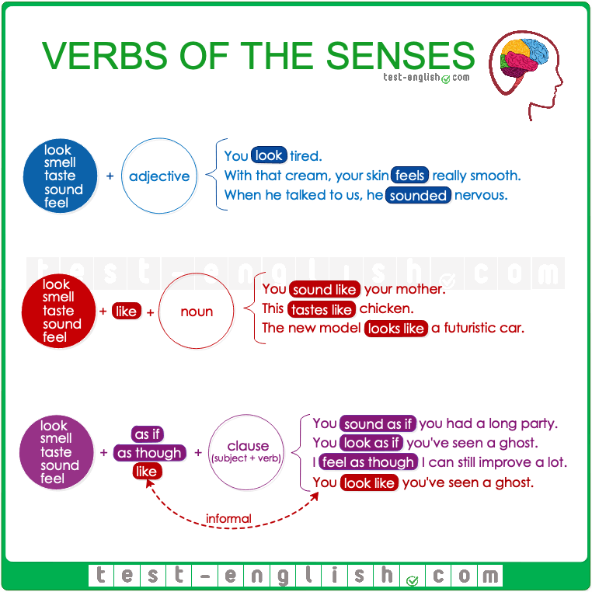

#### ****Look, smell, taste, sound, feel**** + adjective

We can use **feel, smell, taste, sound**, and **feel** before an adjective to talk about how something feels, tastes, etc.

* When you use that cream, your skin **feels** really **smooth**.
* When he talked to us, he **sounded nervous**.

#### ****Look, smell, taste, sound, feel + like**** + noun

We can also use **feel, smell, taste, sound**, and **feel** **+** **like** before a noun.

* You **sound like your mother**.
* This **tastes like chicken**.

🔍 **Note** that we say **smell/taste of** to talk about the smell or flavour of the real thing, and we say **smell/taste like** when it’s a smell or flavour similar to the real thing. Compare:

* The soup **smells of** cheese. (=There is cheese in it.)
* The soup **smells like** cheese. (=The smell is similar to the smell of cheese.)

#### ****Look, smell, taste, sound, feel**** + ****as if/as though**** + clause

* You **sound as if you had a long party last night**.
* You **look as though you’ve just seen a ghost**.

🔍 **Note** that in informal English, we often use **feel, smell, taste, sound**, and **feel** **+ like** + clause.

* You sound **like** you had a long party last night.
* You look **like** you’ve just seen a ghost.

## ****Seem, appear**** and ****look****

#### ****Seem**** + adjective, ****seem like**** + noun, ****seem as if/though**** + clause

* You **seem** tired.
* He **seems** clever.
* The final five minutes **seemed like** five hours.
* It **seems as if** they aren’t going to help us.

🔍 **Note** that in informal English, we also use **like**before a clause.

* It **seems like** we’ll never find out the truth.

#### ****Seem, appear**** + ****to**** + infinitive

After **seem**and **appear**, we often use **to + infinitive** (present events), or a **to + have** + past participle (past events).

* She **appears to be** in very good shape.
* It **seems to be** some kind of insect.
* He **seems to have lost** his moral compass.

#### ****It seems/appears**** + ****that****-clause

We can also use **It seems/appears** + **that**-clause.

* It **appears that** he might be telling the truth after all.
* It **seems that** they have improved a lot since the end of the season.

#### ****Seem**** vs ****look****

When we use **seem**and **look** as non-action verbs, there is some difference in meaning.

* You **look** tired. (=I get the impression from seeing your face)
* You **seem** tired. (=I get the impression from the way you behave –your voice, movements, etc.)

Sometimes, we can use one verb but not the other and vice versa.

* She **looks** beautiful. (NOT **seems **, because I get the impression from looking at her physique)
* She **seems** nice. (NOT **looks **, because I get the impression by her behaviour)

## Sense verbs, followed by adjectives or adverbs?

When the verbs of senses are used as non-action verbs, they are copular verbs and copular verbs (like **be**) are followed by adjectives and not by adverbs.

* You **look** **tired**. (NOT **tiredly **)
* She **felt bad** after saying that. (NOT **badly **)

## Get: Different meanings

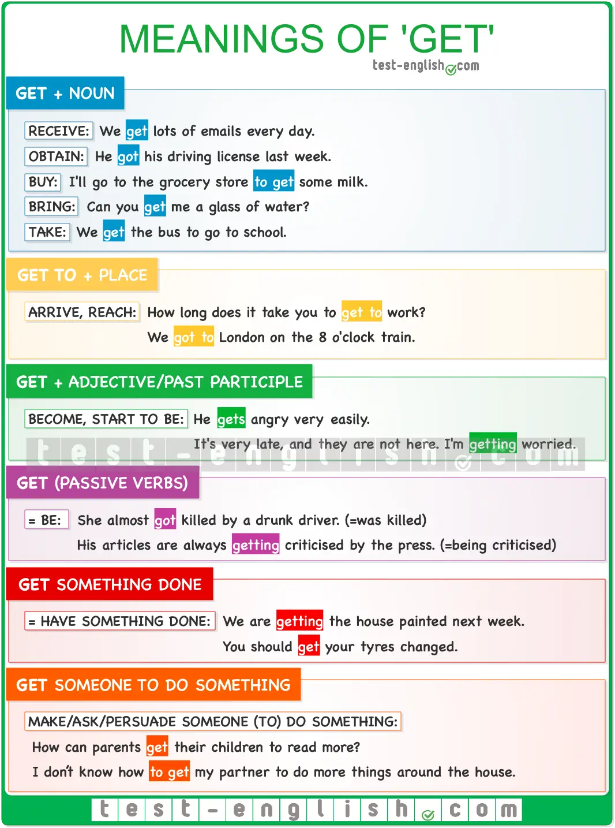

### ****Get**** + direct object= obtain, receive, bring, buy, bring, catch

#### Obtain

* He always **gets** everything he wants.
* He **got** his driving license last week.

#### Receive

* I **got** a letter from John yesterday.
* She **gets** lots of presents from her fans.

#### Buy

* We need to **get** a new computer. The old one is broken.
* Can you go to the shop to **get** some milk?

#### Bring

* Can you **get** me a couple of glasses from the kitchen?
* Can I **get** you a drink?

#### Catch

* Do you think we’ll have time to **get** the 7.40 train?
* I need to **get** the first flight to Seattle.

### ****Get to**** + place = arrive, reach

* He always **gets** home very late.
* We **got** to London on the 8 o’clock train.
* How long does it take you to **get** to work?

### ****Get**** + adjective/past participle= become

#### ****Get**** + adjective

* I’m **getting old**.
* He **gets angry** very easily.
* You should go. It’s **getting dark**.

#### ****Get**** + past participle

* It’s very late and they are not here. I’m **getting worried**.
* He **gets** very **tired** after every concert.
* We **got married** last year.

### ****Get= be**** (passive verb forms)

* I **got caught** by the police after jumping a red light. (=was caught)
* She almost **got killed** by a drunk driver. (=was killed)
* His articles are always **getting criticised** by the press. (=being criticised)

### ****Get something done****= [have something done](https://test-english.com/grammar-points/b1-b2/have-something-done/)

* We are **getting the house painted** next week.
* You should **get your tyres changed**.

### ****Get someone to do something****= make, ask, persuade someone to do something

* How can parents **get their children to read** more?
* I don’t know how to **get my partner to do** more things around the house.

### Conditionals, ****if****, ****wish****, etc.

## Zero, first, second, third and mixed conditionals

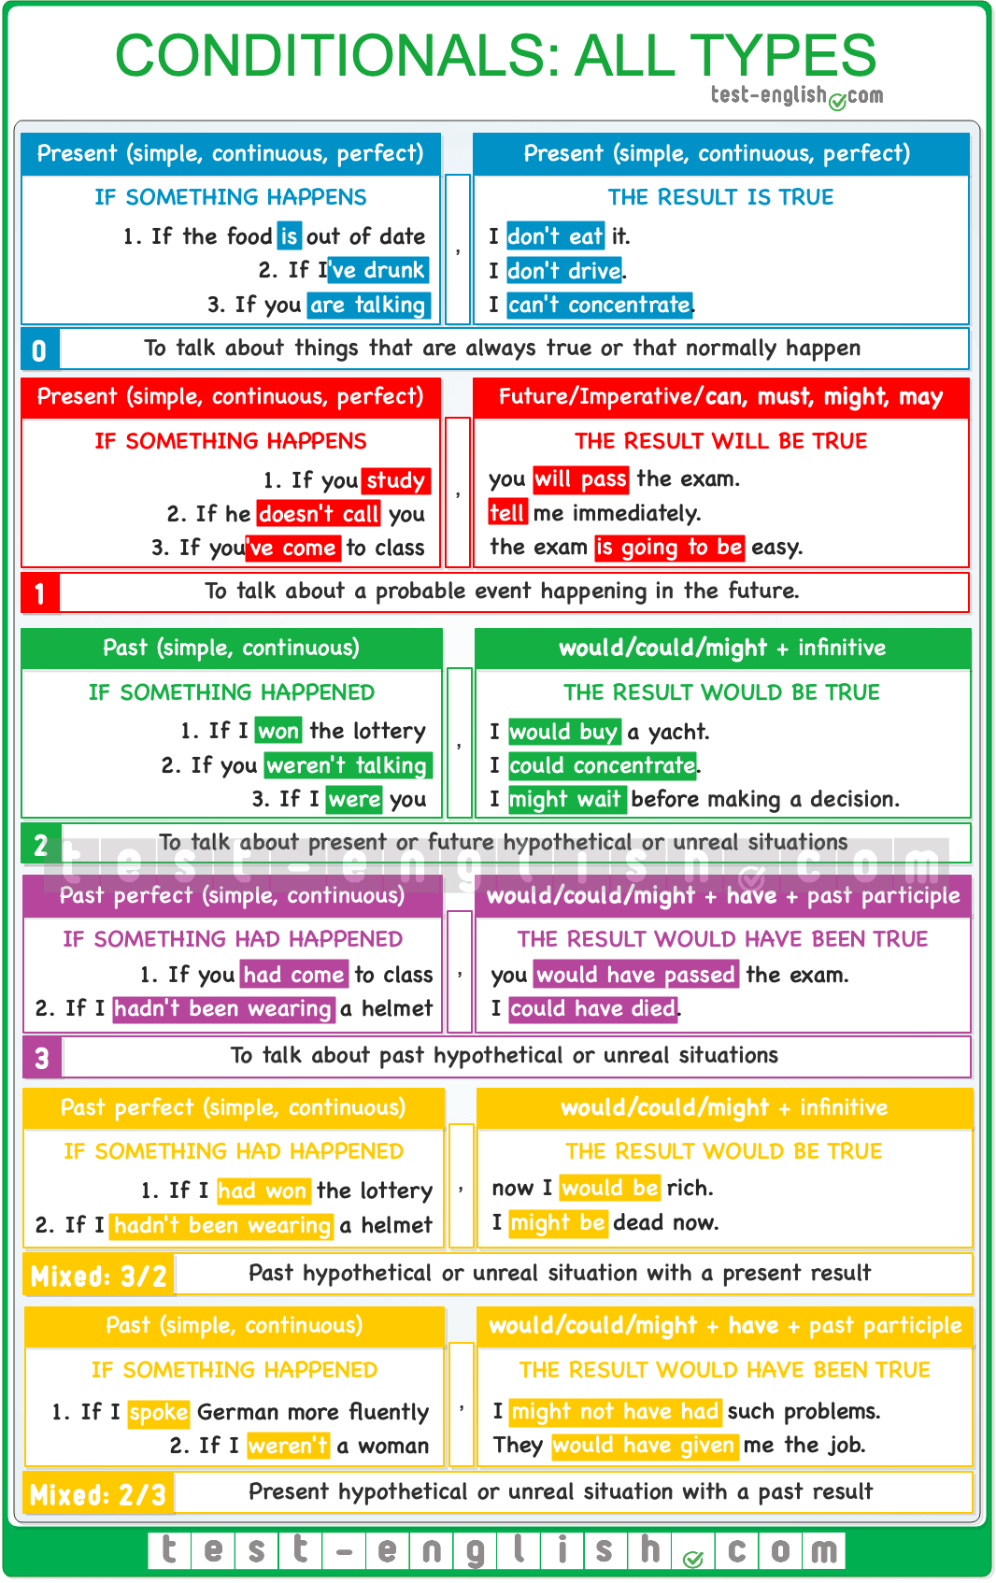

## Zero conditional

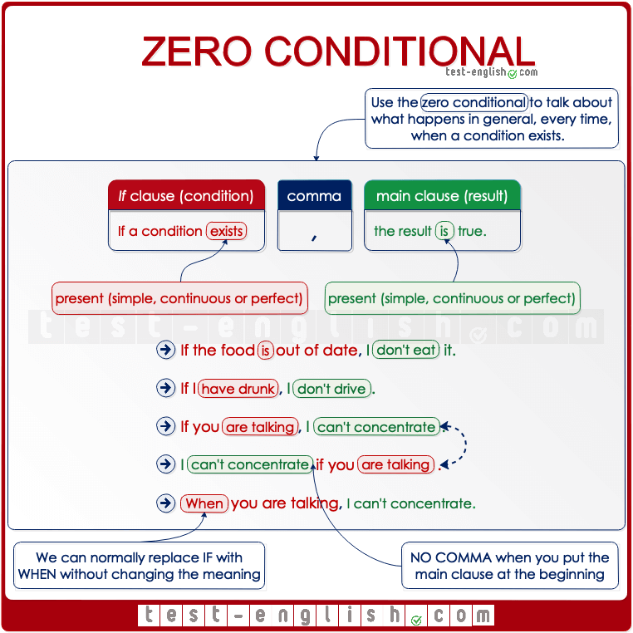  
We use the zero conditional to talk about **general truths** or **results that always happen** if a condition is present. We are talking in general, not about one particular situation.

* + **If** milk **smells** bad, I **don’t drink** it.
  + **If** water **reaches** 100 degrees, it **boils**.
  + **If** I’**ve drunk**, I never **drive**.
  + **If** people **are talking** all the time, I **can’t concentrate**.

We can put the main clause at the beginning. Then we don’t use a comma between the two clauses.

* + I never **go** to bed late **if** I **have** to get up early.

We can usually replace the **if**in this conditional with **when** without changing the meaning.

* + Dogs can attack you **when** you are scared.
  + **When** the weather is bad, people don’t go shopping.

## First conditional

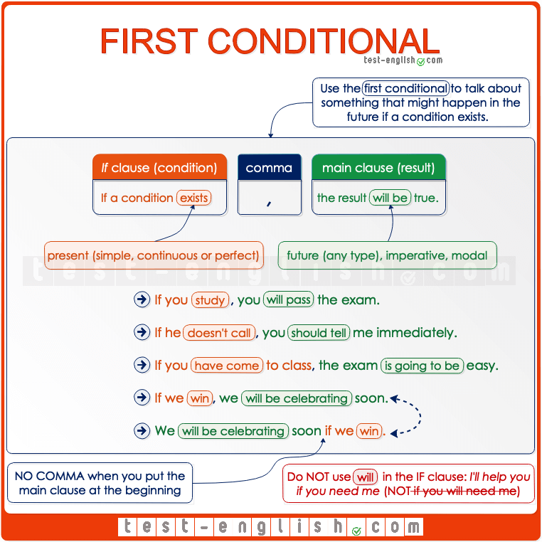  
The first conditional is used to talk about things that might happen in the future if a condition is present. We don’t know if those things will happen or not, but they are a real possibility.

* + If you **study**, you’**ll pass**.
  + If he **doesn’t call** you, **tell** **me** immediately.
  + If you’**ve come** to class, the exam **is going to be** easy.
  + If you **help** me, I’**ll have finished** by the end of the month.

We don’t use **will** in the **if**clause.

* + I’ll help you if you **need** me (NOT ~~if you will need me)~~

#### ~~Unless = if (not)~~

~~We can also use~~ **~~unless~~**~~in conditional sentences to mean~~ **~~if~~** ~~… (~~**~~not~~**~~)~~

* + ~~I won’t go on holiday~~ **~~unless~~** ~~I save some money. =~~
  + ~~= I won’t go on holiday~~ **~~if~~** ~~I~~ **~~don’t~~** ~~save some money.~~

#### ~~First vs zero conditional~~

~~We use the first conditional to talk about a particular situation, whereas we use the zero conditional to talk about what happens in general.~~

* + ~~If you don’t use oil, it tastes awful. (I’m talking about what happens every time.)~~
  + ~~If you don’t use oil, it will taste awful. (I’m talking about this particular occasion.)~~

## ~~Second conditional~~

~~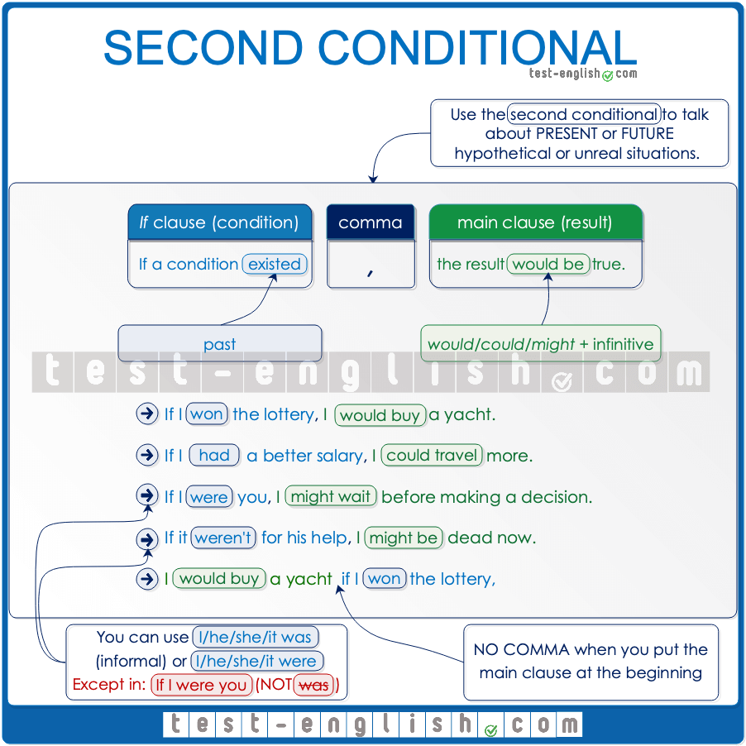  
  
We use the second conditional to talk about hypothetical or imaginary situations in the present or the future. We can use past simple or past continuous in the if-clause and we can use~~**~~would, could~~**~~or~~**~~might~~** ~~+ simple infinitive (do) or continuous infinitive (be doing) in the main clause.~~

* + ~~If there~~ **~~was~~** ~~a fire, it~~ **~~would be~~** ~~impossible to escape.~~
  + ~~If you~~ **~~weren’t making~~** ~~so much noise, I~~ **~~could concentrate~~**~~.~~
  + ~~I~~ **~~wouldn’t have~~** ~~a car if I~~ **~~lived~~**~~in the city.~~
  + ~~If it~~ **~~weren’t~~** ~~for him, I~~ **~~might not be talking~~** ~~to you right now.~~

~~When we use the verb~~**~~be~~** ~~in the if-clause, we can use either~~**~~was~~** ~~(more formal) or~~**~~were~~** ~~(spoken English) after~~**~~I, he~~**~~,~~**~~she~~**~~or~~ **~~it~~**~~.~~~~But when we are giving advice, we always use~~ **~~if I were you~~** ~~(NOT~~**~~was~~**~~).~~

* + **~~If~~****~~he~~****~~was~~**~~/~~**~~were~~** ~~rich, he~~ **~~wouldn’t be living~~** ~~in this house.~~
  + **~~If I were you~~**~~, I’d call him as soon as possible. (NOT~~**~~was~~**~~)~~

~~As with all conditional types, we use a comma after the if-clause when it goes at the beginning of the sentence, but we don’t use a comma when the if-clause goes at the end.~~

* + ~~If you~~ **~~weren’t making~~** ~~so much noise, I~~ **~~could concentrate~~**~~.~~
  + ~~I~~ **~~could concentrate~~**~~if you~~ **~~weren’t making~~** ~~so much noise.~~

## ~~Third conditional~~

~~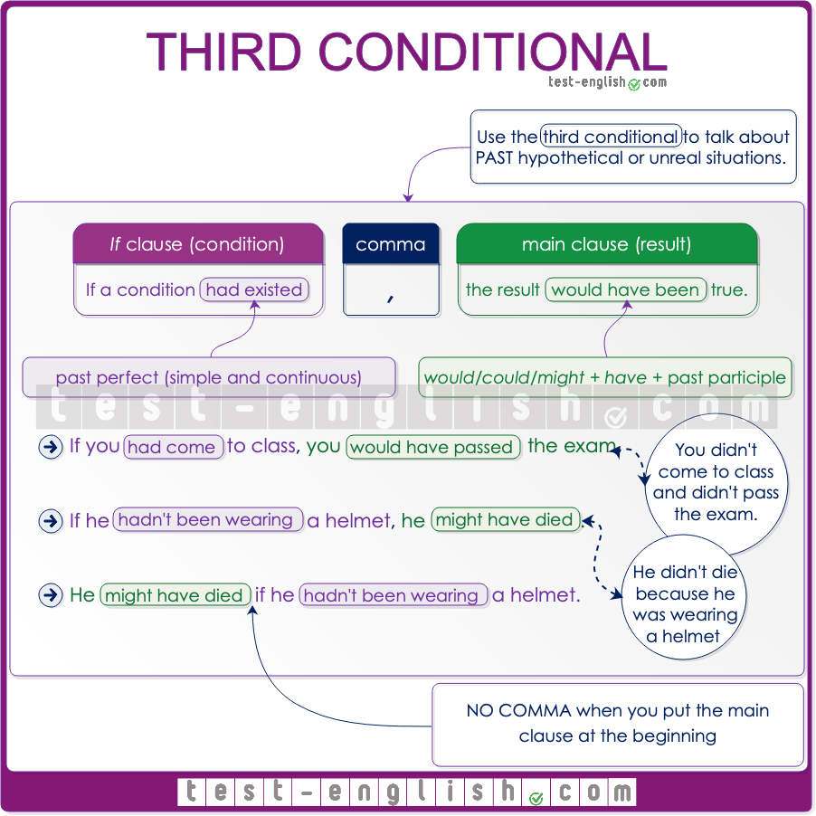  
  
We use the third conditional to talk about hypothetical or imaginary situations in the past. We can use the past perfect simple or past perfect continuous in the if-clause and we can use~~**~~would, could~~**~~or~~**~~might~~** ~~+ the perfect infinitive in the main clause.~~

* + ~~If you~~ **~~had come~~** ~~to class more often, you~~ **~~would have passed~~** ~~the test.~~
  + ~~I~~ **~~wouldn’t have been~~** ~~late if I~~ **~~hadn’t overslept~~**~~.~~
  + ~~He~~ **~~could have died~~** ~~if he~~ **~~hadn’t been wearing~~** ~~a helmet.~~
  + ~~If the jacket~~ **~~had been~~** ~~a bit cheaper, I~~ **~~might have bought~~** ~~it.~~

## Mixed conditionals

We use mixed conditionals to mix talking about the present and the past in the same sentence. The mixed conditional is a combination of the [second and the third conditional](https://test-english.com/grammar-points/b1-b2/second-third-conditionals/):  
  
➟ We can use past simple or continuous in the **if**-clause (to refer to the present or future) and **would**/ **should**/ **might** **have** + **past participle** in the main clause (to refer to the past).  
  
➟ We can also use past perfect in the **if**-clause (to refer to the past) and **would**/ **should**/ **might** + **infinitive** (to refer to the present).

* If I **didn’t have** (second conditional) so much work, I **would have gone** (third conditional) to the party last night.
* If I **spoke**(second conditional) German, I **would have understood** (third conditional) them.
* If I **had won** (third conditional) the lottery, I **would be** (second conditional) rich.
* If I **hadn’t dropped** (third conditional) school, I **could have** (second conditional) a better job now.

## Alternatives to ****if**** in conditional sentences

#### As long as / provided (that) / providing (that) / on condition (that) / only if

We can use the expressions **as long as, provided/ providing (that), on condition (that),** or **only if**instead of **if**when we want to emphasise the condition that needs to be present so that something can happen or be done.

* I’ll tell you what really happened **as long as** you keep the secret.
* I’ll lend you the money **provided (that)** you pay me back next month.
* They will speak to the press **on condition (that)** they remain anonymous sources.
* We will invest the money, but **only if** you can prove that it’s a safe investment.

#### Whether or not

We use **whether or not** when there are two alternatives, and we want to say that something will happen or will be true in any of those two alternatives. Compare:

* I’ll help him **if** he needs me. (=I will help him only if he needs me.)
* I’ll help him **whether or not** he needs me. (I will help him if he needs me, and I will help him if he doesn’t need me, too.)

#### Even if

We also use **even if** with a similar meaning to ‘whether or not’. It is used to emphasise that something will still be true or will happen if another thing happens.

* **Even if** you apologise, he’ll never forgive you. (=Whether or not you apologise, he’ll never forgive you.)

#### Suppose/supposing

We normally use **suppose**or **supposing** at the beginning of a sentence to make someone imagine a situation. It means ‘what would happen if’, or simply ‘if’ (imagining a situation).

* **Supposing** I got a job, I wouldn’t be able to travel with you next summer.
* **Suppose** she doesn’t believe you, what would you do then?

## Inversion in conditional sentences

#### Should you find

In **first conditional** sentences, it’s possible to use **should** at the beginning of the sentence instead of **if**. This form is formal, and it’s common to use an imperative form in the main clause.

* **Should** you find the answer, please let me know as soon as possible. (=If you find the answer)
* **Should** you change your mind, you know where to contact us. (=If you change your mind)

#### Had we arrived

In **third conditional** sentences, we can invert the auxiliary verb **had** and leave **if** out. Had we arrived = If we had arrived.

* **Had we arrived** earlier, we could have prevented the incident.
* **Had they looked** further into the data, they might have realised there was a mistake.

#### Were we to announce

We can also find cases of inversion with this structure: **were** + subject + **to.** + infinitive. It is used to talk about **future improbable events** (like the **second conditional**).

* **Were we to announce** the truth, we would receive a lot of criticism. (=If we announced …)
* **Were they to buy** a new house, they would need to sell the old one first. (=If they bought …)

#### Negative forms: ****should I not, had we not, were we not****

When **should**, **had** or **were** are negative, contracted forms are not used, and **not** is used after the subject.

* **Shouldn’t you wish** to retake the test, you must let us know before the end of June. 
* **Should you not wish** to retake the test, you must let us know before the end of June. 
* **Hadn’t you refused** my invitation, we would have had the most incredible time in our lives. 
* **Had you not refused** my invitation, we would have had the most incredible time in our lives. 
* **Weren’t** you my brother, I would call the police. 
* **Were you not** my brother, I would call the police. 

## Mixed conditionals

Mixed conditionals are a combination of two types of conditional patterns, usually the [second and third conditionals](https://test-english.com/grammar-points/b1-b2/second-third-conditionals/). We can have a third conditional in the **if**-clause and a second conditional in the main clause, or a second conditional in the **if**-clause and a third conditional in the main clause.

#### Grammar chart

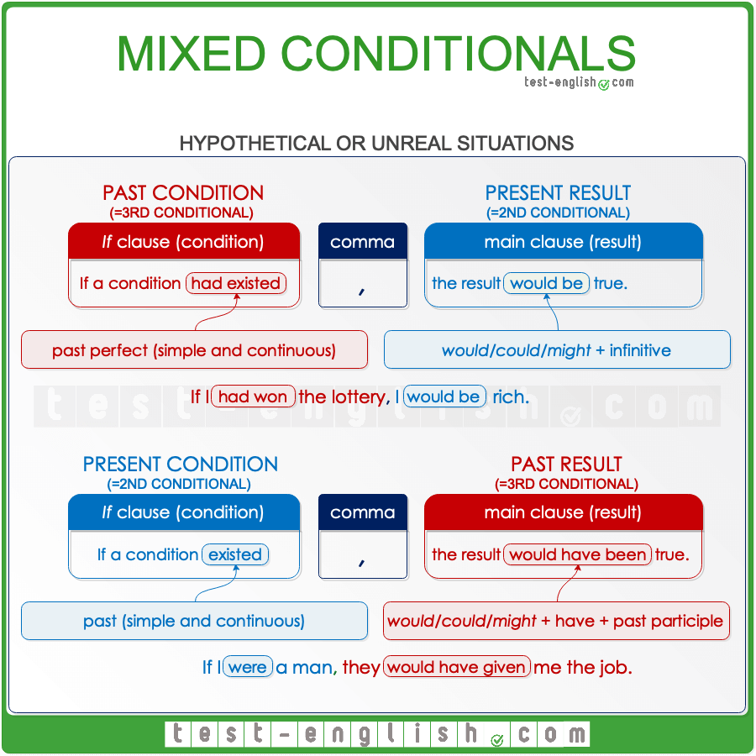

#### Second and third conditionals

In a second conditional, we use past in the **if** clause and **would/might/could + infinitive** in the main clause. It is used to talk about hypothetical situations happening in the **present or future**.

* If I **were** rich, I**‘d buy** that house.

In a third conditional, we use past perfect in the **if** clause and **would/might/could + have + past participle** in the main clause. It is used to talk about hypothetical situations happening in the **past**.

* If you **had studied** more, you **would have passed** the exam.

A mixed conditional is a combination of second and third conditionals.

#### Mixed third/second conditional

We use this combination to talk about a hypothetical condition happening in the past (third conditional) with a present result (second conditional). We use past perfect in the **if** clause and **would/could/might + infinitive** in the main clause.

* If I **had been elected**, I **would be** the president now.
* If I **had won** the lottery, I **would be** rich.
* I **might have** a better job now if I **hadn’t dropped** out of school.

#### Mixed second/third conditional

We use this combination to talk about a hypothetical condition happening in the present (second conditional) with a past result (third conditional). We use past in the **if** clause and **would/could/might + have + past participle** in the main clause.

* If I **were** a man, they **would have given** me the job.
* If I **didn’t have** so much work, I **would have gone** to the party last night.
* I **would have understood** them if I **spoke** German.

🔍 **Note** that in this type of combination, the present condition also existed in the past when the result in the main clause took place. Let’s take a look, for example, at the first sentence:

* If I **were** a man, they **would have given** me the job.

If I were a man now would mean that I would also have been a man in the past, when I was not given the job. As I’m not a man now (which implies that I wasn’t a man when I applied for the job either), I didn’t get the job.

## I wish/If only

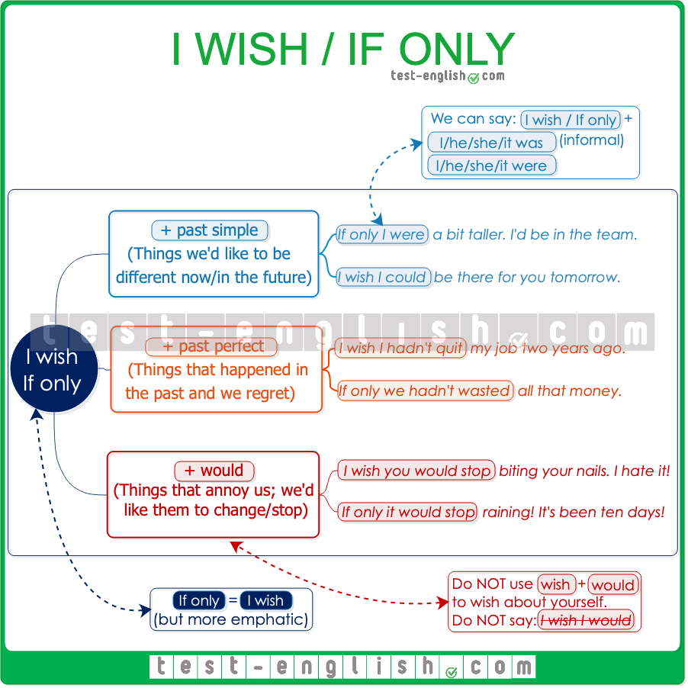

#### I wish I did

We can use **wish** + past simple to talk about things that we would like to be different in the **present** or **future** (but which are very unlikely or impossible).

* I **wish** things **were** different, but this is the way they are.
* We **wish** we **had** enough money to help you.
* I **wish** I **could** be there for you tomorrow.

#### I wish I had done

We can use **wish** + past perfect to talk about things that happened in the past and that we regret (we would have wanted them to be different).

* I **wish** I **hadn’t quit** my job two years ago.
* I **wish** we **hadn’t wasted** all that money.

#### I wish you would do

We can use **wish** + person/thing + **would** + infinitive when we talk about situations that annoy us and want them to change or stop.

* I **wish you would stop** biting your nails. I hate it when you do it.
* I **wish it would stop** raining. It’s been three days!

We CANNOT use this structure to wish for ourselves.

* I wish **I would… **

#### If only

We can use **if only** instead of **I wish** to mean the same. The only difference is that **if only** is more emphatic.

* **If only** I **was/were** a bit taller!**\***
* **If only** you **had followed** my advice.
* **If only**you **would make** a bit of an effort. You are wasting your life!

🔍 **Note** that we can use **were** instead of **was** with **I/he/she**after **I wish/if only**.

## Would rather/would sooner

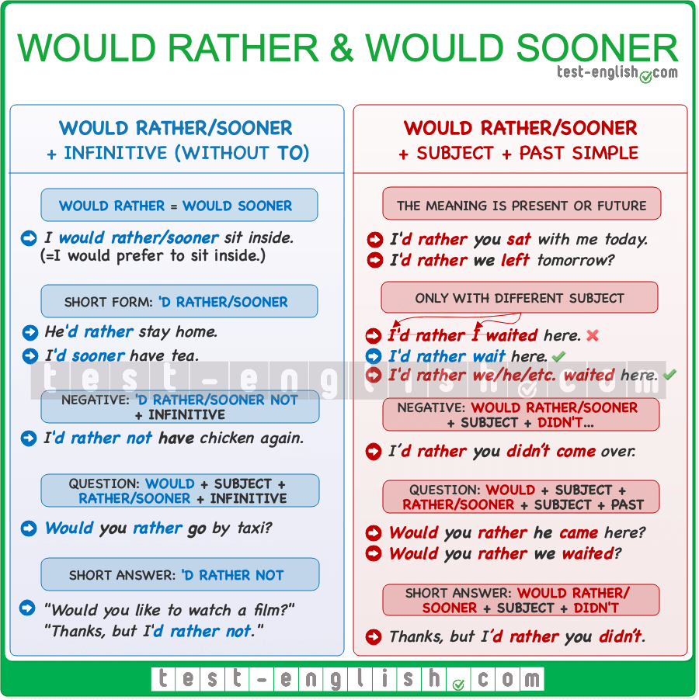

#### Would rather (than)/would sooner (than)

We use [**would rather** or **would sooner**](https://test-english.com/grammar-points/b1/would-rather-would-sooner/) + infinitive to talk about preference. We can use them with **than** in affirmative sentences or with **or**in questions.

* I’**d rather/sooner have** tea, please.
* I’**d rather/sooner have tea than** coffee.
* Would you rather/**sooner** **have** tea **or** coffee?

#### ****Would rather/would sooner**** + subject + past simple

When we use a different subject after **would rather** or **would sooner**, we use the past simple to refer to the present or future.

* We’**d rather/**sooner she was**/were** with us now.*
* She’**d rather/sooner I picked** her up after lunch.
* Would you rather**/sooner we went** by bus **or** by train?

🔍 **Note** that we can use **were** instead of **was** with **I**/**he/she**after **would rather** or **would sooner**.

#### ****Would rather/would sooner**** + subject + past perfect

When we use a different subject after **would rather** or **would sooner**, we use past perfect to refer to the past.

* I’**d rather/sooner you hadn’t spoken** to her like that.
* I’**d rather/sooner you had called**me before.

## It’s time

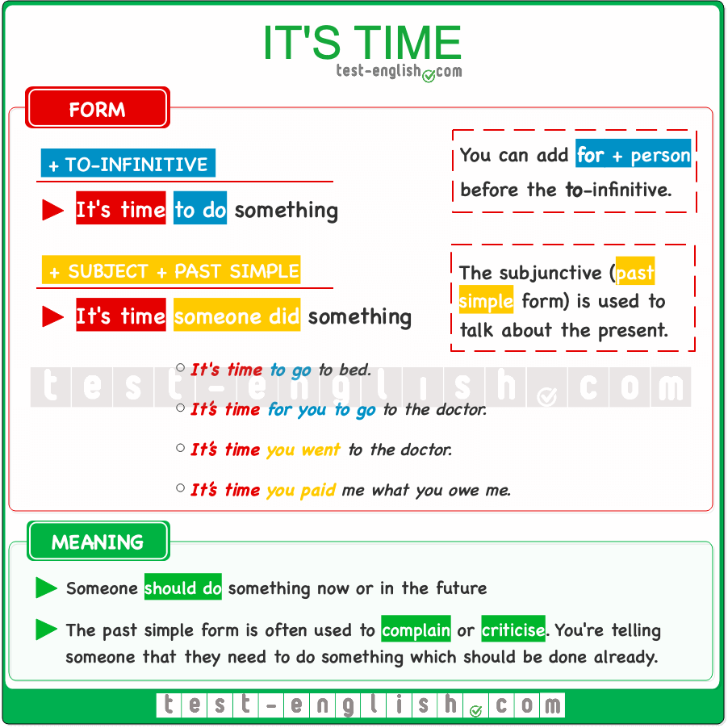

#### ****It’s (high) time**** + subject + past simple

We can use [**it’s time**](https://test-english.com/grammar-points/b1/had-better-its-time/) or **it’s high time** followed by a **subject** and a **past simple** verb to say that something should be done now or in the future.

* **It’s time you went** to the doctor.
* I really think **it’s high time you took** a decision. We can’t go on like this any longer.

We can also use the alternatives **it’s time + to**-infinitive or **it’s time for someone + to**-infinitive.

* **It’s time for you to go** to the doctor.
* **It’s time to take** a decision.

## Other expressions

#### Suppose/supposing/imagine/what if

**Suppose**, **supposing,** **imagine**, and **what if**can be used like we use **if** in conditionals. So after these words, we use the present tense for real situations (first conditional), and the past simple or past perfect for unreal situations (second and third conditionals).

* **Imagine** you **meet** him in the street; what are you going to tell him? (=**First conditional**: If you meet him in the street, what are you going to tell him?)
* **What if** you **found** a suitcase full of money? What would you do? (=**Second conditional**: If you found a suitcase full of money, what would you do?)
* **Supposing** she **hadn’t told** you anything, you would have acted differently. (=**Third conditional**: If she hadn’t told you anything, you would have acted differently.)

## Other expressions in conditionals – Grammar chart

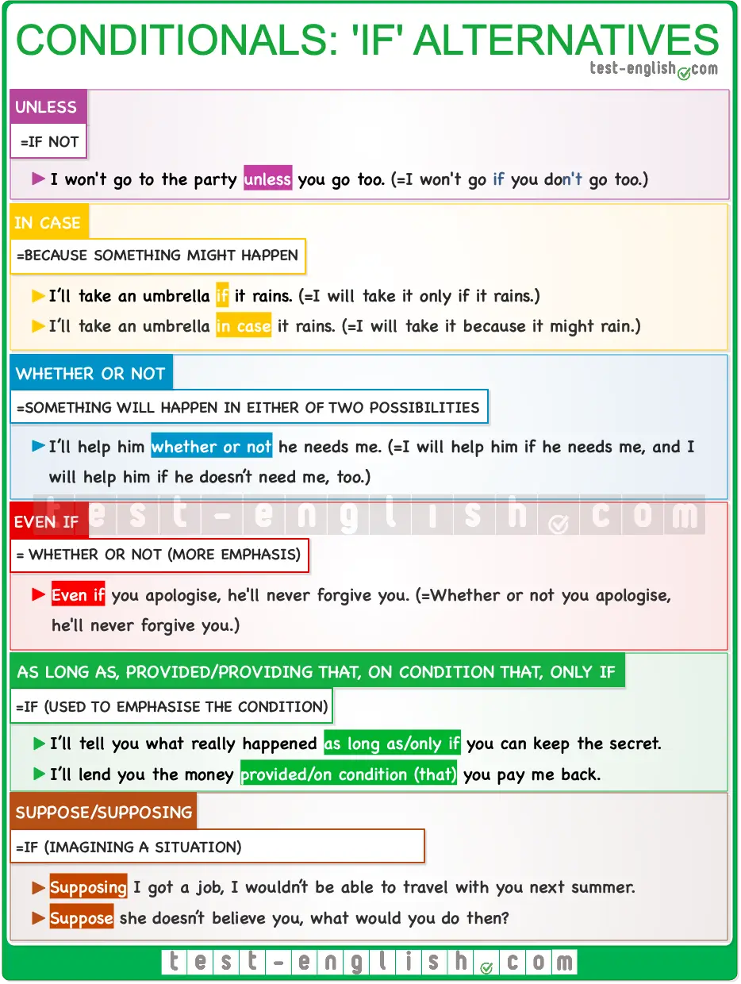

#### Unless (= if not)

We can use **unless**in conditional sentences to mean ‘if … (not)’.

* I won’t go on holiday **unless** I save some money.
* = I won’t go on holiday **if** I **don’t** save some money.

#### In case

We use **in case** to talk about things that we do to be prepared for something that might happen or might be needed in the future.

* I’ll take my umbrella **in case** it rains. (=because it might rain)

#### As long as / provided (that) / providing (that) / on condition (that) / only if

We can use the expressions **as long as, provided/providing (that), on condition (that),** or **only if**instead of **if**when we want to emphasise the condition that needs to be present so that something can happen or be done.

* I’ll tell you what really happened **as long as** you keep the secret.
* I’ll lend you the money **provided (that)**you pay me back next month.
* They will speak to the press **on condition (that)** they remain anonymous sources.
* We will invest the money, but **only if** you can prove that it’s a safe investment.

#### Whether or not

We use **whether or not** when there are two alternatives, and we want to say that something will happen or will be true in any of those two alternatives. Compare:

* I’ll help him **if** he needs me. (=I will help him only if he needs me.)
* I’ll help him **whether or not** he needs me. (I will help him if he needs me, and I will help him if he doesn’t need me, too.)

#### Even if

We also use **even if** with a similar meaning to ‘whether or not’. It is used to emphasise that something will still be true or will happen if another thing happens.

* **Even if** you apologise, he’ll never forgive you. (=Whether or not you apologise, he’ll never forgive you.)

#### Suppose/supposing

We normally use **suppose**or **supposing** at the beginning of a sentence to make someone imagine a situation. It means ‘what would happen if’, or simply ‘if’ (imagining a situation).

* **Supposing** I got a job, I wouldn’t be able to travel with you next summer.
* **Suppose** she doesn’t believe you; what would you do then?

### Passive

## Passive voice with reporting verbs

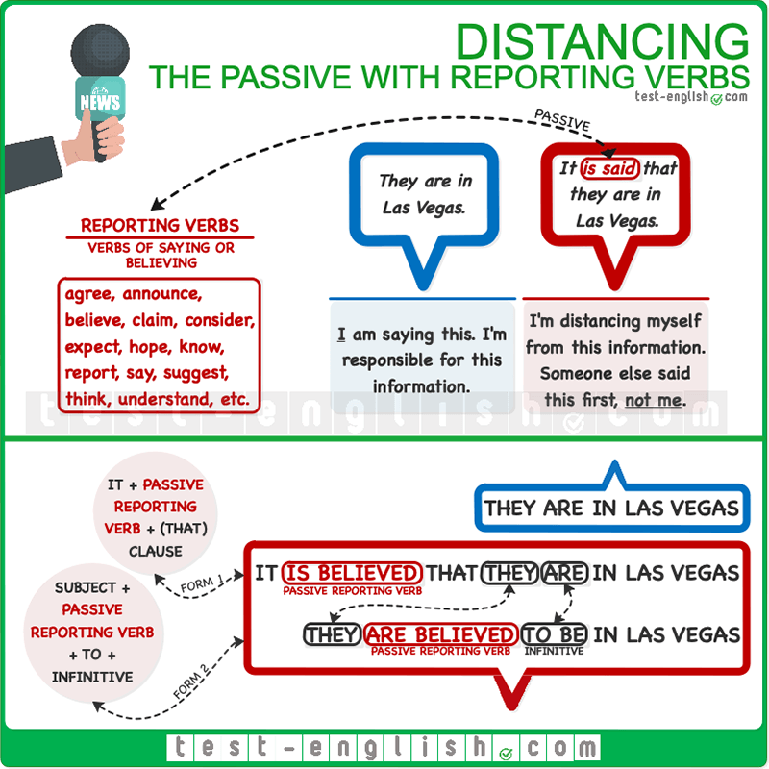

In news reports and formal writing, passive forms of reporting verbs (verbs of saying or believing) are common. This resource allows us to give information when we don’t know whether it is true, allowing us to distance ourselves from the information.  
  
Reporting verbs include **agree, announce**, **believe**, **claim**, **consider**, **expect**, **hope,** **know**, **report**, **say**, **suggest**, **think**, **understand**, **etc.** And we can use their passive form for distancing in two different ways.

#### It is said that …

**It**+ passive reporting verb + **that**-clause (subject + verb)

* **It is believed that** the murderer is no longer in the country.
* **It has been announced that** they are going to cancel the tour.
* **It has been suggested that** the team can’t be trusted defensively.
* **It was thought that** the building could collapse.

#### They are said to be

Subject + passive reporting verb + **to**-infinitive

* **He is thought to be** a close associate of the terrorist.
* **The terrorist is believed to have fled** to the mountains.

When we use this pattern, we use the **simple infinitive** or the **continuous infinitive** when the reported action is **simultaneous** to the reporting.

* He is said **to be** an art collector.
* They were believed **to be** secretly in love.
* They are thought **to be living** under strict protection.

We can also use the **simple infinitive** to refer to the **future**.

* She is expected **to become** a superstar.

We use the **perfect infinitive** or the **perfect continuous infinitive** when the reported action is **previous** to the reporting (earlier in the past).

* She was thought **to have left** the previous week.
* He is claimed **to have hit** another student.
* He is known **to have been hiding** somewhere in Panama since he escaped.

#### There are said to be

We can also use the same structure with the pronoun **there**.

* **There are said to be** new leads on the case.
* **There is believed to be** a new donor who is partially financing the campaign.

## Other distancing expressions

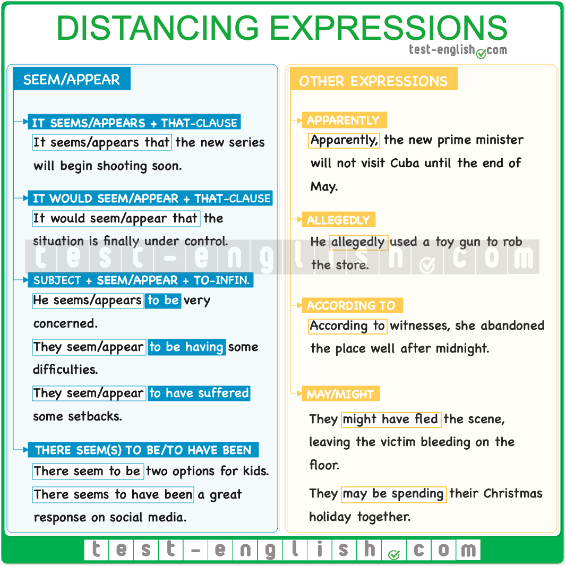

### Seem/appear

We can also use the verbs **seem** and **appear** to distance ourselves from the information we give.

#### ****It seems/appears + that****-clause

* **It seems/appears that** the new series will begin shooting in about two months.

#### ****It would seem/appear + that****-clause

It means the same as **it seems that**, but it is more formal.

* **It would seem/appear that** the situation is finally under control.

#### Subject + ****seem/appear**** + ****to****-infinitive

* The *new secretary* ***seems/*appears** **to be** very concerned about climate. (Simple infinitive)
* They **seem/appear** **to be having** some difficulties. (Continuous infinitive)
* Their leaders **seem/appear** **to have suffered** some setbacks. (Perfect infinitive)
* The company **seems/appears to have been doing** very well over the last year (Perfect continuous infinitive)

#### There seem(s)to be/to have been

* **There seem to be** two options for kids.
* **There seems to have been** a great response on social media.

## Apparently, allegedly, according to

There are expressions that we can also use for distancing.

### Apparently

* **Apparently**, the new prime minister will not visit Cuba until the end of May.

### Allegedly

We use **allegedly** to give information when something wrong appears to have been done, but there is no proof.

* He **allegedly** took a knife and stabbed the victim in the stomach.

### According to

* **According to** witnesses, she abandoned the place well after midnight.

### Might/may

We can also use **might** or **may** to speculate and say that something is possible but that maybe it isn’t true.

* They **might have fled** the scene, leaving the victim bleeding on the floor.
* They **may be spending** their Christmas holiday together.

## Passive verbs with two objects: Grammar chart

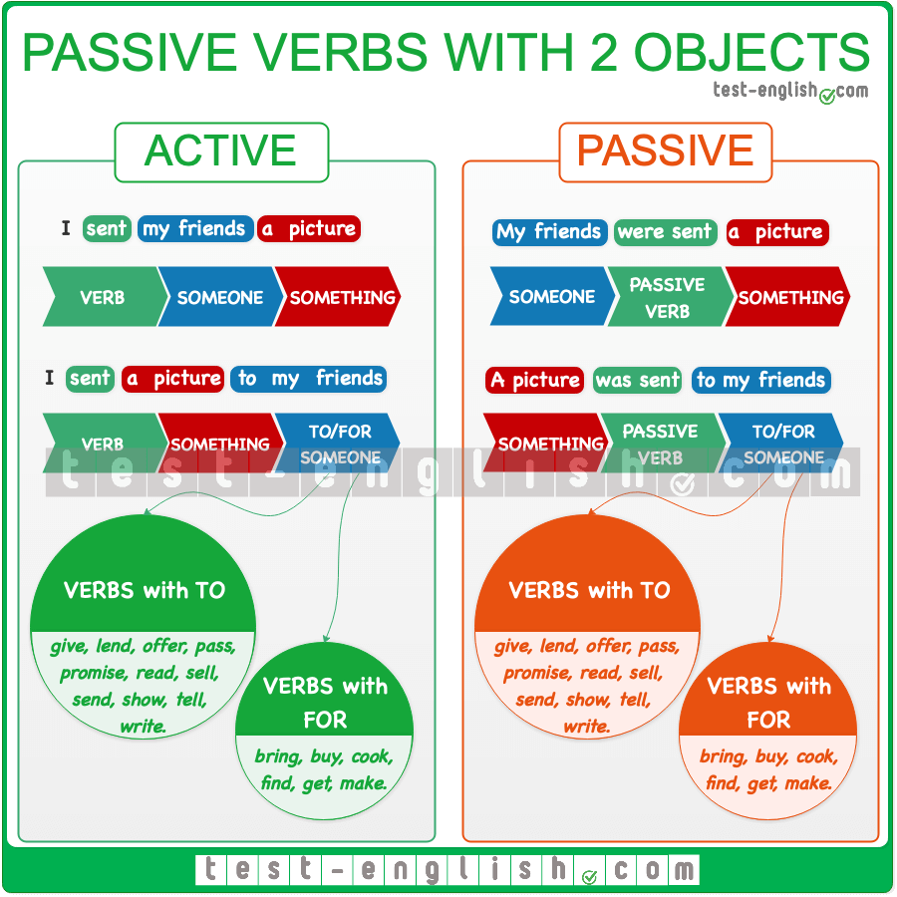

In a passive sentence, the subject is the object of the corresponding active sentence.

* Somebody said something.
* Something was said (by somebody).

Some [verbs can take two objects](https://test-english.com/grammar-points/a2/verbs-with-two-objects/). Some of these verbs are **bring, get, give, make, offer, promise, send, show, etc.**

* I sent my friends a picture. (= I sent a picture to my friends.)

With these verbs, it is possible to make two different passive sentences because you can use either of the two objects as the subject of the passive sentence:

* My friends were sent a picture.
* A picture was sent to my friends.

It is more common to begin the passive sentence with the person: My friends were sent a picture.

### -ing and the infinitive

## Verb + object + ****to****-infinitive

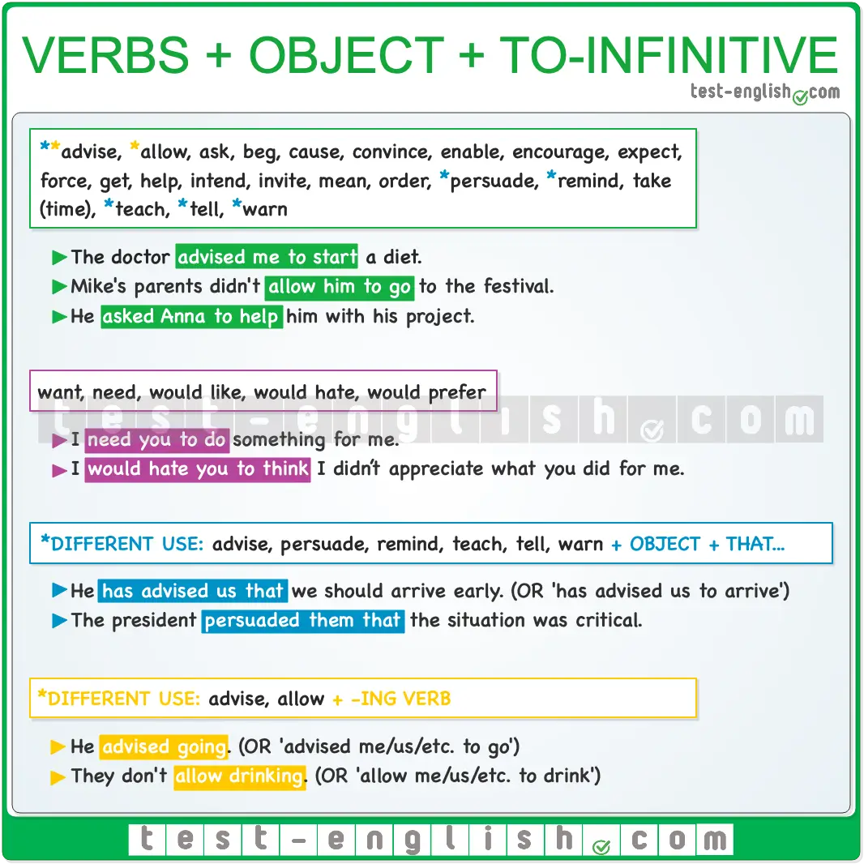

#### After certain verbs

We can use the following verbs + object + **to**-infinitive: **advise, allow, ask, beg, cause, convince, enable, encourage, expect, force, get** (see [get uses](https://test-english.com/grammar-points/b2/get/)), **help, intend, invite, mean, order, persuade, remind, take** (time)**, teach, tell,** **warn**.

* He **advised me not to take** the job.
* I **beg you to stay**, please.
* I don’t **expect you to understand**.
* They **persuaded him to tell** the truth.

#### Want, need, would like, would hate, would prefer

We can also use **want, need, would like, would hate, would prefer** + object + **to**-infinitive.

* I **need you to do** something for me.
* She **wants me to go** to the doctor with her.
* They **would like me to be** available at all times.
* I **would hate you to think** I didn’t appreciate what you did for me.
* I **would prefer you** to be quiet.

#### Verbs also used in other ways

Advise, persuade, remind, teach, tell, warn  
  
We can use **advise, persuade, remind, teach, tell,** or **warn** with an object followed by a **to**-infinitive or a **that**-clause.

* Our mentor has **advised us that** we should start working on the project as soon as possible.
* The president **persuaded them that** the situation was critical.
* I called him to **remind him** he had to take all the necessary equipment.
* They **taught me** things aren’t always as they seem.
* Danny **told me that** he is going to be appointed director of overseas operations.
* He **warned us that** temperatures would drop dramatically the following week.

Advise, allow  
  
We can use **advise** and **allow** + object + **to**-infinitive. But if they are followed by the verb (without the object), this verb must take the **-ing** form.

* He advised **me to go**.
* He advised **going**.
* They don’t allow **us to drink**.
* They don’t allow **drinking**.

## Verb + ****for someone**** + ****to****-infinitive

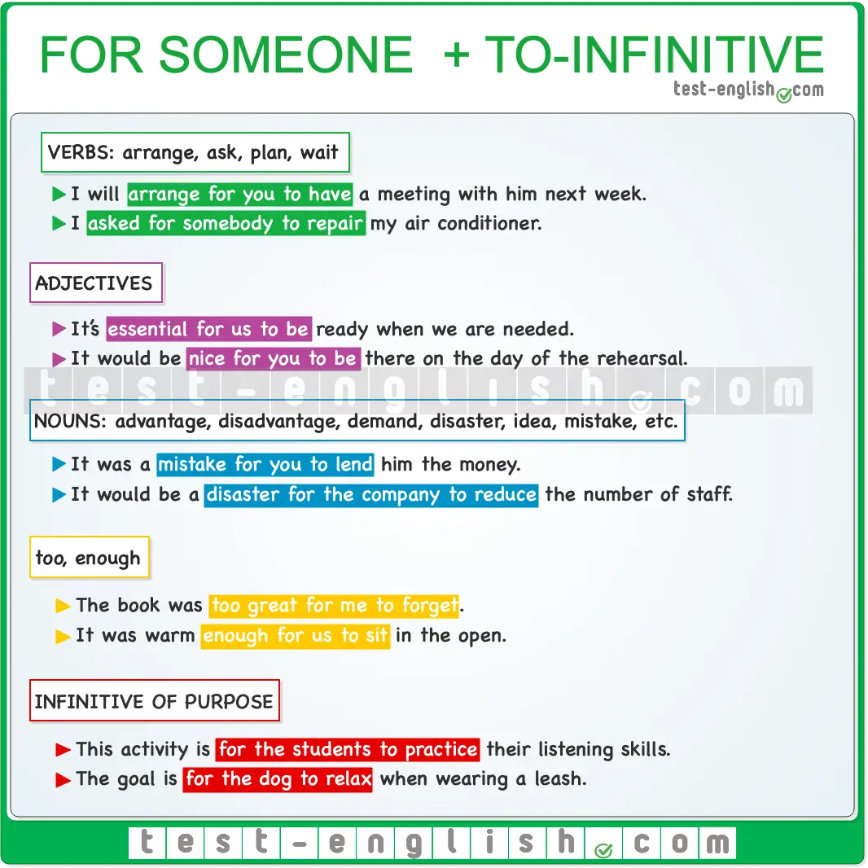

Arrange, ask, plan, wait  
  
We say **arrange, ask, plan**, or **wait** + **for someone** + **to**-infinitive.

* I will **arrange for you to have** a meeting with him next week.
* I asked **for somebody to repair** my air conditioner.
* They **are planning for him** to turn his ideas into action.
* We **waited for them** to arrive.

Adjectives  
  
We can use certain adjectives + **for someone** + **to**-infinitive.

* **It’s essential for us to be** ready when we are needed.
* **It would be nice for you to be** there on the day of the rehearsal.
* **It’s difficult for Sarah to make** ends meet now that she’s working part-time.

Nouns  
  
We can use certain nouns such as **advantage, disadvantage, demand, disaster, idea, mistake, etc.** + **for someone** + **to**-infinitive.

* It was a **mistake for you to lend** him the money.
* It would be a **disaster for the company to reduce** the number of staff.
* I think it’s a good **idea for him to go** to the interview.
* An extra room is an **advantage for families to use** it as a play area.

Too/enough  
  
We can also use **too** or **enough** + **for someone** + **to**-infinitive.

* The book was **too great for me to forget**.
* It was **warm enough for us to sit** in the open.

Infinitive of purpose  
  
We can also use the same structure after an infinitive of purpose.

* The purpose of this activity is **for the students to practice** their listening skills.
* The goal is **for the dog to relax** when wearing a leash.

## Verb + object + infinitive without ****to****

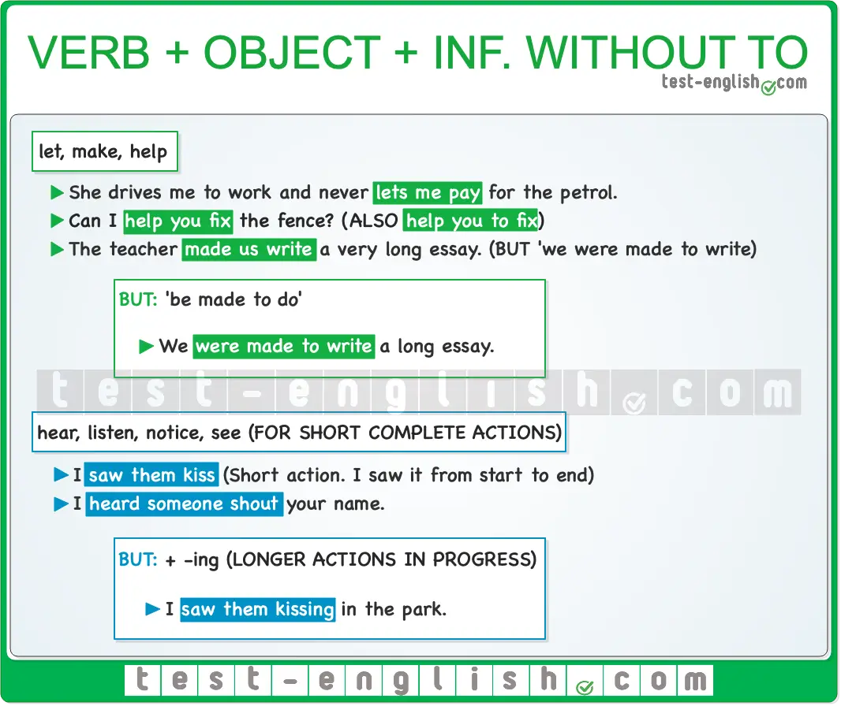

#### Let, make, help

We can use the verbs **let**, **make**, and **help**followed by object + infinitive (without **to**).

* She drives me to work and never **lets me pay** for the petrol.
* The teacher **made us write** a very long essay.
* Can I **help you fix** the fence?  (But **help somebody to do** is also correct)

Be made to do  
  
We say **make**+ someone + infinitive (without **to**), but we say someone + **be** **made** + **to**-infinitive.

* They **made the staff wear** their uniform every day.
* The staff **were made to wear** their uniform every day.

#### Hear, listen, notice, see

We can use **hear, listen, notice, see** + object + infinitive without **to** to talk about a short or complete action (see [B1+ verb patterns](https://test-english.com/grammar-points/b1-b2/gerund-or-infinitive/)):

* I **saw** them **kiss** (I saw the action from start to end. It was probably a short kiss.)
* I **heard** someone **shout** your name. (I heard the shouting from start to end.)

❗ **But** we use **hear, listen, notice, see, watch** + object + **-ing** to talk about an action in progress, an action that is longer and incomplete.

* I **saw** them **kissing** in the park. (The action was in progress. I didn’t see it finish.)

## Verb + object + gerund

In this kind of construction, the object of the main verb is the subject of the verb in the gerund form. The following verbs can be used before object + gerund: **dislike, hate, imagine, involve, keep, mind, prevent, not like, remember, resent, risk, stop**.

* I **hate him telling** me what to do.
* They **kept me waiting** for over an hour.
* I **don’t like them acting** like this.
* Be cool, or you can **risk them losing** interest.

## All forms of gerunds and infinitives

You can see all the gerund and infinitive forms in the table below. Some forms are not included in the table because they don’t exist or are very rarely used.  
  
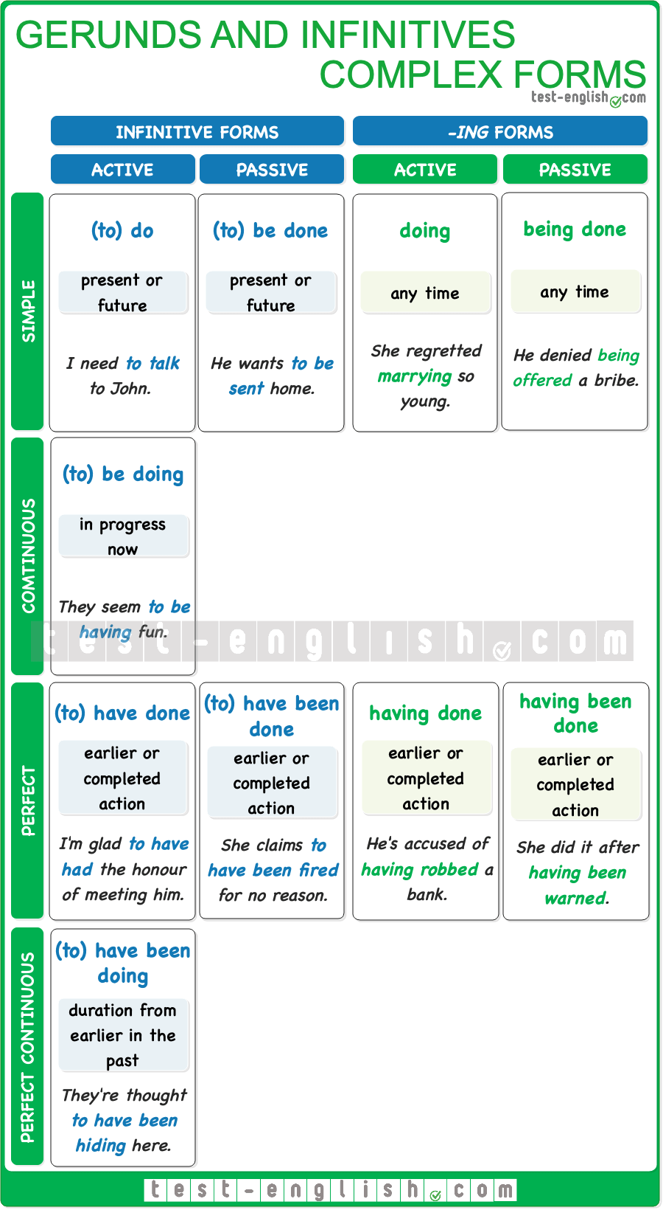

## Simple, continuous and perfect infinitives and gerunds

We use the perfect infinitive or the perfect gerund to emphasize that the action is complete or in the past.

#### Simple gerund vs perfect gerund

There is usually no difference between using the simple gerund or the perfect gerund because the context usually makes it clear when the action happened.

* He **denied stealing** the money. (=It’s clear the money was stolen before denying it)
* He **denied having** **stolen** the money.
* She **regretted marrying** too early. (=It’s clear she married before regretting it)
* She **regretted having married** too early.

But sometimes, there is a difference in meaning between using the simple gerund or the perfect gerund.

* He **denied being** married. (=he denied that he was married ‘now’ at the time of the denial)
* He **denied having been** married. (=he denied that he had been married before, in the past)

#### Simple infinitive vs perfect infinitive

As it happens with the gerund, sometimes there’s no difference between using the simple or the perfect forms of the infinitive.

* It was stupid of me **to say** anything on Twitter.
* It was stupid of me **to have said**anything on Twitter.

However, there is usually a difference in meaning between using the simple or the perfect infinitive forms, and we need to use the perfect forms to make clear that the action expressed by the infinitive was previous to the action described by the main verb.

* I’m very glad **to work** here. (=now)
* I’m very glad **to have worked** here. (=in the past)

#### Continuous infinitive

We use the continuous infinitive when the action is in progress around the time expressed by the main verb.

* I’m glad **to be spending** this weekend with you.
* You shouldn’t **be doing** this right now, should you?

#### Perfect continuous infinitive

We use the perfect continuous infinitive to express duration from earlier in the past towards the time expressed by the main verb.

* I’m glad **to have been sharing** my life with you.
* They are thought **to have been hiding** in the mountains.

#### Perfect infinitive after passive reporting verbs

After a passive reporting verb, we use a simple or continuous infinitive to refer to the present or future and a perfect infinitive to refer to the past. (⇒ See B1+ Grammar » [The passive with reporting verbs](https://test-english.com/grammar-points/b1-b2/passive-reporting-verbs/))

* They **are believed to be** lovers. (=now)
* They **are believed to have been** lovers. (=in the past)
* She **is thought to be living** in Brussels. (=now)
* She **is thought to have been living** in Brussels (=from the past till now)

#### Perfect infinitive after ****would like, would hate, would rather, would prefer****

We always use the perfect infinitive after **would like, would hate, would rather, would prefer** to refer to an earlier action or event. Compare:

* I **would like to see** you once more. (=in the future)
* I **would like to have seen** you once more. (=in the past)
* She **would rather be** with you. (=now)
* She **would rather have been** with you. (=in the past)

## Passive infinitives and gerunds

We use passive infinitives or passive gerunds to describe actions which are done to the subject. (⇒ See B1+ Grammar » [The passive voice – all tenses](https://test-english.com/grammar-points/b1-b2/passive-voice-all-tenses/))

* He is too young **to be allowed** to be here.
* This place needs **to be taken care** of.
* I don’t mind **being told** what to do.
* He denied **having been offered** money to kill the senator.

## When to use gerund or infinitive

## In the table below, you can see when to use gerund or infinitive.

### Articles, nouns, pronouns, and determiners.

## Reflexive and reciprocal pronouns

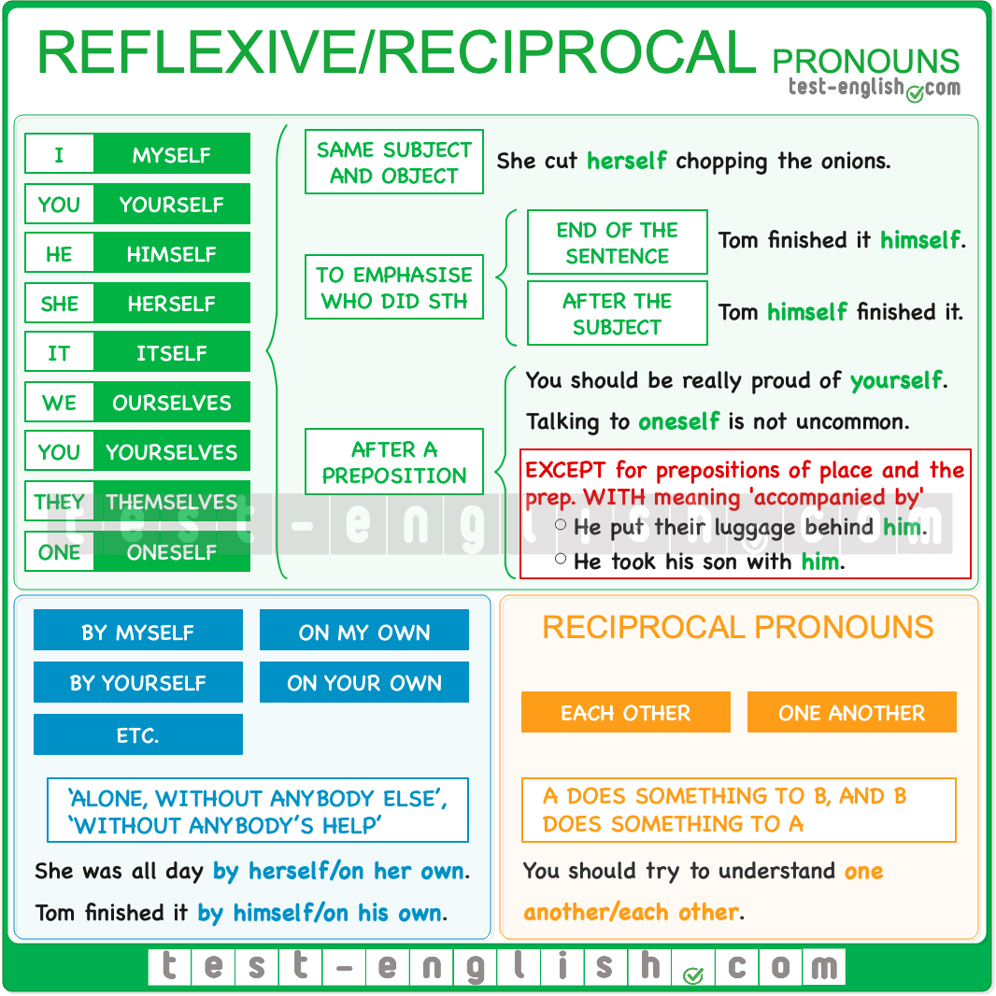

### Reflexive pronouns

The reflexive pronouns are **myself, yourself, himself, herself, itself, ourselves, yourselves, themselves.**There is also a reflexive generic pronoun: **oneself**.

#### Same subject and object

Reflexive pronouns are normally used when a subject and an object are the same person.

* She cut **herself**, chopping the onions.
* We really enjoyed **ourselves** at the party.
* Talking to **oneself** is not necessarily a sign of madness.

#### After preposition

We can use reflexive pronouns after most prepositions if they refer back to the subject.

* He should be really proud of **himself**.
* With the 3-D printer and this scanner, you can print a small version of **yourself**.

#### NOT after prepositions of place

We don’t use reflexive pronouns after prepositions of place; we use object pronouns instead.

* She left her handbag in the chair in front of **herself**. 
* She left her handbag in the chair in front of **her**. 
* They put their luggage behind **them**.

And we don’t use reflexive pronouns after **with** when it means ‘accompanied by’.

* He took his son with **him**.

#### To emphasise who did the action

We also use a reflexive pronoun to emphasise that the subject does the action and nobody else. In this sense, we can use the reflexive at the end of the sentence or after the subject.

* I will talk to Anna **myself**.
* I think you should do it **yourself** instead of having it done.
* Paul **himself** designed everything.

#### By oneself

We can say **by myself, by yourself, etc.** to mean ‘alone, without anybody else’, or also to mean ‘without anybody’s help’.

* My son doesn’t like to be **by himself**; he always wants us around.
* She raised her four children **by herself**.

We can also say **on my own**, **on your own**, etc.

* I was **on my own** all morning.
* She did it **on her own**.

#### Verbs with NO reflexive pronoun

Students of English often make mistakes when they use some verbs which are used reflexively in their language but not in English. Some of these verbs are **dress**, **shave**, **wash**, **relax**, **hurry**, or **open**.

* The first thing I do is **wash**, **shave**, and **dress myself**. 
* The first thing I do is **wash**, **shave**, and **dress**. 
* When I arrive home, I only want to **relax** on the sofa.
* Please **hurry**, or we’ll be late.
* The door **opened**, and everybody got in.

### Reciprocal pronouns

We use **each other** or **one another** when person A does something to person B and person B does something to person A.

* When the twins found **each other**, they had been living apart for more than ten years.
* You should try to understand **one another**.

We also can use the possessive forms **each other’s** and **one another’s**.

* The lovers were found in **each other’s** arms.
* The couple enjoyed **one another’s** company so much that they soon decided to move in together.

## Generic pronouns: Common-gender pronouns

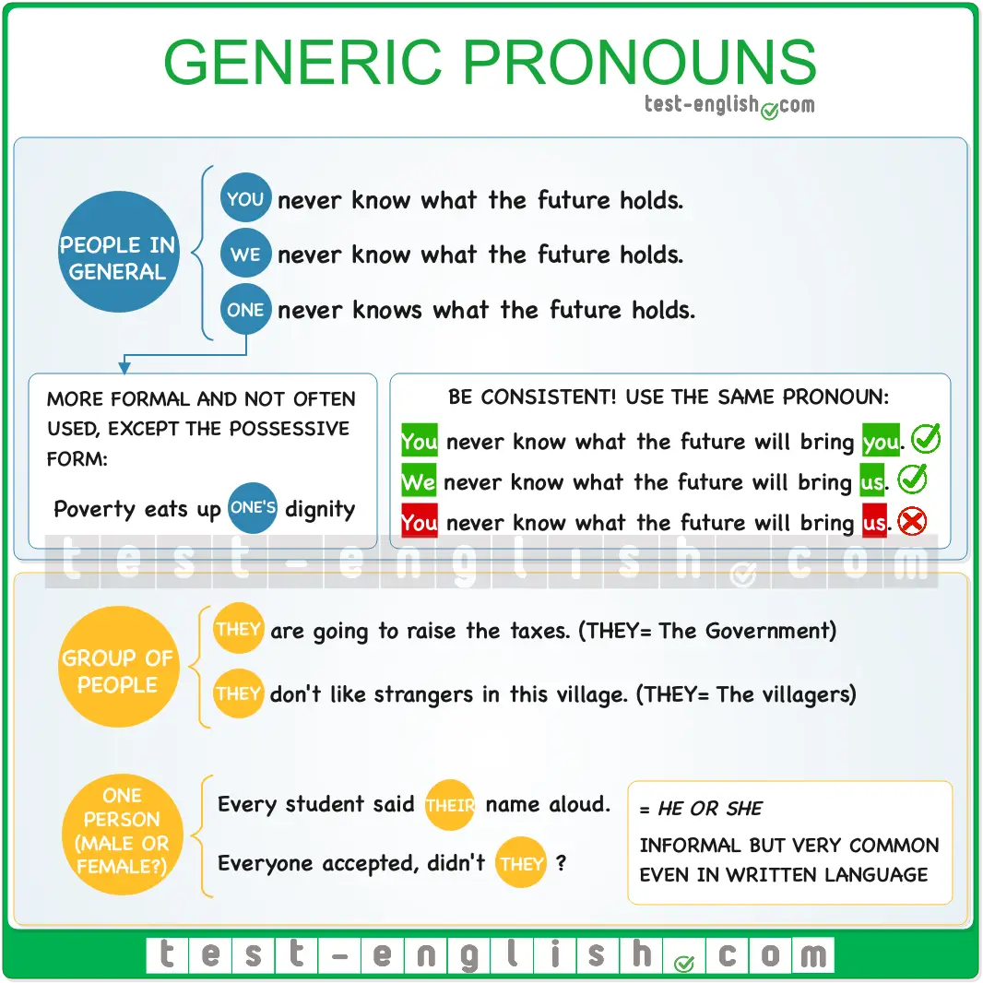

### One, you, we

#### Meaning

We can use **one**, **you** or **we** to talk about people in general, including the speaker and hearer, and not one person in particular.

* **One** can never know what to expect from politicians. (Or also: You/We can never know.)
* In these situations, **you** must never lose **your** temper.
* **We** are human and will always make mistakes.

#### Register

**One** is more formal than **we** or **you** and is rarely used in spoken English. However, the possessive determiner **one’s** is a little more common.

* Education always changes **one’s** life for the better. (Or also **your/our** life.)
* Poverty eats up **one’s** dignity.

#### Subject, object, etc.

**One**, **you**, **we** can be used as a subject or object, and they are often used in their reflexive form (**oneself, yourself, ourselves**).

* Sometimes, the government treats **you/us** as if **you/we** were a child.
* There is the tendency just to lie down and let life treat **one** as it deems fit.
* Success and failure always teach **you/us** something about **yourself/ourselves**.
* Helping others helps **oneself**.

#### Consistency

We can normally choose one pronoun or the other for generic reference, but what is important is that we keep consistency throughout the text.

* **You** never know what the future will bring **you**. 
* **We** never know what the future will bring **us**. 
* **You** never know what the future will bring **us**. 

### They

#### A group of people

In English, we often use **they** to refer to people in general or a more specific group of people that does not include the speaker or hearer, such as people in a country, city, or place, or authorities, police, etc.

* **They** don’t like strangers in this village.
* **They** are going to raise our taxes this year.
* **They** are going to open a new pub opposite my house.

#### Singular reference (= he or she)

In informal English, we use **they,** **them** or **their**to refer to one generic person who could be male or female. Many grammarians consider this use incorrect, but it is very common, even in written language.

* A good journalist should never reveal where **they** get **their** information.
* Before the class, every student said **their** name aloud.

The use of **they**, **them,** **their** for generic singular reference is often preceded by an indefinite singular pronoun.

* **Someone** has left **their** suitcase in the taxi.
* **Everyone** accepted, didn’t **they**?
* **Nobody** wanted to give us **their** phone number.

## Possessive ****‘s****

We normally use **‘s** with people or animals. However, we can also use it with time expressions, shops, places (cities, countries, etc.) and organisations.  
  
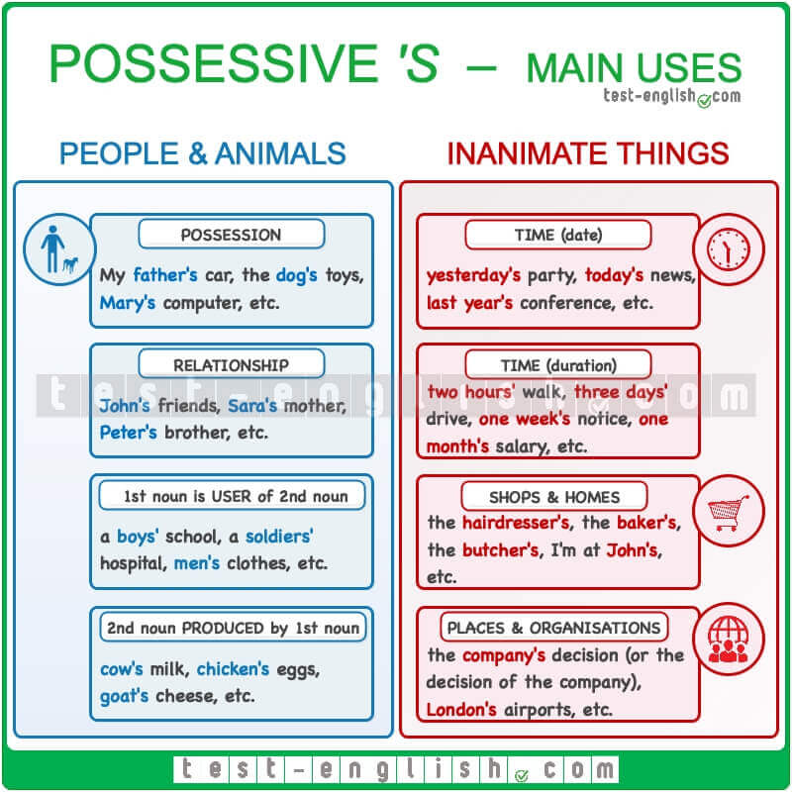

🔍 **Note** that we can use both the possessive **‘s** or **of** when talking about places or organisations,

* **The decision of the country/The country’s decision** to raise taxes is very controversial.
* **The prediction of the bank/The bank’s prediction** is very optimistic.

Look at the table below to see how to use the possessive case.

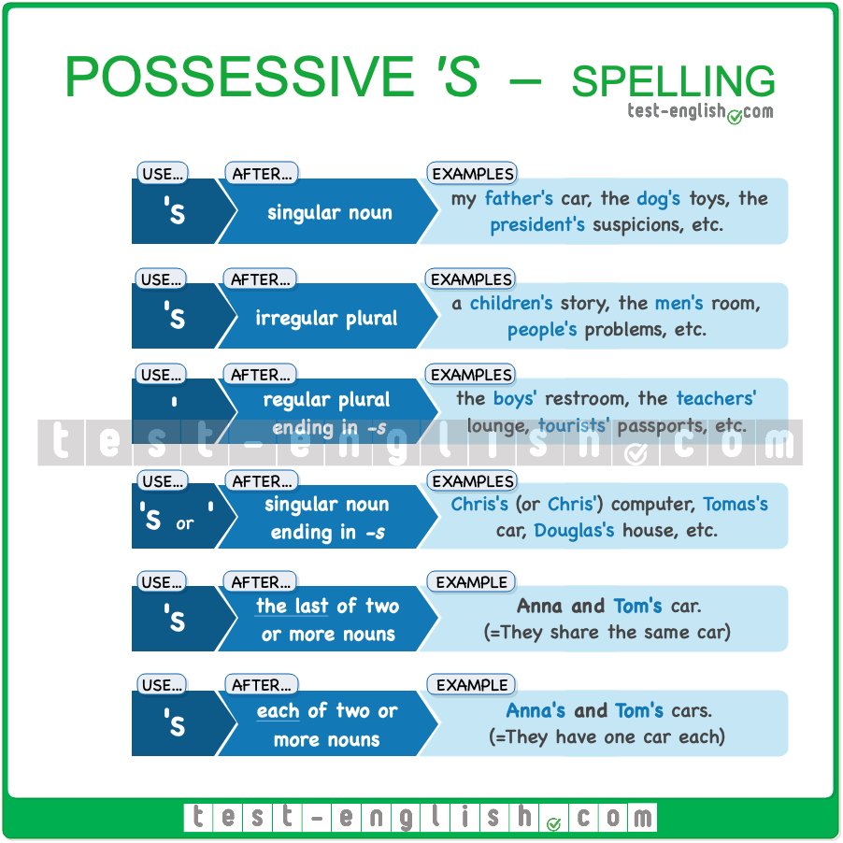

🔍 **Note** that we use **of** + possessive case or possessive pronoun if there is a determiner (**a, some, this, etc**.) before the nouns.

* **Some** friends of **Anna’s** came to the party. (=some of Anna’s friends.)
* **Some** friends of **hers** came to the party.
* Isn’t that **a** friend of your **sister’s**? (=one of your sister’s friends.)

## Using possessive ****of****

#### Inanimate things and abstract nouns

We normally use **of** instead of **‘s** when talking about inanimate things, parts of things, or abstract nouns.

* We enjoyed the **beauty of the park**.
* The **head of the shower** is broken.
* Go to the **end of the street**.
* Love is the **secret of life**.

#### Long noun phrases

We also use **of** instead of **‘s**with long noun phrases.

* This is the child **the neighbours who live next door’s child**. 
* This is the child **of the neighbours who live next door**. 
* That’s the wife **of one of my friends from Liverpool**.

## Compound nouns

In many cases, we use **noun + noun**, instead of possessive **‘s** or **of**. When we use **noun + noun**, the first noun is acting as a modifier of the second noun, like an adjective, and is normally singular (**tourist destination, stomach bug, school bus, etc.**). Sometimes more than one form is possible:

* The **head of the shower/shower head** is broken.
* What’s the **school policy/school’s policy** on bullying?

However, we often prefer one form over the other because it’s more common: **bus stop, car key, toothpaste, car park, ice cream, haircut, etc**.

#### One word, two separate words or two words linked with a hyphen?

Compound nouns are often two separate words, e.g. **school bus, car park, etc**., but very common compound nouns are sometimes used as one word, e.g. **bathroom, haircut, etc**., and sometimes linked with a hyphen, e.g. **letter-box**. But on many occasions, you can see the same compound noun written in different ways.

#### Containers

We can use a compound noun to refer to a container, which is usually empty: **a tea cup, a wine glass, a beer glass, a matchbox, etc.**

* Can you pass me those **tea cups**? I’m going to wash them. (=they are empty)
* She keeps the insects that she catches in that **matchbox**.

❗ **But** we use **noun + of + noun** to refer to a container together with its contents: **a cup of tea, a glass of wine, a glass of beer, a box of matches, etc.**

* Would you like a **cup of tea**? (=a cup with tea in it)
* I need to light this candle. Do you have a **box of matches**?

## The use of the possessive ‘****s**** with time expressions

We don’t normally use the [possessive **‘s**](https://test-english.com/grammar-points/b2/compound-nouns-possessive-forms/) with inanimate things. In those cases, we generally use **of** instead. For example, we say:

* the end **of** the street 
* the **street’s end **
* the first page **of** the document 
* the **document’s first page **

However, the possessive **‘s** is often used in time expressions to talk about the duration of something. For example:

* You need **two years’ experience** to get a job.
* He lives **one hour’s drive** from the airport.
* The **three hours’ journey** to the valley was amazing.

🔍 **Note** that the apostrophe is sometimes not included, but this is usually not considered correct.

## When do we need to use the possessive ****‘s**** with time expressions?

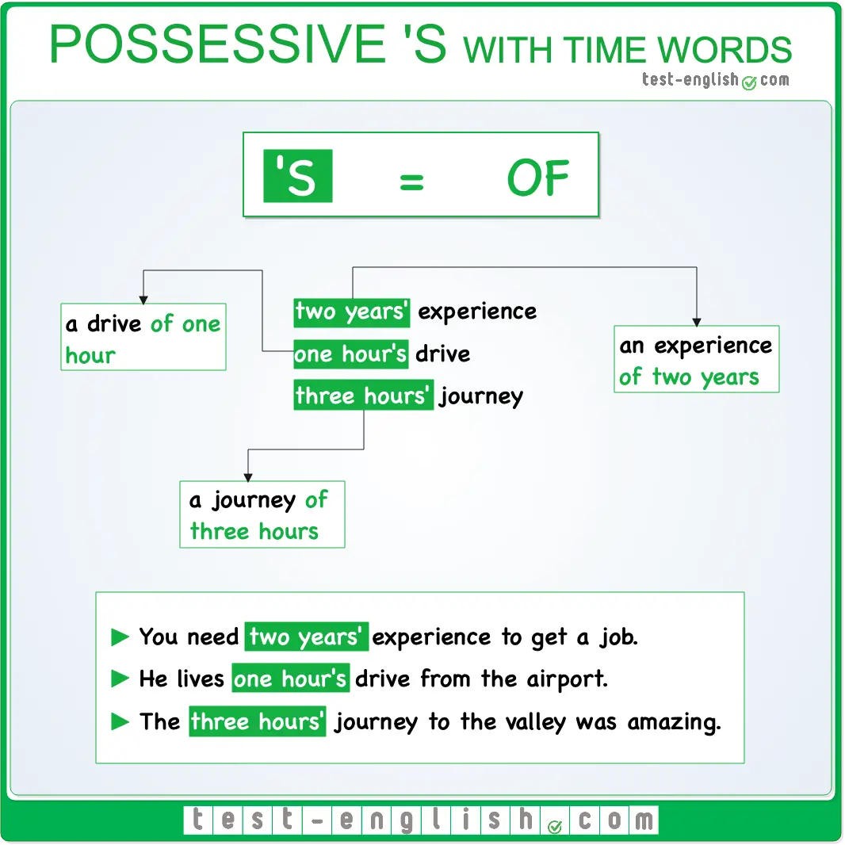

If you are not sure whether you should use the possessive **‘s** with a time expression, you can try replacing it with the word **of**. If the expression still makes sense, it means that you should use the **‘** (apostrophe) or **‘s**.  
  
For example, we say:

* two years**‘** experience (=an experience **of** two years)
* one hour**‘s** drive (=a drive **of** one hour)
* three hours**‘** journey (=a journey **of** three hours)

But we say:

* It’s two months old. (‘two months of old’ does not make sense.)
* She is nine months pregnant. (‘nine months of pregnant’ does not make sense.)

## The possessive ****‘s**** with singular and plural time expressions

The [form of the possessive **‘s**](https://test-english.com/grammar-points/b2/compound-nouns-possessive-forms/) with time expressions is the same as with other nouns.

* Add **‘s** after singular nouns: one year**‘s** notice, an hour**‘s** walk, etc.
* Add only **‘** (apostrophe) after plural nouns ending in **-s**: three years**‘** notice, two hours**‘** walk, etc.

## A two-day journey = two days’ journey

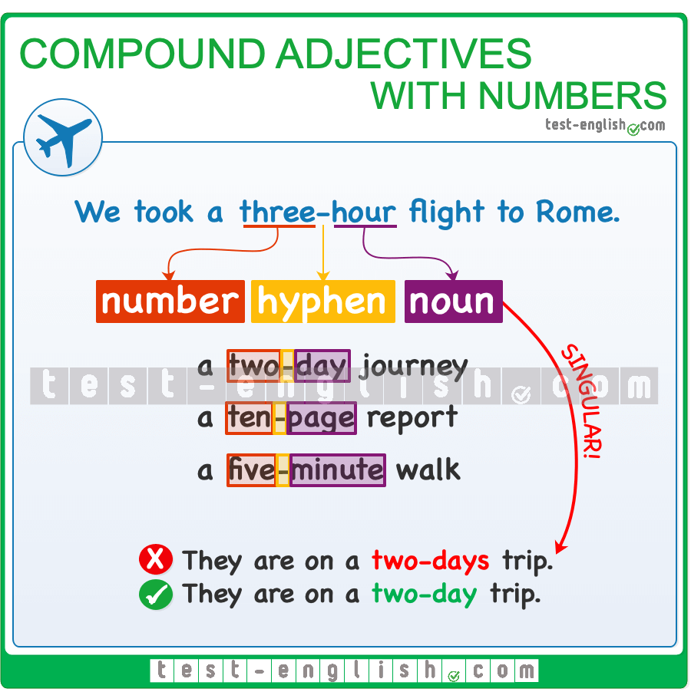

We also often use **number + time expression** before nouns to talk about how long something lasts.  In this case, the number and the time expression are joined by a hyphen, and the time word is singular.

* a **four-hour** journey = four hours’ journey
* a **thirty-minute** delay = thirty minutes’ delay
* a **two-hour** drive = two hours’ drive

🔍 **Note** that this type of **number + noun** compound adjective is also used to talk about other kinds of measurements.

* a **one-hundred-dollar** bill
* a **five-litre** bottle
* a **twenty-foot** container

### Relative clauses, relative pronouns and adverbs

## Defining vs non-defining

There are two types of relative clauses: defining and non-defining. In the grammar chart below, you can see the main differences between them.  
  
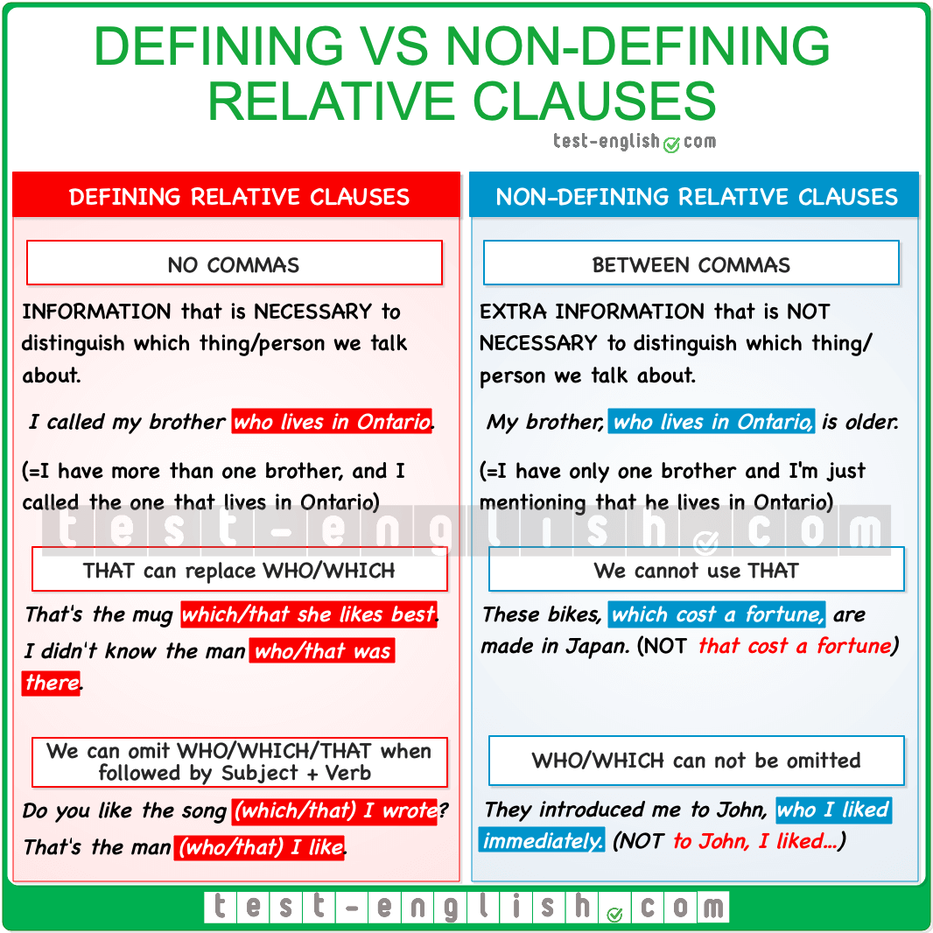

## Relative pronouns

Relative pronouns are the words that introduce relative clauses. They can act as the subject or the object of the relative clause.  
  
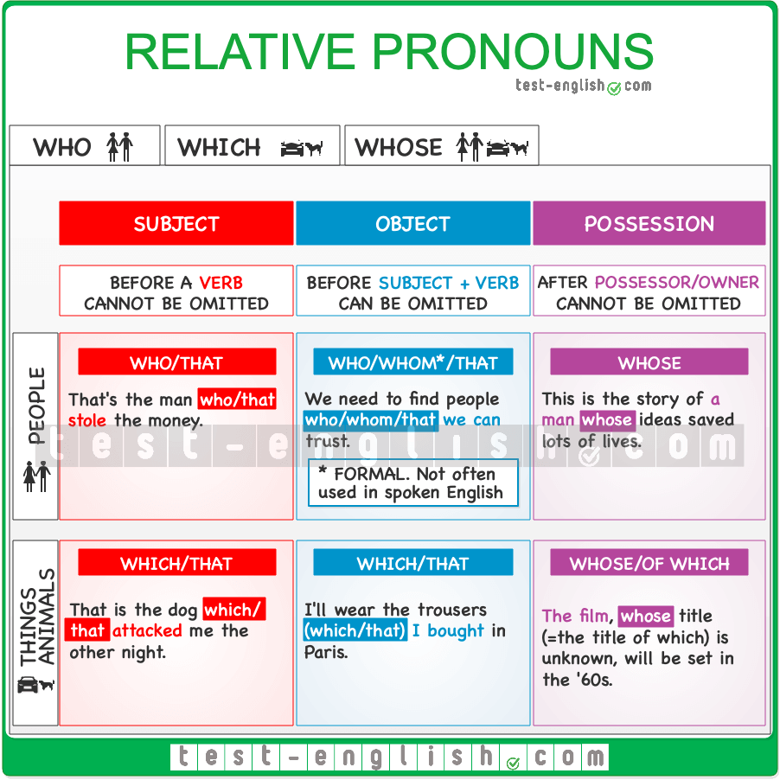

❗ **Note** that **that** can be used in informal English instead of **who/whom/which**, but it is never used after a comma (in non-defining relative clauses) or after a preposition.

* That’s the man **who/that** offered me the job.
* My mother’s older brother, **who (that )** lives in New York, is coming to visit.
* That’s the house in **which (that )** they lived all their lives.

#### ****Which/that**** vs ****What****

We use **which/that**as relative pronouns. They refer back to a noun or sentence.

* I gave her the letter **which/that** I had been keeping since the war. (which/that= the letter)
* He offered to help us, **which** was a nice gesture. (which= He offered to help us)

We don’t use **what** as a relative pronoun. It cannot be used to refer back to a sentence or noun.

* I gave her the letter **which/that** I had been keeping since the war. 
* I gave her the letter **what** I had been keeping since the war. 
* He offered to help us, **which** was a nice gesture. 
* He offered to help us, **what** was a nice gesture. 

We use **what** independently to mean ‘the thing/s that’.

* I didn’t like **what** he did.= I didn’t like **the thing/s that** he did.
* **What** I don’t understand is why we are here. (what= the thing that)

## Prepositions in relative clauses

When the relative pronoun is the complement of a preposition, we can use the preposition before the relative pronoun or at the end of the relative clause.

#### Preposition + relative pronoun

It’s not very common to use prepositions before relative pronouns, we just do it in formal language.

* He wrecked the car **for which** he had paid a fortune.
* He was a man **for whom** everybody had great respect.

❗ **Note** that after a preposition, we can only use the pronouns **whom** or **which**. (NOT **who** or **that**).  
  
We can also use **whose** after a preposition.

* The team signed then the young Maradona, **in whose** skills everybody had their hopes.

#### Preposition at the end of the relative clause

The most common position of the preposition is at the end of the relative clause.

* He wrecked the car **for which** he had paid a fortune. (Formal; not common in spoken English)
* He wrecked the car**(which/that)** he had paid a fortune **for**. (Informal)

## Relative adverbs

Relative adverbs introduce relative clauses, just like relative pronouns, but in this case, they are used to introduce information about time (**when**), place (**where**), or reason (**why**).  
  
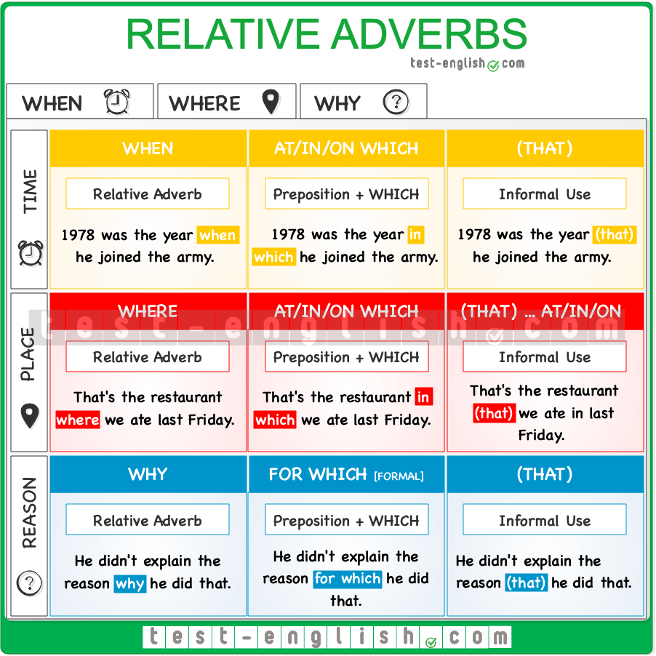

❗ **Note** that we can use a preposition **+ which** instead of a relative adverb. However, this structure is more formal and not as common.

* The coach changed the time **when** the players had to get up.
* =The coach changed the time **at which** the players had to get up.
* The bench **where** they were sitting was dirty.
* =The bench **on which** they were seated was dirty.

## Quantifier + ****of which/whom****

In non-defining relative clauses (=between commas), we can use **of which/whom** after a quantifier such as **some, any, none, all, both, several, enough, many** and **few***.*

* Their daughters, **both of whom** are in university, don’t visit them very often.
* The students, **none of whom** had failed the exam, were thrilled.
* Their house was full of cats, **most of which** had been found in the street.
* The two rooms, **neither of which** had windows, were small and dirty.

We can also use a quantifier + **of whose**.

* I belong to a reading club, **most of whose members** are retired teachers.
* The parents, **some of whose children** were already grown-ups, marched down the street.

### ****there**** and ****it****

## ****There**** and ****it****: Preparatory subjects

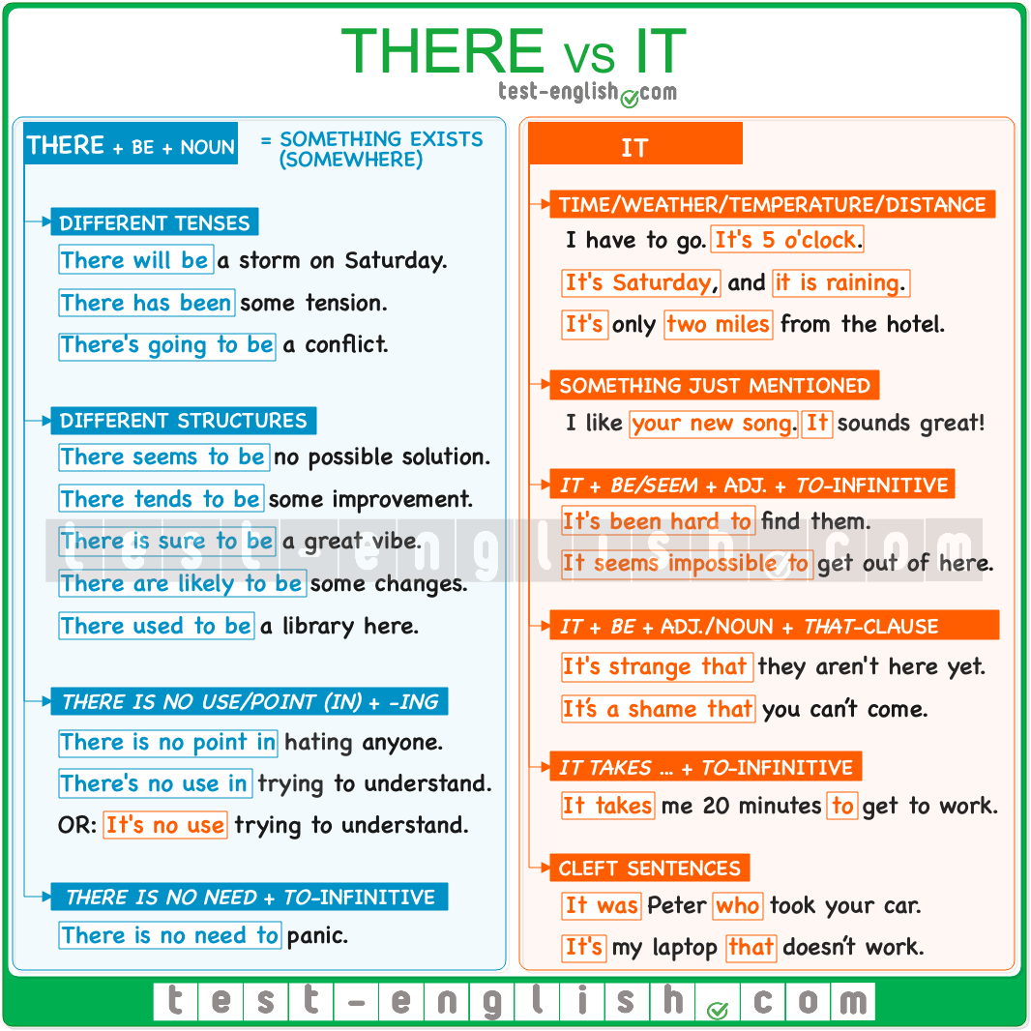

### ****There**** + ****be**** + noun

#### Use and meaning

We use **there**as some kind of preparatory subject to say that something exists somewhere. We put the real subject after the verb **be**.

* **There are** lots of people in the waiting room.
* **There used to be** a fancy restaurant on this street.

#### Different tenses

We can use **there** + **be** with **be** in any verb tense, in active or passive voice, and with or without modal verbs.

* **There will be** a storm on Saturday.
* **There has been** some tension between the participants.
* **There must be** something wrong here.
* **There’s going to be** a conflict between the two parties.

#### Different structures

We can also use the structures **there seem(s) to be, there tend(s) to be**, or we can use **there + be** before expressions of probability such as **sure, likely, bound, etc.**

* **There seem to be** no consequences for his actions.
* Unfortunately, **there seems to be** no possible solution to the problem.
* In nature, **there tends to be** an evolutionary arms race between predator and prey
* **There is sure to be** a full house and a great vibe at the festival, so buy your tickets today.
* **There are likely to be** some side effects, but the new drug looks promising.

We can also use **there + used to**.

* **There used to be** a library at the end of this street.

❗ **Note** that the negative form is **there didn’t use to be**.

* There didn’t use to be any bars in our neighbourhood.

#### There is no use (in), there is no point (in), there is no need

We often use the expressions **there is no use/point (in) + -ing** and **there is no need + to-infinitive**.

* **There is no point in** **hating** those who hate you.
* **There is no use in** **trying** to make him understand. He doesn’t want to understand.
* Yes, we made a mistake, but **there is no need to panic**; we’ll find out how to fix this.
* **There is no need for you to worry**. Everything’s OK.

### ****It**** as a preparatory subject

#### Time, weather, temperature, distance

* **It’s** 5 o’clock.
* **It’s** Saturday tomorrow.
* **It’s** snowing.
* **It’s** very hot today; it’s 35 degrees.
* **It’s** only 2 miles from the hotel.

#### Something already mentioned

We use **it** to refer to something that we have already mentioned.

* ‘What is that?’ ‘**It** seems like an old piece of metal.’ (it= that)
* I read a good book last week. **It** was my second book this month. (it= the book)

#### ****It + be**** + adjective + ****to**** + infinitive

We use **it** + **be/seem** as a preparatory subject before an adjective + **to**-infinitive. The infinitive clause is the real subject of the sentence, but we put it at the end because it’s long.

* **It seems impossible to get** out of here unharmed.
* **It’s been quite hard to go** through all the difficulties we have encountered.
* **It’s nice to hear** from you again.

🔍 **Note** that we also often use **it + be** + noun + **to**-infinitive.

* It would be a pleasure to have you at my house.

#### ****It + be**** + adjective + ****that-****clause

We also use **it** as a preparatory subject when the real subject of the sentence is a **that**-clause.

* **It’s unlikely that** they will ever agree.
* **It’s surprising that** the paramedics could save that woman’s life.
* **It’s just wonderful that** we can all be here today.

🔍 **Note** that we also often use **it + be** + noun + **that**-clause.

* It’s a shame that you can’t come.

#### ****It takes … to**** + infinitive

We use this structure to talk about the time we need to do something.

* **It takes** me 20 minutes **to** **get** to work every day.
* How long did **it take** you **to write** your essay?

#### Cleft sentences

We can use **it** at the beginning of [cleft sentences](https://test-english.com/grammar-points/b2/cleft-sentences) to emphasise one element of the sentence.

* **It was** Peter **who** took your car.
* **It’s** my laptop **that** doesn’t work.
* **It was** in the evening **that** they arrived.

### ****There**** and ****it****

#### It’s no use/there’s no use

With the word **use** we can use either **there** or **it** as preparatory subjects.

* **It’s no use** **arguing** with your brother. It’s not really his fault.
* **There’s no use** (**in**) **arguing** with your brother. It’s not really his fault.

### Auxiliary verbs

## Have: Auxiliary or main verb

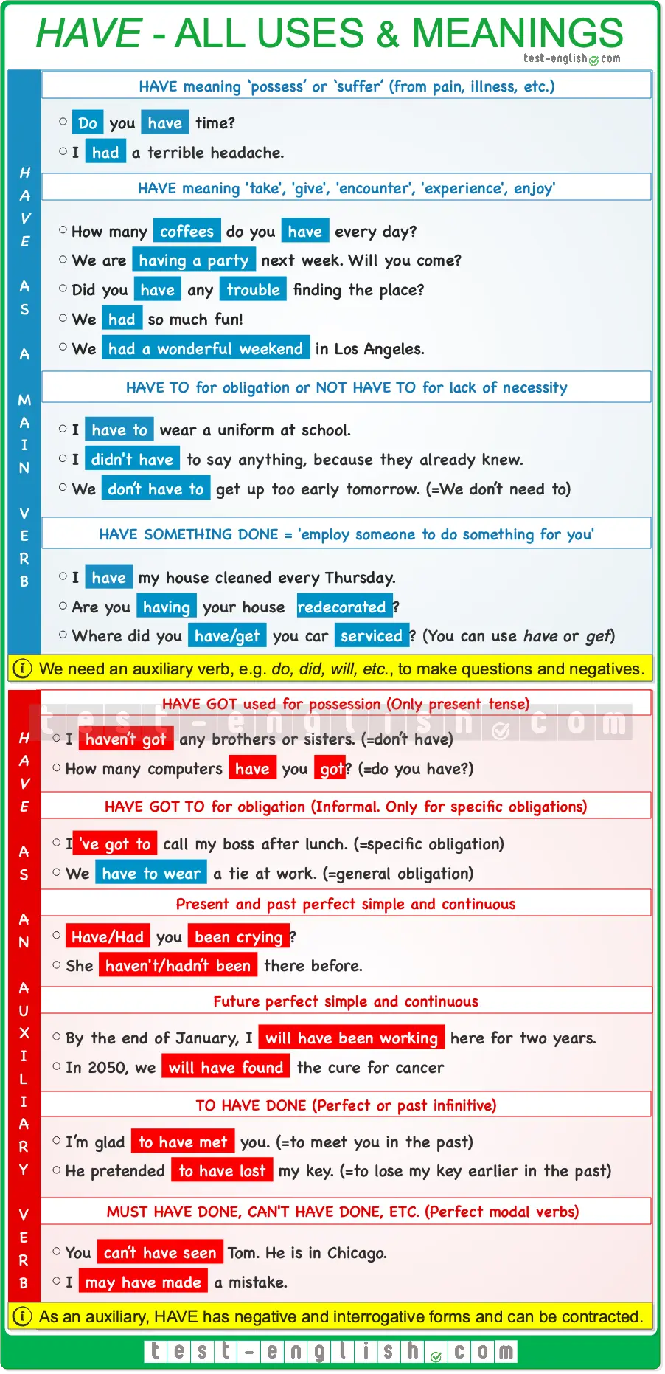

### ****Have**** as a main verb

When we use **have**as a main verb, it works as any other verb. We need an auxiliary verb, e.g. **do**, to make questions and negatives, and we don’t normally use its contracted form.

#### ****Have**** meaning ‘possess’ or ‘suffer’ (from pain, illness, etc.)

We use **have** to talk about possession. We need the verb **do**to make questions and negatives. The past form is **had**, and it’s a stative verb, so it CANNOT be used in progressive forms.

* **Do** you **have** time?
* I’**ve had** this watch since I was a child.
* I **have** a terrible headache.

#### ****Have to**** for obligation

**Have to** is used to express obligation, usually to talk about obligation coming from others: rules, regulations, etc. In this case, **have**is also a stative verb.

* We **have to** wear a uniform at school.
* Remember you **have to** return the book before next month.

We need **do**or another auxiliary verb to make questions and negatives.

* You **won’t have to** show me your credentials; it won’t be necessary.
* I **didn’t have to** say anything because they already knew.

The **negative** form of **have to** is used to talk about **lack of necessity** (NOT about prohibition)

* I **don’t have to** get up too early tomorrow. (=I don’t need to)

#### Have something done

When we [have something done](https://test-english.com/grammar-points/b1-b2/have-something-done/), it means that we ’employ someone to do something for us’.

* I **have** my house **cleaned** every Thursday. (=I employ someone to clean my house.)

We can also use **have something done** when something bad happens to us.

* He **had** his wallet **stolen** in Piccadilly.
* They **had** their house **destroyed** by the fire.

**Have** here is a dynamic verb, so it can be used in progressive forms.

* We **are having** the house **redecorated**.

In informal speech, it’s common to use **get** instead of **have.**

* Where did you **get** your car **serviced**?

#### ****Have**** meaning ‘take’ (a shower, a drink, etc.), ‘give’ (a party), etc.

**Have** can have different meanings depending on the words that come after it. It can mean:

➟ **‘Take’** (a meal, a drink, a shower, a bath, a massage, a lesson, etc.)

* I’m going to **have a massage** tomorrow.
* How many **lessons** do you **have** every week?

➟ **‘Give’** (a party)

* We are **having a party** next week; do you want to come?

➟ **‘Encounter’** (trouble, difficulties)

* Did you **have** any **trouble** finding the place?

➟ **‘Experience’**, ‘enjoy’ (day, weather, time, etc.)

* We **had** so much **fun**!
* We **had a wonderful weekend** in Los Angeles.

In all these cases, **have** is a dynamic verb, so it can be used in continuous forms.

* I’**m having** a lot of problems with my new computer.
* We **are having** fantastic weather.

In all these cases, **have**is a main verb, and we need **do** or **did** or another auxiliary to make questions and negatives.

* **Do** you **have** a shower in the mornings?
* You **won’t have** any trouble.

### ****Have**** as an auxiliary verb

When **have**is used as an auxiliary verb, it normally has negative and interrogative forms, and it can be contracted.

#### ****Have got**** used for possession

In informal English, it is common to use **have got** instead of **have** to talk about possession. When expressing possession, the verb **have**is not an auxiliary verb when used on its own, but it is an auxiliary verb in **have got**.

* I **haven’t got** any brothers or sisters = I **don’t have** any brothers or sisters.
* How many computers **have** you **got**? = How many computers **do** you **have**?

The verb **have got** only exists in the present tense.

* We **hadn’t got** an umbrella and got wet. 
* We **didn’t have** an umbrella and got wet. 

#### ****Haven’t**** for possession

In negative sentences, sometimes we leave out **got** to express possession.

* I **haven’t** time to do what I want.
* I **haven’t** a clue.
* I **haven’t** the slightest idea.

#### ****Have got to**** for obligation

In informal English, we can also use **have got** to express the idea of obligation. It is normally used to talk about specific obligations rather than general obligations.

* I’**ve got to** call my boss after lunch. (=specific obligation)
* I **have to wear** a tie at work. (=general obligation)

#### Present and past perfect simple and continuous

We use **have** in the [present perfect simple and continuous](https://test-english.com/grammar-points/b1-b2/present-perfect-simple-continuous/). These are verb tenses that we often use to express the idea of duration.

* I’**ve been writing** all morning.
* We’**ve been married** for ten years.

We also use **have** in the [past perfect simple and continuous](https://test-english.com/grammar-points/b1-b2/narrative-tenses/).

* She told me she **hadn’t been** there before.
* I could see in her eyes that she **had been crying**.

#### Future perfect simple and continuous

We use **have** in the future perfect simple for actions that will be **completed** at a certain time **in the future**.

* In 2050, we **will have found** the cure for cancer.

We also use **have** in the future perfect simple to express the duration of a situation until a certain time in the future.

* In 2030, we **will have been** married for 25 years.

We use the present perfect continuous with dynamic verbs to express the duration of a situation until a certain time in the future.

* By the end of January, I **will have been working** on this project for two years.

#### Perfect or past infinitive: ****to have done****

We use the verb **have** in the perfect infinitive to talk about things that happened in the past.

* I’m glad **to have met** you. (=to meet you in the past)
* He pretended **to have lost** my phone number. (=to lose my phone number earlier in the past)

#### Perfect modal verbs: ****must have done, can’t have done, etc.****

We use the verb **have**to form the [past modal verbs of deduction](https://test-english.com/grammar-points/b1-b2/past-modal-verbs/).

* You **can’t have seen** Tom. He is in Chicago.
* I **may have made** a mistake.

## Ellipsis

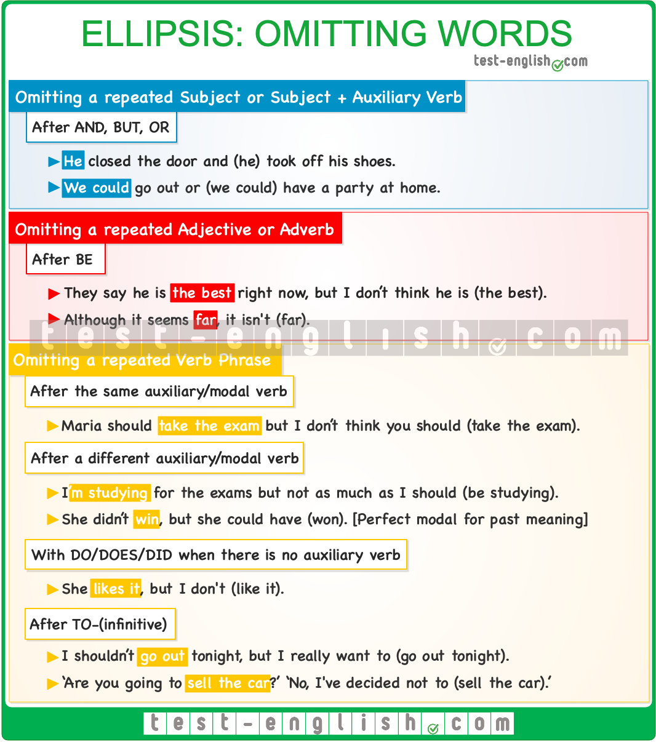

### Repeated subject or subject + auxiliary verb

After **and, but,** and **or**, we can leave out a repeated subject or a subject + auxiliary verb.

* He closed the door **and** (he)**took off** his shoes.
* We could go out **or** (we could) **have** a party at home.
* She called, **but** (she) **didn’t leave** a message.

#### Repeated adjective or adverb after ****be****

* They say he is the best right now, but I don’t think he **is** (the best).
* Although it seems far, it isn’t (far).

### Repeated verb phrase

#### After the same auxiliary/modal

We can avoid repeating an adjective, a verb, or a verb phrase and repeat only the auxiliary or modal verb.

* Maria should take the exam, but I don’t think you **should** (take the exam).
* She’ll go to the meeting, but I **won’t** (go to the meeting).

#### After a different auxiliary/modal

We can also omit a repeated verb phrase when we use a different auxiliary or modal verb.

* I’m studying for the exams, but not as much as I **should** (be studying).
* I told you I’d help you, but I **can’t** (help you).

We may need to leave two auxiliaries to express past meaning in the second clause or sentence.

* She didn’t win, but she **could have** (won).
* ‘Did you go?’ ‘No, but I **should have** (gone).’

#### With ****do/does/did**** when there is no auxiliary verb

Use **do/does/did** in the second clause or sentence when the verb is present or past simple.

* She doesn’t like it, but I **do**.
* She liked it, but I **didn’t**.

#### After ****to****-(infinitive)

This is called a **reduced infinitive**. It’s when you leave out a repeated infinitive or infinitive verb phrase after **to**.

* I shouldn’t go out tonight, but I really **want to** (go out).
* ‘Are you going to sell the car?’ ‘No, I**‘ve decided not to** (sell the car). ‘

## Substitution

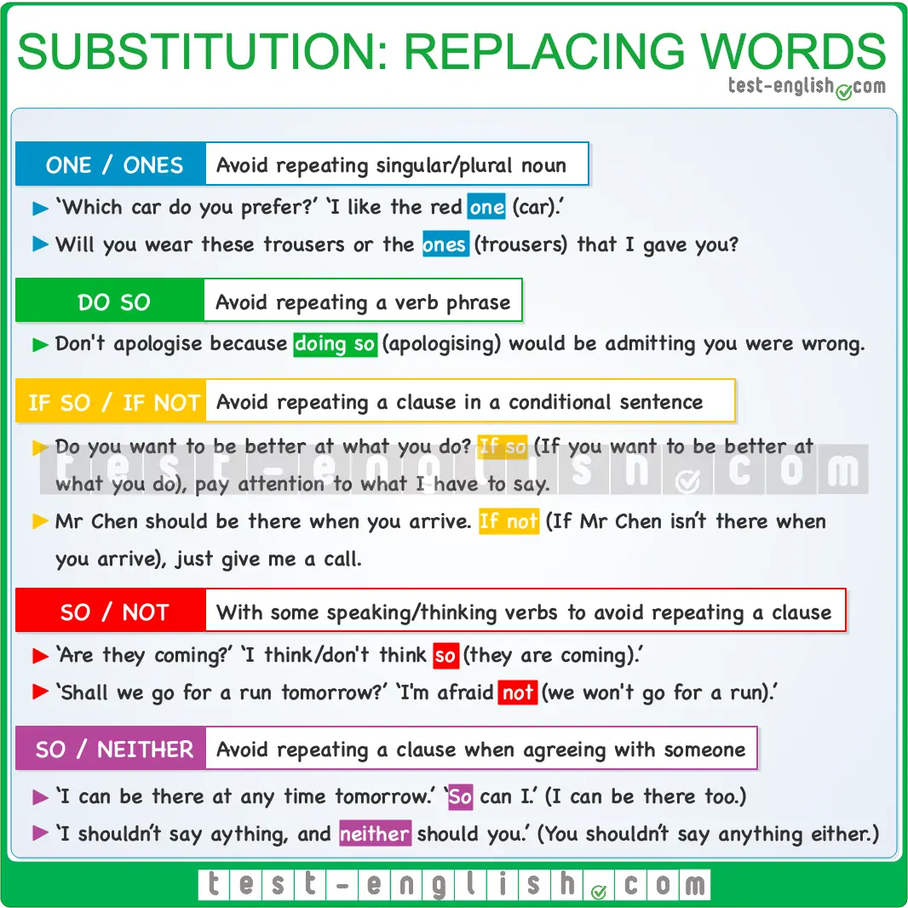

#### One, ones

We can use **one** to avoid repeating a singular countable noun, and we can use **ones** to avoid repeating a plural noun.

* ‘Do you need a pen?’ ‘No, I’ve already got **one**.’
* ‘Which car do you prefer?’ ‘I like the red **one**.’
* Will you wear these trousers or the **ones** that I gave you?
* I’d lend you a pen, but this is the only **one** I have.

#### Do so

We can use **do so** (or **does so, did so, doing so**, etc.) to avoid repeating a verb phrase.

* If I can help, I’ll be happy **to do so**. (=to help)
* I won’t apologise because **doing so** would be admitting that I was wrong. (=apologising)

We can also use **do it/that** (more informal) instead of **do so**.

* They told me to be quiet, and I **did it/that/so**.

#### If so, if not

We can use **if so**/**if that is so** (positive) or **if not** (negative)to avoid repeating a clause in a conditional sentence.

* Do you want to be better at what you do? **If so**, pay attention to what I have to say. (=If you want to be better at what you do)
* Mr Chen should be there when you arrive. **If not**, just give me a call. (=If Mr Chen isn’t there when you arrive)

#### Using ****so**** and ****not**** as substitutes for clauses

We use **so** after certain verbs of thinking and speaking to avoid repeating a positive clause. This use is common with the verbs **assume, believe, expect, guess, hope, imagine, presume, suppose, suspect, say, tell sb, think** and the expressions **be afraid**, and **it seems/appears**.

* ‘Are they coming?’ ‘I **think so**.’ (=they are coming)
* ‘I didn’t do it.’ ‘If you **say so**.’ (=that you didn’t do it)
* ‘Is she going to be there?’ ‘I **hope so**.’ (=she’s going to be there)

When we want to avoid repeating a negative clause, we can use a positive verb + **not** or a negative verb + **so**.  We can use either of those forms with the verbs **appear, seem,** and **suppose**.

* ‘Did they leave a copy of the key?’ ‘It **doesn’t seem so**/It **seems not**.’

We usually use a positive verb + **not** with **be afraid, assume, guess, hope, presume,** and **suspect**.

* ‘Shall we go for a run tomorrow?’ ‘I’**m afraid not**. I have to be at the office all day.’

We normally use a negative verb + **so** with **believe, expect, imagine,** and **think**.

* ‘Will it take long to fix it?’ ‘I **don’t think so**.’

#### So, neither

We can use [**so** and **neither**](https://test-english.com/grammar-points/a2/so-neither/) + auxiliary + subject to avoid repeating a clause when we are agreeing with someone.

* ‘I can be there at any time tomorrow.’ ‘So **can I**.’ (=I can be there at any time tomorrow too.)
* ‘I shouldn’t take the offer, and **neither should you**.’ (=and you shouldn’t take the offer either.)

If there is no auxiliary verb in the first clause or sentence, we use **do/does** or **did**.

* ‘I love this book.’ ‘**So do I**.’
* ‘We arrived on time, and **so did all the other guests**.’

### Adjectives and adverbs

## Modifying comparatives

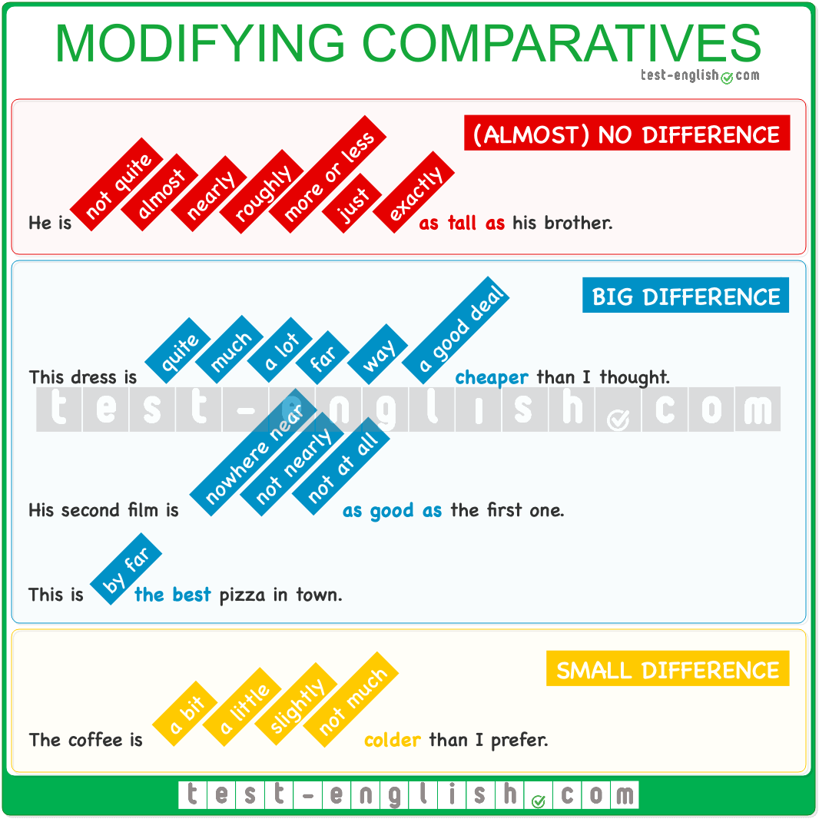

When we are comparing things in English, we can use modifiers to describe different degrees of difference. For example, you can describe your brother as **taller** than you, but if the difference in height is big, you can say that he is **much**or **far taller** than you.

### Describing a big difference

#### Quite/much/a lot/far/way/a good deal

We can use **quite, much, a lot, far, way** or **a good deal** with comparative adjectives.

* This dress is **quite cheaper** than the one I saw yesterday.
* It’s **much hotter** today than it was yesterday.
* He’s **a lot less experienced** than his brother.
* The journey to the city is **far longer** than I anticipated.
* This project is **way more complicated** than the last one.
* This new phone is **a good deal more expensive** than the previous model.

#### Nowhere near/not nearly/not at all  as … as

We can also modify the comparative form **as**+ adjective **+ as** to describe a big difference. To do this, we can add **nowhere near, not nearly,** or **not at all** before the first **as**.

* The new restaurant is **nowhere near as crowded as** the one downtown.
* She’s **not nearly as experienced as** she claims to be.
* This book is **not at all as interesting as** the one I read last week.

#### By far + superlative

We can use **by far** with superlative adjectives to emphasise the greatest difference among a group.

* This is **by far the best** pizza I’ve ever tasted.
* He is **by far the most** talented musician in the band.

### Describing a small difference

#### A bit/a little/slightly/not much

We can use **a bit, a little, slightly, not much**with comparative adjectives to describe small differences.

* This shirt is **a bit less expensive** than the one I bought last month.
* It’s **a little warmer** today than yesterday.
* The coffee is **slightly colder** than I prefer.
* This option is **not much cheaper** than the one I suggested.

### Describing no difference or almost no difference

#### Almost, nearly, not quite, roughly, more or less, just, exactly as … as / the same as

We can use the modifiers **almost, nearly, not quite, roughly,** **more or less, just,** or **exactly** before the structure **as**+ adjective + **as** or before **the same as** to describe an (almost) inexistent difference.

* She’s **almost as tall as** her brother.
* He’s **nearly as fast as** Mike in running races.
* The flavour of this dish is **not quite as spicy as** I expected.
* The distance to the beach is **roughly the same as** to the park.
* The party was **more or less as boring as** I’d expected.
* I’m **just/exactly as capable as** you are.

### Using modifiers with nouns

We can also make comparisons using **more** or **less** with nouns instead of adjectives:

* I have **more games** than you.
* They owe **less money** than we thought.

In these cases, we can also use modifiers.

* I have **far more games** than you.
* They owe **much less money** than we thought.
* She has **a lot more experience** than her colleague.
* She has only **a little more time** than I do.
* There is **not much more traffic** today than there was yesterday.
* He has **slightly more food** left than his friend.
* She has **not quite as many friends as** she used to.
* We have **roughly the same number of cars as** our neighbours.

## Compound adjectives

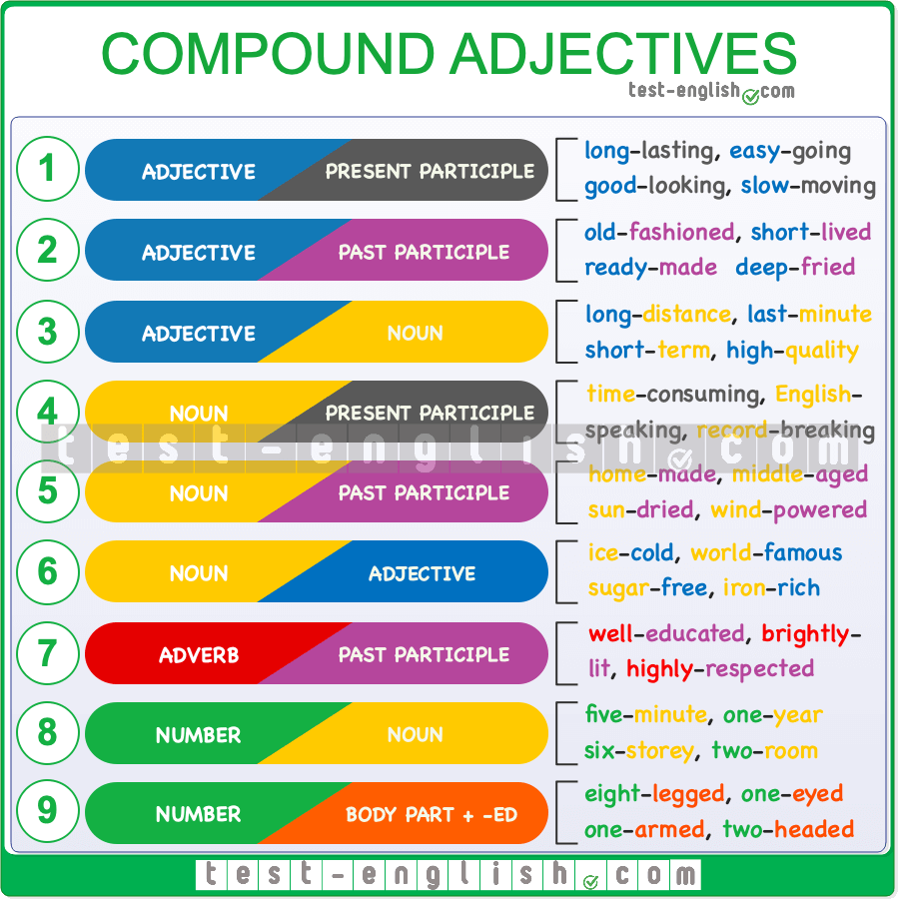

### What are adjectives?

[Adjectives](https://test-english.com/grammar-points/a1/adjectives/) are words we use before nouns or after the verb **be** or a [sensory verb](https://test-english.com/grammar-points/b1-b2/verbs-of-the-senses/) (such as **taste, look, smell, etc.**) to describe objects, people, places, and other things.

### What are compound adjectives?

Compound adjectives are combinations of two or more words that function collectively as a single descriptive unit. These multi-word adjectives are typically connected with hyphens to indicate that they work together as one idea. Take, for instance, the phrase **a well-known actor**. Here, **well-known** is a compound adjective formed by combining the adverb **well** with the past participle **known** to offer a precise characterisation of the actor.

### When should we use the hyphen?

The hyphen should be used to connect the different words of a compound adjective when we use it **before a noun**, but when we use the adjective after the verb **be** or a **sensory verb**, the words often remain separate.

* He is a **well-known** actor.
* This actor is **well known** for his impactful performances.

However, some common compound adjectives are consistently hyphenated. It’s a good idea to consult a dictionary or verify online.

* Their relationship was **short-lived**.

While English speakers might occasionally skip the hyphen, its correct use is crucial to prevent misunderstandings. Consider the difference in these sentences:

* He is a **large truck driver**. (This means the driver himself is large.)
* He is a **large-truck driver**. (This indicates he drives large trucks.)

Another example:

* He is an **old book collector**. (This implies the book collector is old.)
* He is an **old-book collector**. (This means he is a collector of old books.)

The presence or absence of the hyphen can shift meaning. In the latter example, the hyphen shows that **old** describes the books, not the collector.  
  
We can form compound adjectives from various word combinations. It’s crucial to note that when a compound adjective includes a noun as one of its components, **the noun is always in the singular form**. Why is this? Because adjectives in English don’t have plural forms, and this rule applies to compound adjectives as well. Here are the most common types of compound adjectives:

### Adjective + Present Participle

* long-lasting: My phone has a **long-lasting** battery.
* easy-going: Tom is an **easy-going** student.
* good-looking: Sara has a **good-looking** boyfriend.
* slow-moving: I am on a **slow-moving** train.
* loose-fitting: I prefer wearing **loose-fitting** clothing.

### Adjective + Past Participle

* short-haired: I’ve seen that **short-haired** woman before.
* old-fashioned: My father has very **old-fashioned** ideas.
* short-lived: They had a **short-lived** relationship.
* ready-made: I eat a lot of **ready-made** meals.
* deep-fried: She ordered some **deep-fried** chicken.

### Adjective + Noun

* long-distance: John is a **long-distance** runner.
* last-minute: It was a **last-minute** decision.
* short-term: He signed a **short-term** contract.
* full-length: She wore a **full-length** skirt.
* high-quality: It is a **high-quality** product.

### Noun + Present Participle

* time-consuming: It is a **time-consuming** task.
* English-speaking: Australia is an **English-speaking** country.
* record-breaking: It was a **record-breaking** achievement.
* mouth-watering: She made us a **mouth-watering** meal.
* thought-provoking: It was a **thought-provoking** lecture.

### Noun + Past Participle

* home-made: She brought us some **home-made** bread.
* sun-dried: These **sun-dried** tomatoes are delicious.
* middle-aged: My father is a **middle-aged** man.
* wind-powered: John has a **wind-powered** boat.
* grass-fed: I only eat **grass-fed** beef.

### Noun + Adjective

* ice-cold: I feel like an **ice-cold** beer.
* world-famous: He is a **world-famous** author.
* sugar-free: Dan is on a **sugar-free** diet.
* iron-rich: Spinach is an **iron-rich** vegetable.
* cruelty-free: I only wear **cruelty-free** make up.

### Adverb + Past Participle

* well-educated: She is a very **well-educated** woman.
* highly-respected: He is a **highly-respected** man.
* badly/well-behaved: They have two **well-behaved** boys.
* brightly-lit: We sat in a **brightly-lit** room.
* densely-populated: India is a **densely-populated** country.

### Number + Noun

[Number-noun adjectives](https://test-english.com/grammar-points/b1/compound-adjectives-with-numbers-a-two-day-trip/) are very common in English, especially to describe time, size, or features.

* five-minute: Let’s take a **five-minute** break.
* one-year: He signed a **one-year** contract
* six-storey: I live in a **six-storey** building.
* two-room: I live in a **two-room** flat.
* five-day: I work a **five-day** week.

It’s important to remember that in number-noun combinations, you should **write the number in full** (unless it is an extremely large number) and **keep the noun singular**.

* I had a **2-minutes** break. 
* I had a **two-minute** break. 
* Ken has a **3-bedrooms** house. 
* Ken has a **three-bedroom** house. 

### Number + body part + ****-ed****

* eight-legged: Spiders are **eight-legged** insects.
* one-eyed: A cyclops is a **one-eyed** creature.
* one-armed: I met a **one-armed** man.
* two-headed: I drew a **two-headed** monster.
* three-horned: A rhinoceros is a **three-horned** animal.

We sometimes make compound adjectives using **three or more words**, though this is not as common. And, as with two-word compound adjectives, we use a hyphen to connect the words.

* I have a **two-year-old** daughter.
* They used **state-of-the-art** technology.

## What is an inversion with a negative adverbial?

In formal English, we can use a **negative or restrictive adverb** at the beginning of a sentence to make it more emphatic or dramatic. When we do this, the adverb is then followed by an inversion: **auxiliary verb + subject (+ verb)**. See the example below:

* I could find my keys **nowhere**. ⇒ **Nowhere** **could I find** my keys.

When there is no auxiliary verb, we use **do**/**does** (present) or **did** (past) as auxiliary.

* I understand the true meaning **only now**. ⇒ **Only now** **do I understand** the true meaning.
* I did**n’t** say anything **until she arrived**. ⇒ **Not until she arrived** **did I say** anything.

## Common adverbs used with this structure

In the table below, you can see some of the most common negative or restrictive adverbials that are sometimes used at the beginning of the sentence for emphasis.  
  
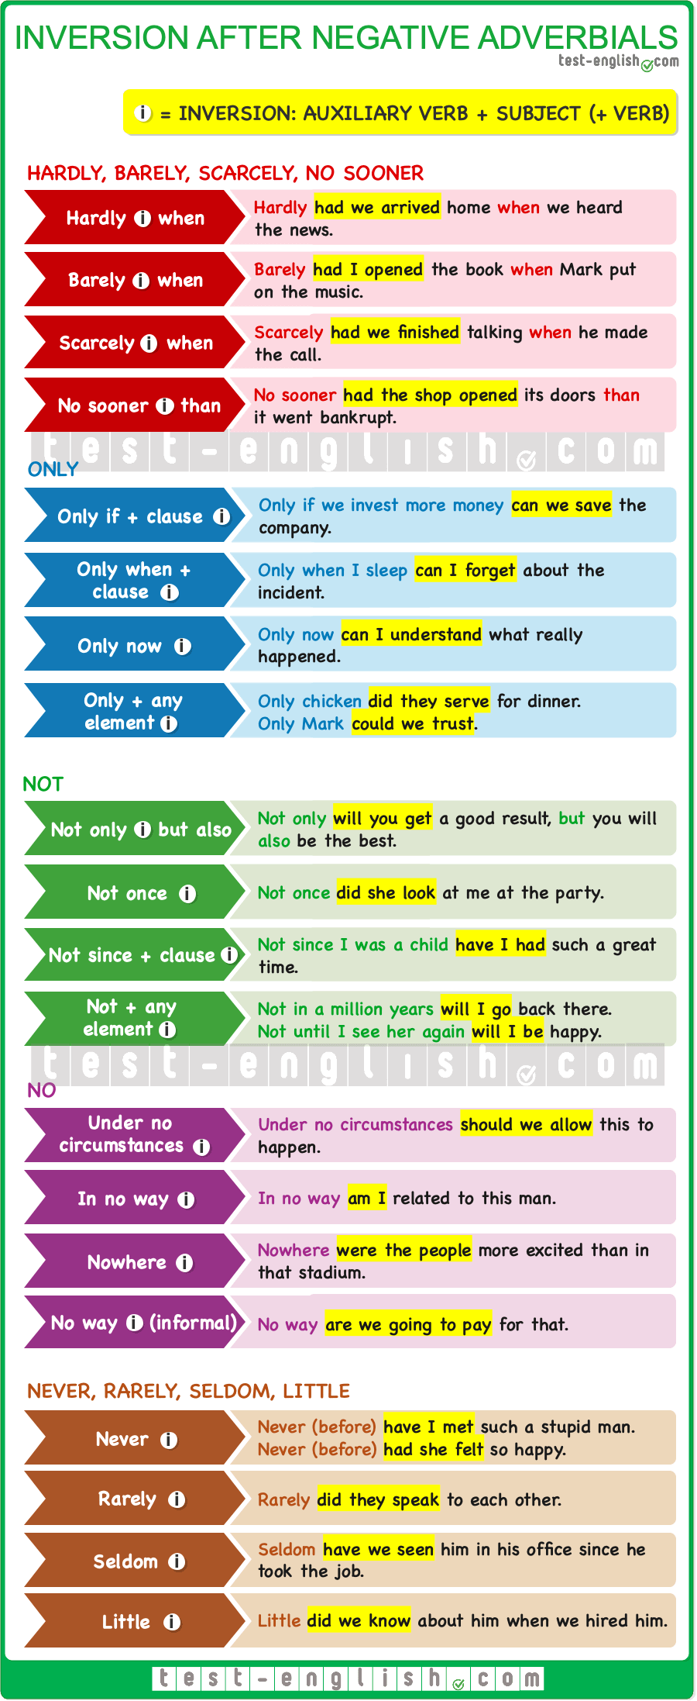

#### Hardly, barely, scarcely, no sooner

We normally use **hardly … when, barely … when**, **scarcely … when**, and **no sooner … than** in narratives with past perfect in the inversion.  
  
We use **no sooner … than** (NOT **that**, or **when**)

#### Adverbial + clause + inversion

❗ **Note** that after some adverbials, such as **only if**and **only when** we use a subordinate clause (subject + verb), and that the inversion is never in the subordinate clause but in the main verb of the sentence. Check the sentence below:

* **Only when do I sleep I can forget** about the accident. 
* **Only when I sleep** **can I forget** about the accident. 

The same happens with other adverbials, such as **not since**and **not until**; we use a subordinate clause (subject + verb), and the inversion is never in the subordinate clause but in the sentence’s main verb. Check the sentence below:

* **Not since was I a child** **I have had** such a great time. 
* **Not since I was a child** **have** **I had** such a great time. 

If you are in doubt, it’s always useful to look at the sentence without the negative adverbial at the beginning.

* **I can forget** about the accident only when I sleep.
* **I haven’t had** such a great time since I was a child.

The main subject and verb are at the beginning of the sentence, and this is the element that must be in the inversion.

#### Not

We must always use **not** followed by another element before the inversion.

* **Not** **can we see** such great expressions of art **often**. 
* **Not often** **can we see** such great expressions of art. 

#### Adverbs of frequency

We can also use inversion after the negative or restrictive adverbs of frequency, such as **seldom**, **rarely**, or **never**.  
  
We often use **never** to talk about experiences. In that case, we normally use present perfect or past perfect.

### Prepositions

## 50 common Noun + Preposition collocations

Some nouns often need a preposition, and we always use the same dependent prepositions for the same nouns. For example, when we use the word **interest** before a preposition, this preposition is always **in**. In the same way, we use the term **contact**with the preposition **with**, or we say **room for**:

* I have no **interest in** what you are saying.
* I will be in **contact with** you soon.
* We don’t have **room for** the sofa.

These word combinations are called noun-preposition collocations, and knowing which preposition to use can be challenging. One thing that we can do is check if we know an adjective or verb that is related to a noun. If we know the preposition for that adjective or verb, then we know the preposition for the noun because it’s the same one:

* **Adjective:** Joe had a **successful** career **in** the army.
* **Verb:** He **succeeded in** fixing the tap.
* **Noun:** I wished him **success in** his new job.

However, this is certainly not always the case, and the best way to remember these combinations of words is to practice and regularly read and listen to English. When you read or hear something repeatedly, you’ll soon start to recognise what sounds right.  
  
In the grammar chart below, you can see some common noun + **preposition** collocations.  
  
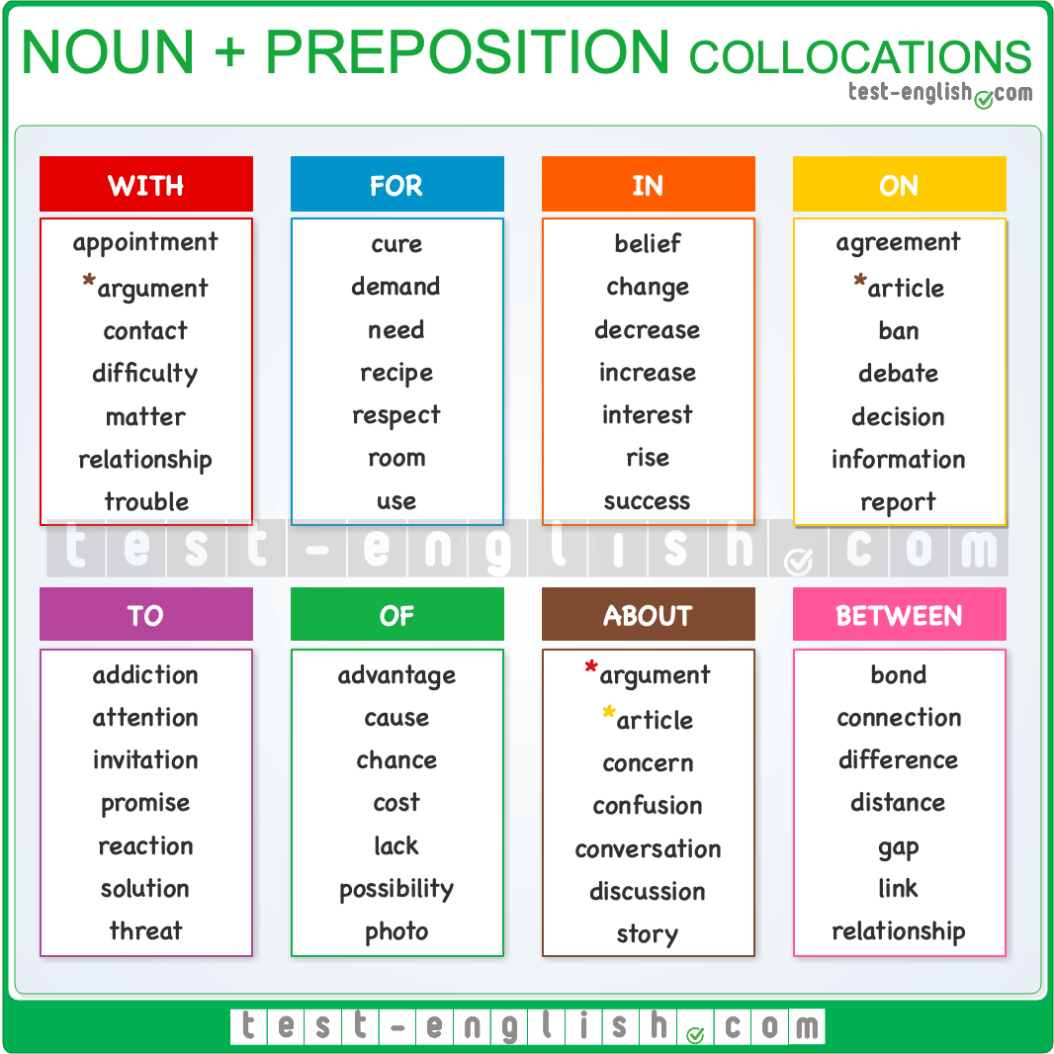

**\***Some nouns that can be followed by **more than one preposition** depending on the context, therefore having different meanings. For example, when the noun **argument** is followed by the preposition **with**, it usually refers to a person. However, when it is followed by the preposition **about**, it refers to the topic of the argument.

* John had an **argument with** Tom.
* We had an **argument about** my study habits.

**\***Some nouns can also be used with more than one similar preposition to have the same meaning.

* I read an **article about** the war.
* I read an **article on** climate change.

### Example sentences

#### Noun + WITH

* APPOINTMENT: I have an **appointment with** the doctor.
* ARGUMENT: Sam had an **argument with** his sister.
* CONTACT: They don’t have much **contact with** their father.
* DIFFICULTY: Joe is having **difficulty with** his homework.
* MATTER: What is the **matter with** Tom?
* RELATIONSHIP: We have a good **relationship with** our father.
* TROUBLE: Gary is in **trouble with** the teacher.

#### Noun + FOR

* CURE: Sadly, there is no **cure for** this disease.
* DEMAND: The **demand for** oil has increased significantly.
* NEED: There really is no **need for** these precautions.
* RECIPE: You really must give me the **recipe for** this cake.
* RESPECT: I have little **respect for** our new manager.
* ROOM: We have **room for** one more person in the car.
* USE: I have no **use for** a bicycle.

#### Noun + IN

* BELIEF: His **belief in** the kindness of others is admirable.
* CHANGE: They’re concerned by the **change in** his behaviour.
* DECREASE: There was a **decrease in** the number of students.
* INCREASE: There has been a sharp **increase in** house prices.
* INTEREST: He has always shown an **interest in** sailing.
* RISE: There has been a **rise in** house prices.
* SUCCESS: We’re happy about Tom’s **success in** his exams.

#### Noun + ON

* AGREEMENT: We came to an **agreement on** the subject.
* ARTICLE: I read an interesting **article on** evolution.
* BAN: There has been a **ban on** cars in the city centre.
* DEBATE: I listened to a fascinating **debate on** gun control.
* DECISION: We finally reached a **decision on** the project.
* INFORMATION: We need some **information on** the client.
* REPORT: Peter is writing a **report on** gun crime.

#### Noun + TO

* ADDICTION: His **addiction to** these pills is concerning.
* ATTENTION: You must pay **attention to** the teacher.
* INVITATION: He sent us an **invitation to** his wedding.
* PROMISE: He made a **promise to** his parents.
* REACTION: The patient had a severe **reaction to** the drugs.
* SOLUTION: We hope to find a **solution to** this problem.
* THREAT: Increasing temperatures pose a **threat to** wildlife.

#### Noun + OF

* ADVANTAGE: You must take **advantage of** this opportunity.
* CAUSE: The **cause of** the explosion is not yet known.
* CHANCE: He has little **chance of** passing the exam.
* COST: The **cost of** living has risen in the past year.
* LACK: The **lack of** rain has affected many farmers.
* POSSIBILITY: There is a strong **possibility of** rain this afternoon.
* PHOTO: He keeps a **photo of** his family in his wallet.

#### Noun + ABOUT

* ARGUMENT: Mum and I had an **argument about** homework.
* ARTICLE: I recently read an **article about** Spanish history.
* CONCERN: There was a lot of **concern about** the matter.
* CONFUSION: There was **confusion about** the new regulations.
* CONVERSATION: I overheard their **conversation about** the party.
* DISCUSSION: We had an interesting **discussion about** the issue.
* STORY: He told me a **story about** a prince and a frog.

#### Noun + BETWEEN

* BOND: The **bond between** Jeremy and his son is special.
* CONNECTION: I missed my **connection between** the two flights.
* DIFFERENCE: What’s the **difference between** the two models?
* DISTANCE: What’s the **distance between** the two cities?
* GAP: There were wide **gaps between** the floorboards.
* LINK: The **link between** the two suspects is obvious.
* RELATIONSHIP: The **relationship between** the two boys changed.

### Conjunctions and clauses

## Clauses of contrast

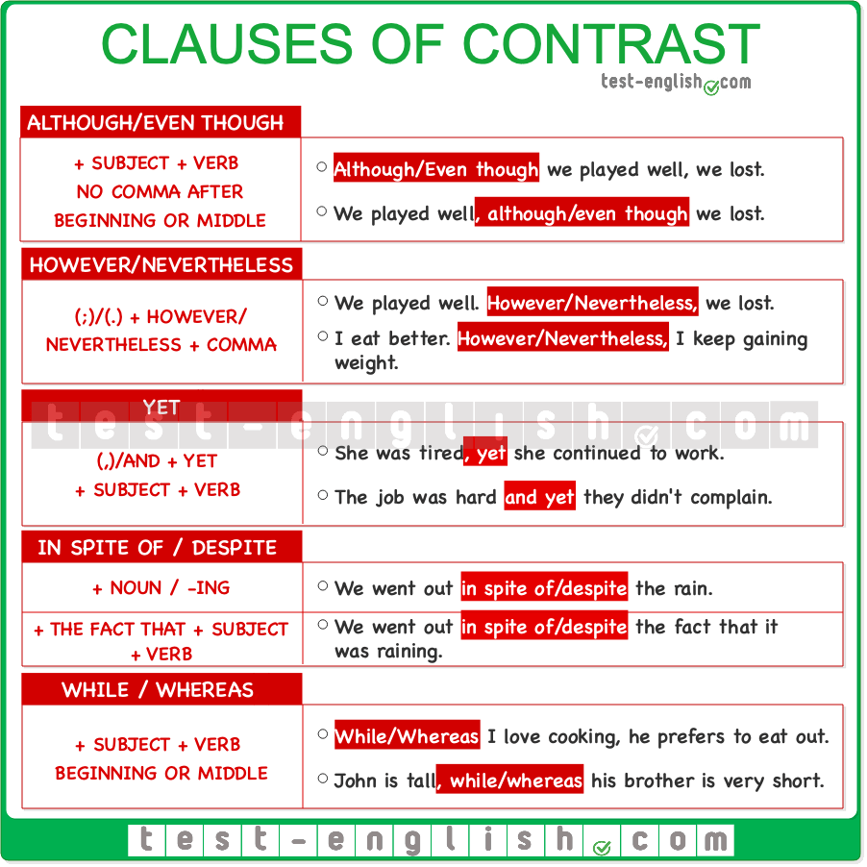

#### Although, even though

We can use **although/even though** at the beginning or middle of a sentence followed by a clause (subject + verb). We NEVER use a comma after **although** or **even though**.

* **Although/Even though** we had a bad game, we won.
* We won, **although/even though** we had a bad game.

#### However

We use **however** to connect two different sentences. We normally use **however** at the beginning of the second sentence after a full stop (.) or a semi-colon (;). **However**is ALWAYS followed by a comma.

* We didn’t like the hotel. **However**, we had a fantastic time.
* We went to the beach; **however**, the weather wasn’t perfect.

We can also use **however**at the end of the sentence.

* We didn’t like the hotel. We had a fantastic time, **however**.

#### Yet

The word **yet** means ‘but’ or ‘however’, and we use it to introduce a contrast to something that has just been mentioned. It is followed by a subject and verb, and it often appears after a comma or the word **and**. It can also be used after a full stop, followed by a comma, but that’s much less common.

* She was tired, **yet** she continued to work.
* The task was difficult and **yet** they managed to complete it.
* She was tired. **Yet**, she continued to work. (Not common.)

#### Despite/in spite of

**Despite** and **in spite of** are usually followed by a noun or a –**ing** verb. They can go at the beginning or in the middle of the sentence.

* **Despite/In spite of** the rain, we went to the concert.
* They arrived **despite/in spite of** leaving very early.

We can use a clause (subject + verb) after **despite/in spite of + the fact that**.

* We went out **despite/in spite of** **the fact that**it was raining.

#### While/whereas

We use **while** and **whereas** to show contrast between two facts or ideas. They can be used at the beginning or in the middle of a sentence, after a comma, and are often interchangeable.

* **While/Whereas** she enjoys cooking, he prefers to eat out.
* Mary likes classical music, **while/whereas** her sister prefers jazz.

## Clauses of purpose

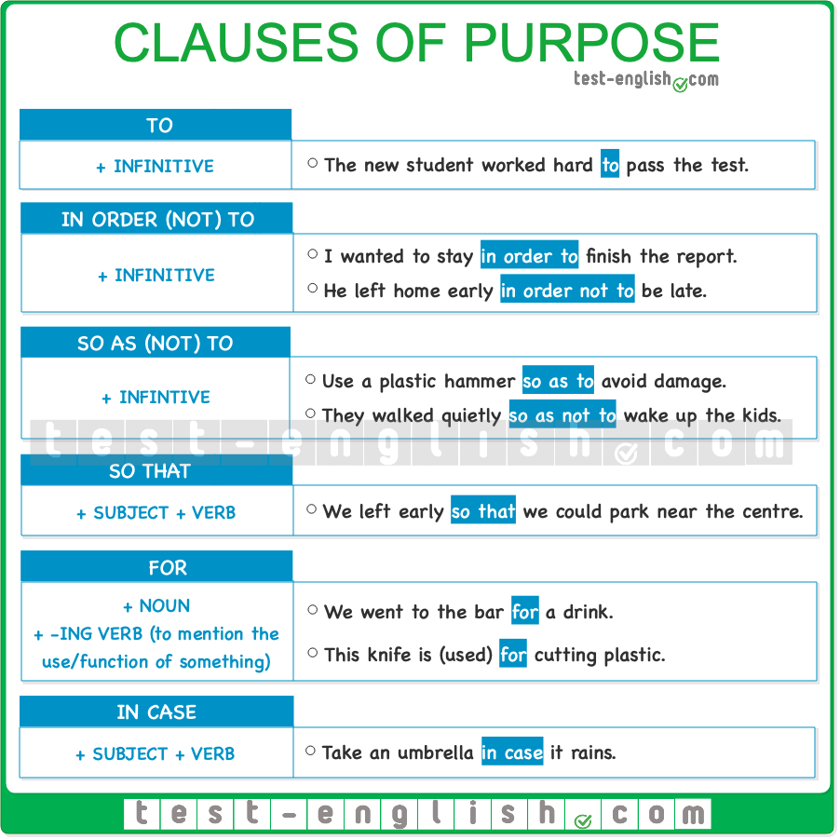

#### ****To**** + infinitive

The most common way to express purpose in English is **to** + infinitive.

* The student worked hard **to pass** the test.

#### ****In order to/so as to**** + infinitive

**In order to** or **so as to** + infinitive are more common in formal English, mainly in writing. The negative forms are **in order not to** and **so as not to** + infinitive.

* We were asked to stay **in order to** **finish** the project.
* He left home early **in order not to** **be** late.
* Use a plastic hammer **so as to avoid** damage.
* They walked quietly **so as not to wake up** the children.

We can also use the structure **in order for someone/something to do something**.

* We need to mobilize the media **in order for the Government to** listen to us.
* Three different surgeries were necessary **in order for him to** survive.

#### ****So that**** + clause

We can also use **so that** + subject + verb to express purpose. We normally use a **modal verb** with this connector, e.g. **could**, **can**, **would, etc.**

* We left early **so that we could** park near the centre.
* He made some flashcards **so that it would** be easier for his mum to remember the instructions.

#### ****For**** + noun

We can also use **for** + noun to express purpose.

* We went to the bar **for a drink**.
* Would you like to go to the park **for a run**?

We can use **for** + –**ing** verb (instead of **to** + infinitive) to talk about the purpose of an object or action when we use the verb **used** or when we imply it.

* This knife is (used) **for cutting** plastic.
* Schools are **for educating**, not **for entertaining**.

#### ****In case**** + clause

To express purpose, we can also use **in case** + subject + verb. We use this form to talk about precautions,  when we do something because something we don’t want might happen.

* Take an umbrella **in case** it rains. (=Take an umbrella so that you won’t get wet if it rains)
* I won’t tell Ann **in case** she tells everyone else.

## Clauses of reason

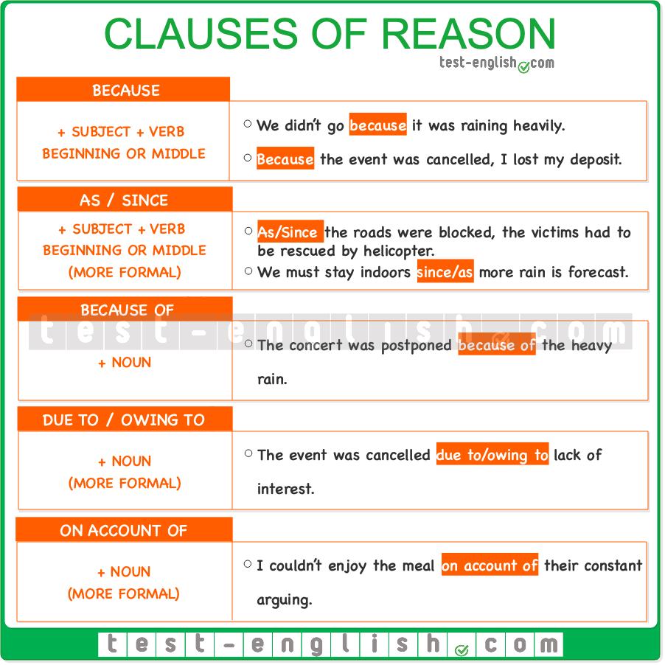

When we want to explain why something happened or why someone did something, we use a clause of reason introduced by a conjunction (**as**, **since**, **because**) or a noun phrase introduced by **because of**, **due to**, **owing to**, or **on account of**.

#### Because

We use **because** before a clause (subject + verb). It can be used at the beginning or the end of a sentence (at the end is more common). A comma is used when the clause of reason is at the beginning of the sentence.

* We didn’t go **because** it was raining heavily.
* **Because** the event was cancelled, they lost their deposits.

#### As/since

We use **as** and **since** in a very similar way to **because**. They are followed by subject + verb and can be used at the beginning or in the middle of a sentence. However, **as** and **since** are more formal expressions and are more common in written than spoken English.

* The Government urged people to stay indoors **since/as** more rain is forecast for the entire weekend.
* **As/Since** the roads were blocked, the victims had to be rescued by helicopter.

#### Because of

We use **because of** before a noun.

* The concert was postponed **because of** the heavy rain.

#### Due to/owing to/on account of

We can also use **due to**/**owing to**/**on account of** before a noun. They mean ‘because of’ but are more formal.

* The event was cancelled **due to/owing to/on account of** lack of interest.
* I couldn’t enjoy the meal **due to/owing to/on account of** their constant arguing.

## Clauses of result

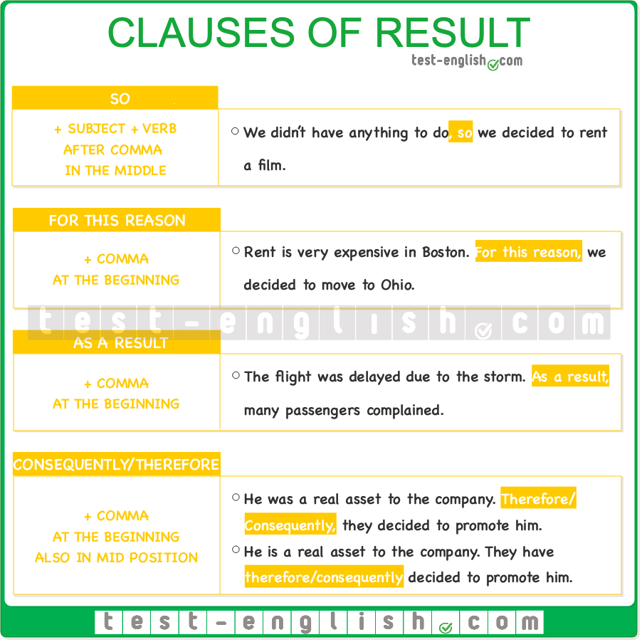

We use clauses of result to talk about the result of an action or situation.

#### So

We can use **so** + subject + verb at the end of a sentence to mean ‘this is why’.

* We didn’t have anything to do, **so** we decided to rent a film.
* I worked very hard today, **so** I’m exhausted.

#### For this reason

We usually use **for this reason** at the beginning of a sentence. We use a comma after it.

* Rent is very expensive in Boston. **For this reason**, we decided to move to Ohio.
* He threatened to commit suicide. **For this reason**, we kept him under surveillance.

#### As a result/consequently/therefore

**As a result, consequently**, and **therefore**are more formal and more common in written language. They are normally used at the beginning of a sentence, followed by a comma.

* The flight was delayed due to the storm. **As a result**, many passengers complained.
* Animals were his only true passion. **Therefore/Consequently**, he decided to study biology.

We can also use **consequently** and **therefore**in the mid position (before the verb, after **be**as the main verb, or after the first auxiliary verb).

* You have been a real asset to the company. We have **therefore/consequently** decided to promote you.

## Discourse markers

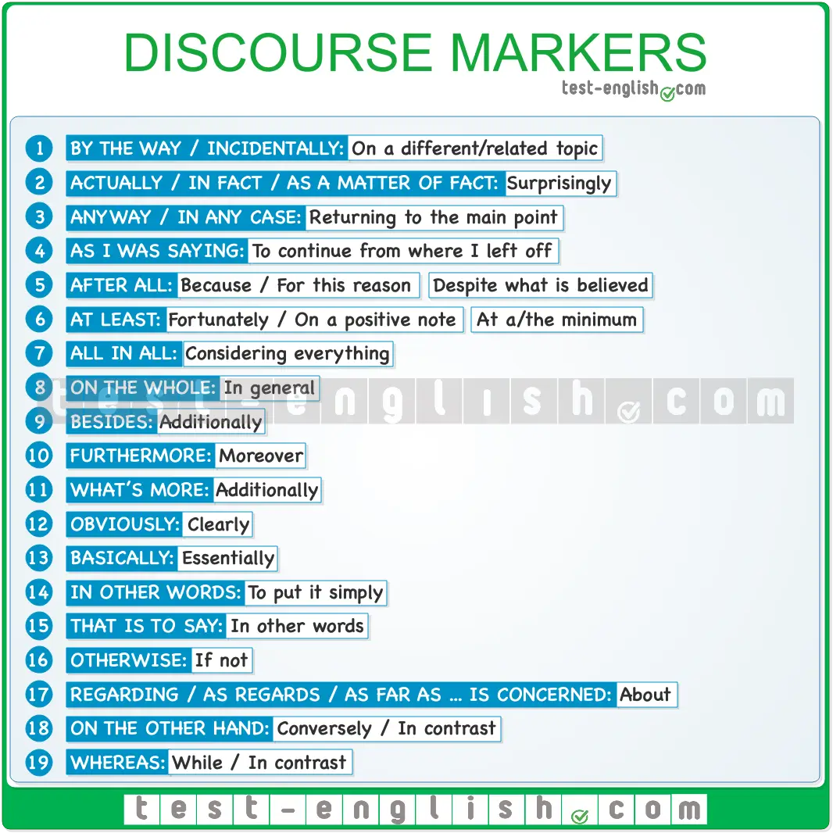

Discourse markers are very important to structure text or speech to connect sentences in a meaningful and logical way. They express [contrast, reason, purpose, result](https://test-english.com/grammar-points/b2/clauses-contrast-purpose-reason-result/), etc. Here, you can find some common discourse markers, their meanings, and some examples.

#### By the way / incidentally

Used to change the subject, to say something you have just thought about that doesn’t have to be connected to what was being said before.

* Well, it has been a very productive meeting, don’t you think? **By the way/Incidentally**, what time is it?
* I’ll try to fix my car this afternoon. **By the way/Incidentally**, do you still have that screwdriver that I lent you?

#### Actually / in fact / as a matter of fact

Used to introduce **information** that might be in some way **surprising** or **unexpected**.

* I don’t like chicken. **Actually/In fact/As a matter of fact**, I have only ever eaten chicken once.
* Everybody thinks he has a terrible temper, but **actually/in fact/as a matter of fact**, he is very kind.

#### Anyway / in any case

Used to **return to an earlier subject** after a digression or to get to the most interesting point.

* It’s not so strange to lose documents. It happens to lots of people all the time. **Anyway/In any case**, we finally found the passports in …

Used to give a **more important reason** for something you are saying.

* I’m too tired to go, and it’s too late, and **anyway/in any case**, it’s too expensive.

#### As I was saying

Used to **return to an earlier subject** in the conversation after an interruption or digression.

* **As I was saying**, we could get up early and spend the whole day there.

#### After all

Used to introduce an **additional point that supports** or explains what you have just said.

* I might understand her better than you; **after all**, she is my wife.
* Don’t be too hard on him. **After all**, he is just a kid.

Used to say that something is **true despite what is believed** or said.

* He is not such a bad professional, **after all**.

#### At least

Used to introduce **positive** information **when talking about** something **negative**.

* Lots of people got injured in the accident, but **at least** nobody died.
* I finished last in the race, but **at least** I finished.

Used to **reduce the effect** of something we have said or to **make something less certain** or definite.

* He knows the president, or **at least** that’s what he says.

#### All in all

= Taking into consideration all the parts of a situation.

* There were some mistakes, but **all in all**, you did a pretty good job.
* Both TVs are great, but **all in all**, I think this one is better for you.

#### On the whole

= Generally

* **On the whole**, men tend to avoid talking about feelings.
* There has been some criticism, but **on the whole**, customers like what we offer.

#### Besides

Used to add additional information (informal)

* I think it’s a beautiful place; **besides**, it’s very cheap.

#### Furthermore

Used to add additional (and often more important) information (formal)

* Electric cars are becoming more powerful and energy-efficient. **Furthermore**, they are much cheaper than a few years ago.

#### What’s more

We use **what’s more** to add something interesting to what we have just said. It’s similar to **furthermore** but more informal.

* Scientists have found a big body of water under the planet’s surface. **What’s more**, they think it’s not the only body of water they will find.
* He said that the new season will premiere this September and **what’s more**, he confirmed that it will not be the last.

#### Obviously

Used to introduce a fact that is easy to see or understand.

* **Obviously**, without qualifications, it’s harder to get a good job.

#### Basically

Used to introduce the most important point or characteristic of something.

* **Basically**, what we do here is produce the plastic parts of the phone.

#### In other words

Used to **say** what has been said **in simpler words**.

* She said we should take a break and have time to ourselves; **in other words**, she dumped me.

#### That is to say

Used to explain or be more precise about something we have said. Similar to **in other words**.

* The best thing about music is its repeatability; **that is to say,** you can listen to the same songs again and again and never get bored.

#### Otherwise

Used **after** an **order** **or** **suggestion** **to say what will happen** if that order or suggestion is not followed.

* Be here at 8 o’clock; **otherwise**, you will miss your turn.

#### Regarding … / as regards … / as far as … is concerned

= About. Used to introduce a topic of conversation.

* **Regarding/As regards** the new player, we’ll have to decide if or when to sell him.
* **As far as** the new player **is concerned**, …

#### On the other hand

Used to introduce a contrasting fact.

* Cycling is good for your health, and it’s a sport that is gentle with your muscles and joints. **On the other hand**, there are many fatal accidents among cyclists.

It can be preceded by **on the one hand:**

* **On the one hand,** cycling is good for your health, and it’s a sport that is gentle with your muscles and joints. **On the other hand**, there are many fatal accidents among cyclists.

#### Whereas

We use **whereas** to compare and contrast two things or ideas. It means ‘while’ when it is used to express contrast.

* The north is cold, **whereas** the south is very hot.
* **Whereas** people used to aspire to have a big house, kids, pets, etc., nowadays, preferences tend more towards apartments.

## Participle clauses

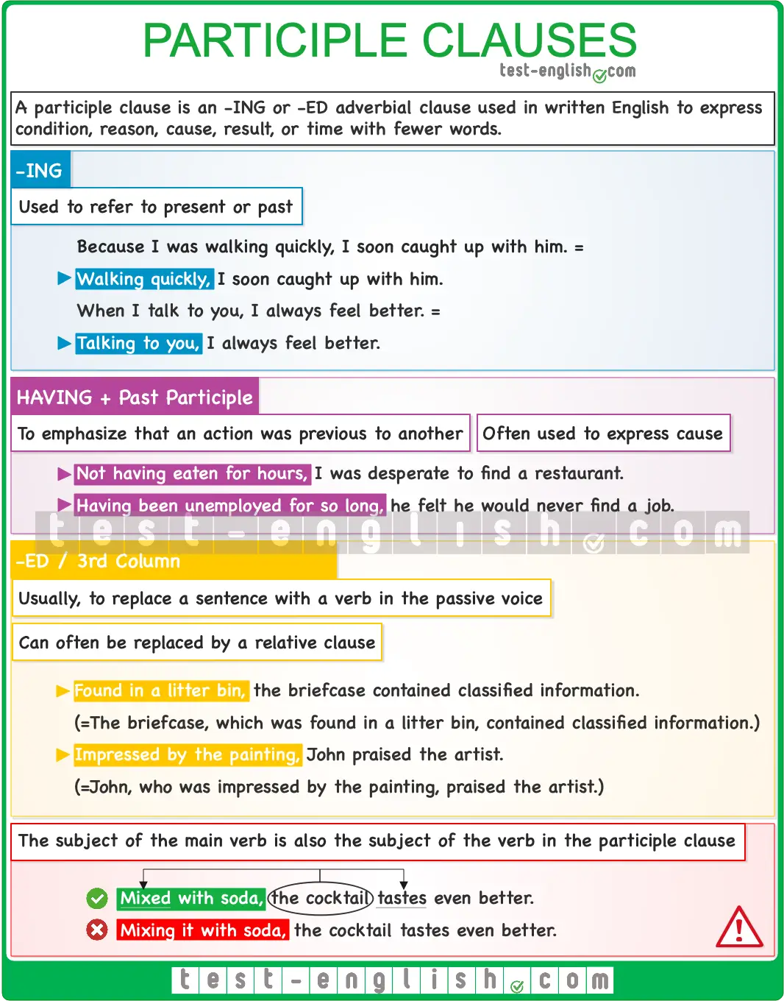

### What are participle clauses?

Participle clauses are not very common in spoken English; however, you can find many examples in written English. They allow us to express condition, reason, cause, result or time similarly to full [adverbial clauses](https://test-english.com/grammar-points/b2/clauses-contrast-purpose-reason-result/), only with fewer words. Look at a couple of examples:

* **After she had finished the exam**, she felt very happy. (time)
* **Having finished the exam**, she felt very happy.
* **As she didn’t know where the theatre was**, she asked for directions at the reception. (reason)
* **Not knowing where the theatre was**, she asked for directions at the reception.

### ****-Ing****

This is one of the most common participle clauses. We can use –**ing** participle clauses to refer to the present or the past.

* **As she was such a great singer**, she had no problems finding a job.
* **Being such a great singer**, she didn’t have problems finding a job.
* **When I talk to you**, I always feel better.
* **Talking to you**, I always feel better.
* **Because I was walking quickly**, I soon caught up with him.
* **Walking quickly**, I soon caught up with him.

### ****Having**** + ****-ed****/third column

By using the perfect –**ing** participle clause, you can emphasise that one action was previous to another. These clauses are commonly used to express the cause of a second action.

* **Having lost all the games**, he felt depressed.
* **Not having eaten for hours**, I was desperate to find a restaurant.

It’s common to have the passive structure **having been** + past participle as an alternative to a **since**-clause (reason):

* **Having been unemployed for so long**, he felt he would never find a job. (=Since he had been…)
* **Having been offered a promotion**, she decided to stay in the company. (=Since she had been…)

### ****-Ed****/third column

Past participle clauses usually replace a sentence with a verb in the passive voice.

* **Found in a litter bin**, the briefcase contained classified information. (=The briefcase **was found**.)
* **Impressed by the painting**, John praised the artist. (=He **was impressed** by the painting.)
* **Founded 20 years ago**, the company has received many awards. (=The company **was founded** 20 years ago.)
* **Located in the city centre**, the bar is very popular among tourists. (=The bar **is located** in the city centre)

🔍 **Note** that these participle clauses can often be replaced by relative clauses:

* The briefcase, **which was found in a litter bin**, contained classified information.
* John, **who was impressed by the painting**, praised the artist.
* The company, **which was founded 20 years ago**, has received many awards.
* The bar, **which is located in the city centre**, is very popular among tourists.

### Used after a preposition or conjunction

Participle clauses can also follow prepositions or conjunctions: **after, before, instead of, without, when, while**, etc. This use of prepositions or conjunctions before participle clauses (mainly –**ing** participle clauses) is quite common:

* Remember to take your bags **when leaving the bus**.
* **Instead of listening to me**, Tom left the room.
* **After having lost many games**, he felt depressed.
* I visited her **after talking with her mother**.
* People often use their phones **while driving**.

### Be careful with this common mistake!

You must always make sure that the subject of the verb in the participle clause and the subject of the verb in the main clause are the same. Using two different subjects is the most common mistake students make when using participle clauses.

* If you mix it with soda, the cocktail tastes even better. (The subject of **mix** is **you**, and the subject of **tastes** is **the cocktail**.)

**Mixing it with soda**, the cocktail tastes even better.  (The subjects are different.)  
**Mixed with soda**, the cocktail tastes even better.  (Same subject)

* If you water them at night, the plants live longer.

**Watering them at night**, the plants live longer.   
**Watered at night**, the plants live longer. 

### Word order

## What are cleft sentences?

**Cleft sentences** are complex sentences that are used to emphasise one particular part of a sentence. They are particularly useful in writing where we cannot use intonation for emphasis, but they are also frequently used in speech.

## Types of cleft sentences

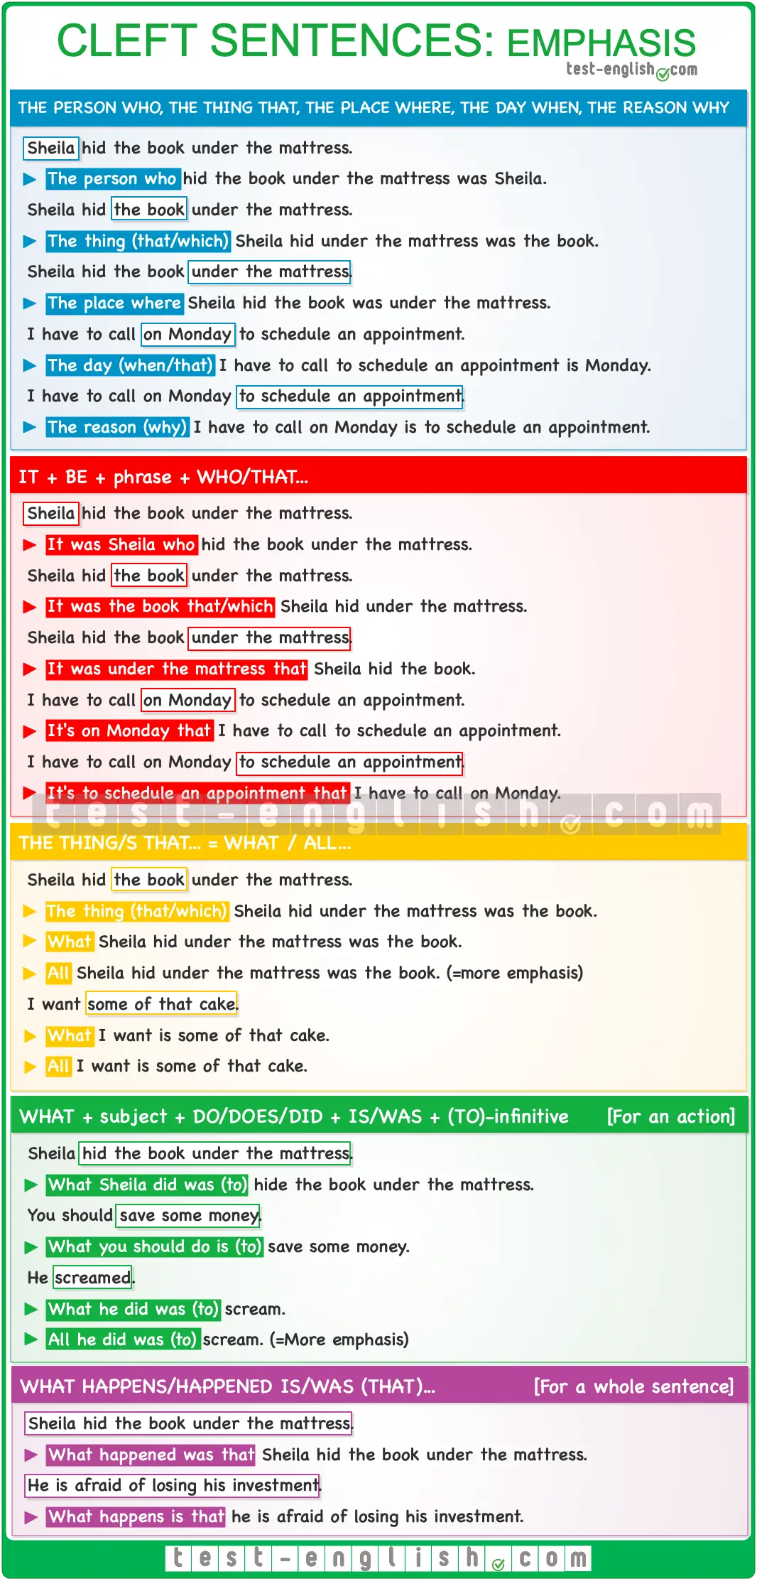

#### The reason why, the thing that, the person/people who, the place where, the day when…

We can focus on an element of the sentence by using these structures with a relative clause. We use the relative pronouns like we use them in any [relative clause](https://test-english.com/grammar-points/b2/relative-clauses/).

#### ****It**** + ****be**** + phrase + relative clause

Instead of **the person who, the thing that, etc.**, we can also use an introductory **it,** the verb **be**in any verb tense that we may need, and the element that we want to focus on.  
  
We can use **who/which**or**that** after a noun phrase, e.g. Sheila, the book, etc.  But we should use **that** after adverbial phrases, e.g. under the mattress, on Monday, etc.   
  
❗ **Note** that we can also use **when**after noun phrases but not after adverbial phrases. Compare:

* It’s **Monday** when I have to call.
* It’s **on Monday** that I have to call.

#### The thing/s that = What/All

We can also use **what** or **all** (more emphasis) instead of **the thing/s that** to focus on an element of the sentence.

#### ****What**** + subject + ****do/does/did/ + is/was + (to)**** infinitive

We use this structure when we want to focus on the verb or verb phrase. In these structures, we can use an infinitive with or without **to**.

#### What happens is (that) … / What happened was (that)

We use this structure when we want to focus on a whole sentence, and not only on an element in the sentence.